Strategic Management Tool Guides
Frameworks for Strategic Analysis

MBA Strategy Course
Grand Canyon University

Included Guides:
EFE Matrix
IFE Matrix
Competitive Profile Matrix
SWOT Matrix
SPACE Matrix
BCG Growth-Share Matrix
IE Matrix
Grand Strategy Matrix
QSPM
Perceptual Map

Table of Contents
Press F9 to update table of contents

The External Factor Evaluation Matrix

What This Tool Does
The External Factor Evaluation (EFE) Matrix provides a structured method for identifying, categorizing, and weighing the external opportunities and threats facing an organization. It converts qualitative environmental scanning into a quantitative summary score that reveals how effectively a company responds to the conditions in its external environment. The output is a single weighted score between 1.0 and 4.0 that tells you whether the organization is capitalizing on opportunities and defending against threats, or whether the external environment is outrunning management's ability to respond.

When to Use It
Use the EFE Matrix during the strategy formulation stage, specifically during external analysis. It should follow environmental scanning work — industry analysis, competitor assessment, political-legal-economic-social-technological (PEST) scanning — and should precede tools that require external input for strategic positioning, such as the Internal-External (IE) Matrix or the SWOT Matrix. The EFE Matrix is most useful when an organization needs to move beyond a general awareness of external conditions to a disciplined, weighted assessment of which factors matter most and how well management is responding.

Before You Start
- Complete an environmental scan covering all relevant external domains (economic, political, legal, technological, social, competitive, demographic)
- Gather industry data, competitor intelligence, and trend analyses that inform which external factors are material
- Identify both opportunities and threats — aim for a balanced list, not one dominated by either category
- Have access to managers or strategic planners who can provide informed judgment on response effectiveness
- Understand the difference between external factors (which the firm does not control) and internal factors (which belong in the IFE Matrix)

Step-by-Step Instructions
Figure TG.2. EFE Matrix Construction Example
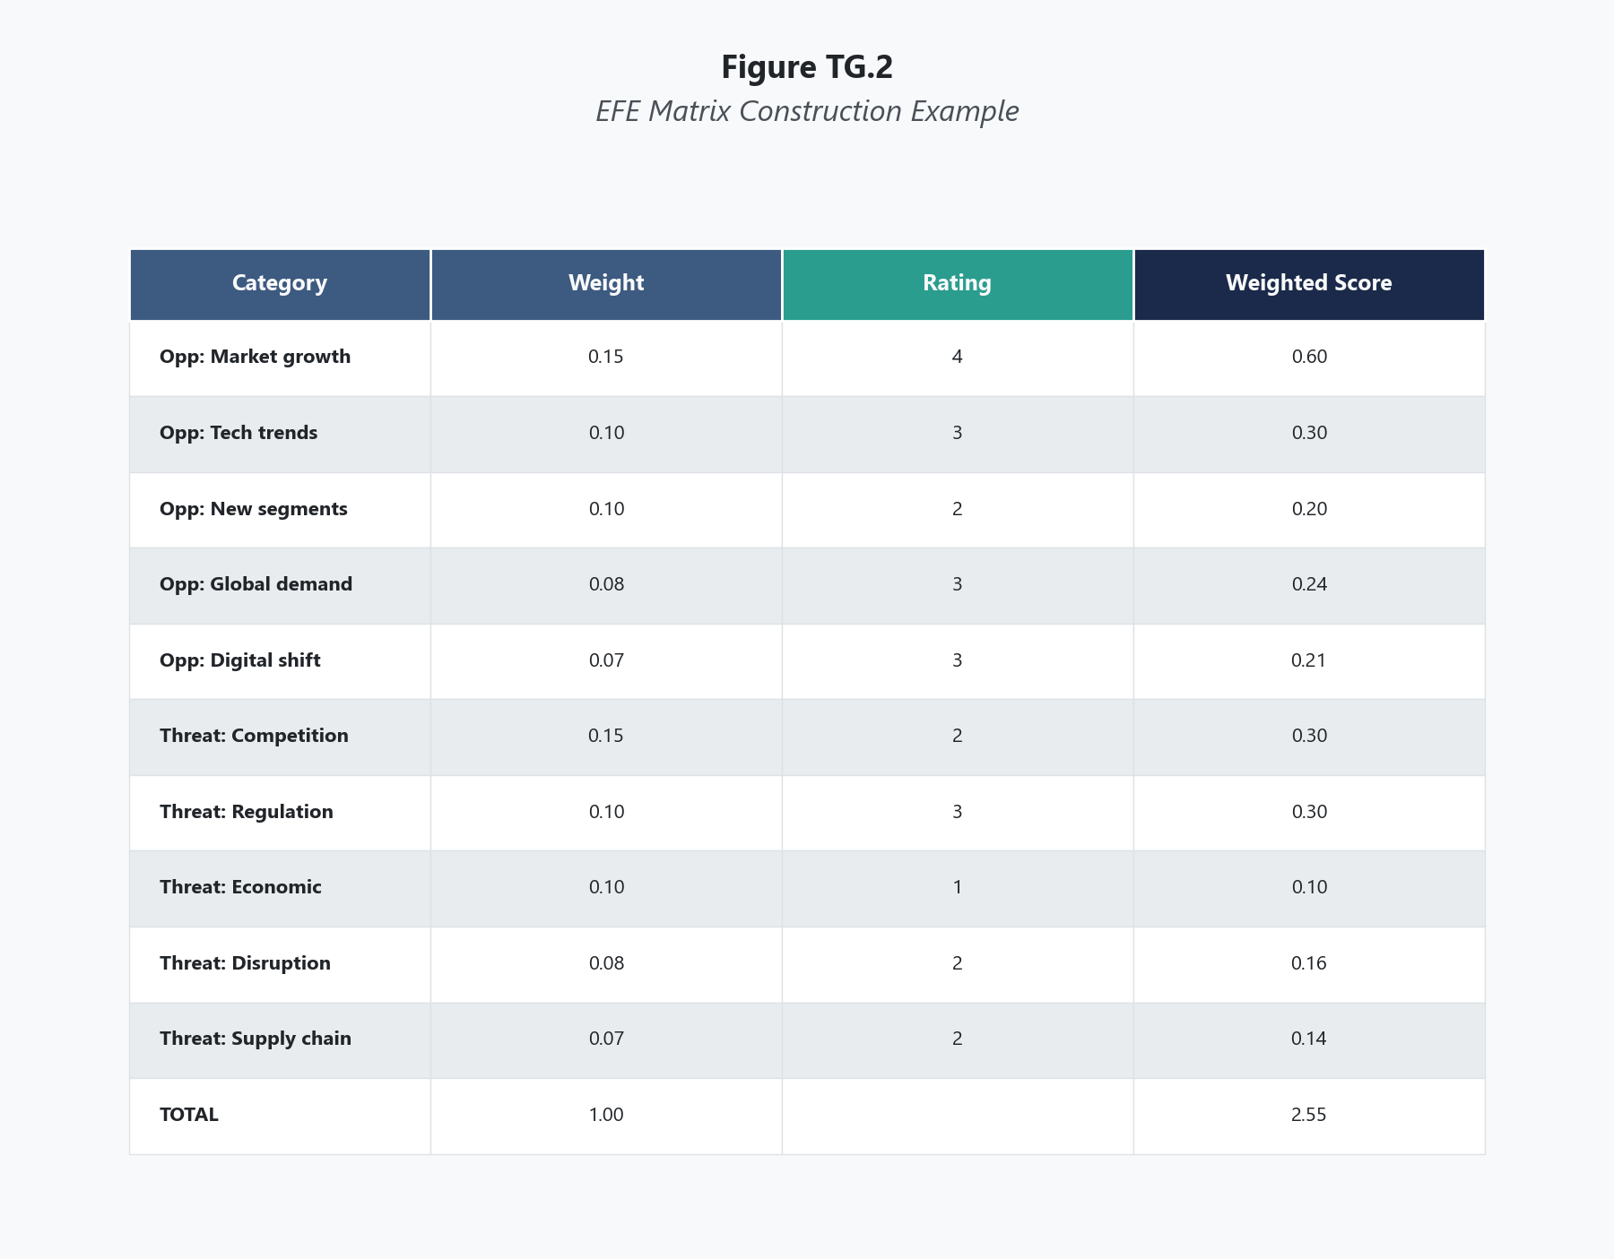
List 15 to 20 external factors, divided between opportunities and threats. These should be specific and actionable, not vague. Each factor should represent a condition in the external environment that could materially affect the organization's strategic position.
Weak factor: "Technology is changing." Strong factor: "Artificial intelligence automation is reducing labor costs in the logistics industry by 12-18% annually, creating cost pressure for firms that have not adopted AI-driven supply chain tools."
Include both opportunities (favorable external conditions the firm could exploit) and threats (unfavorable external conditions that could damage the firm's position). A balanced list typically has 8 to 12 opportunities and 5 to 10 threats, though the actual distribution depends on the industry environment.

Step 2: Assign Weights to Each Factor
Assign a weight between 0.0 and 1.0 to each factor based on its relative importance to success in the industry. The weight reflects how much that factor matters to any firm competing in this industry, regardless of the specific company being evaluated. All weights must sum to exactly 1.00.
A factor with a weight of 0.15 matters considerably more than a factor weighted at 0.03. The weight is an industry-level judgment: if an opportunity or threat would affect every competitor in this market, it deserves a higher weight. If it is only marginally relevant to industry success, it gets a lower weight.
Common mistake: distributing weights evenly across all factors. This defeats the purpose. The whole point is to force prioritization. Some external conditions matter far more than others, and the weights should reflect that reality.

Step 3: Rate the Firm's Response to Each Factor
Assign a rating between 1 and 4 to each factor based on how effectively the firm's current strategies respond to that factor:
- 4 = the firm's response is superior
- 3 = the firm's response is above average
- 2 = the firm's response is average
- 1 = the firm's response is poor
Unlike weights, ratings are company-specific. Two competitors in the same industry would have identical weights (because the external factors and their importance are industry-level realities) but different ratings (because each firm responds differently). A rating of 4 means the company has strategies in place that fully capitalize on an opportunity or effectively neutralize a threat. A rating of 1 means the company has no meaningful response.

Step 4: Calculate Weighted Scores
Multiply each factor's weight by its rating to produce a weighted score. This calculation converts the combination of "how important is this factor?" and "how well does the firm respond?" into a single number for each line item.
For example, an opportunity weighted at 0.12 with a rating of 3 produces a weighted score of 0.36. A threat weighted at 0.08 with a rating of 1 produces a weighted score of 0.08.

Step 5: Sum the Weighted Scores
Add all individual weighted scores to produce a total weighted score. This is the single summary number that characterizes the firm's external strategic position.

Step 6: Interpret the Total Weighted Score
The total weighted score ranges from 1.0 to 4.0, with 2.5 as the midpoint. A score above 2.5 indicates that the organization is responding effectively to external conditions. A score below 2.5 indicates that the organization is not adequately capitalizing on opportunities or defending against threats. See the Interpretation section below for detailed guidance on score ranges.

Scoring Guide
Table 1 EFE Matrix Rating Scale
Rating | Meaning | Application
4 | Superior response | The firm's strategies fully capitalize on the opportunity or effectively neutralize the threat
3 | Above-average response | The firm has strong strategies in place, with minor gaps
2 | Average response | The firm's strategies partially address the factor, with significant room for improvement
1 | Poor response | The firm has no meaningful strategy addressing this factor

Table 2 EFE Matrix Weight Guidelines
Weight Range | Interpretation
0.15 - 0.20 | Critical factor — among the most important in the industry
0.08 - 0.14 | Significant factor — materially affects competitive success
0.03 - 0.07 | Moderate factor — relevant but not primary
0.01 - 0.02 | Minor factor — included for completeness but low relative importance

Interpreting Your Results
The total weighted score tells you how well the organization is positioned relative to its external environment.
If your total weighted score is 3.0 to 4.0: The organization responds effectively to external conditions. Current strategies capitalize on major opportunities and manage key threats. This does not mean the external environment is favorable — it means management is handling whatever the environment presents. Maintain strategic vigilance. External conditions shift, and today's effective response becomes tomorrow's outdated assumption.
If your total weighted score is 2.5 to 2.99: The organization's response is adequate but unremarkable. The firm is not failing, but it is not distinguishing itself from competitors in how it handles external factors. Look for specific factors where ratings are 1 or 2 — these represent the clearest opportunities for strategic improvement. Even a modest increase in response effectiveness on a heavily weighted factor can move the total score meaningfully.
If your total weighted score is 2.0 to 2.49: The organization is underperforming in its response to external conditions. Threats are not being managed effectively, opportunities are being missed, or both. This score should trigger a serious strategic review. Identify the highest-weighted factors with the lowest ratings — these are where the firm is most exposed. Prioritize strategic initiatives that address these gaps.
If your total weighted score is 1.0 to 1.99: The organization is in strategic distress relative to its external environment. Management is failing to respond to the conditions that matter most. This score calls for urgent strategic action, potentially including leadership changes, major strategy reformulation, or repositioning. In extreme cases, it may indicate that the firm's business model is fundamentally misaligned with its environment.
A critical point students miss: the EFE score is relative, not absolute. A score of 3.2 does not mean the external environment is good. It means the firm responds well to whatever environment it faces. A company operating in a hostile environment full of severe threats can still score above 2.5 if its strategies effectively address those threats.

Real-World Example
Consider Starbucks Corporation in the mid-2010s, a period when the company was navigating significant shifts in consumer behavior, competitive intensity, and global expansion challenges.
Table 3 EFE Matrix for Starbucks Corporation (Illustrative, Mid-2010s)
Key External Factors | Weight | Rating | Weighted Score
Opportunities
Growing global demand for premium coffee, particularly in China and Southeast Asia | 0.12 | 4 | 0.48
Expansion of mobile ordering and digital payment adoption among consumers | 0.10 | 4 | 0.40
Increasing consumer preference for ethically sourced and sustainable products | 0.08 | 3 | 0.24
Growth in ready-to-drink coffee and at-home premium coffee segments | 0.07 | 3 | 0.21
Rising demand for non-dairy alternatives and health-conscious menu options | 0.05 | 3 | 0.15
Opportunity to expand licensing and partnerships with grocery retailers | 0.06 | 3 | 0.18
Increasing urbanization in emerging markets creating new store location demand | 0.04 | 2 | 0.08
Threats
Intensifying competition from specialty coffee chains and fast-food coffee offerings | 0.10 | 3 | 0.30
Rising commodity costs for coffee beans due to climate-related supply disruption | 0.09 | 2 | 0.18
Labor cost increases and employee retention challenges in the service industry | 0.08 | 2 | 0.16
Market saturation in the United States limiting domestic same-store growth | 0.07 | 3 | 0.21
Changing consumer preferences away from high-sugar beverages | 0.05 | 3 | 0.15
Potential regulatory changes regarding calorie labeling and nutritional transparency | 0.04 | 3 | 0.12
Currency fluctuation risk in international markets | 0.03 | 2 | 0.06
Cybersecurity risks associated with expanding digital and mobile platforms | 0.02 | 2 | 0.04
Total | 1.00 |  | 2.96

Starbucks' total weighted score of 2.96 indicated an above-average response to its external environment. The company's highest-rated responses aligned with its heaviest-weighted opportunities: global premium coffee demand and mobile ordering adoption. Starbucks had invested aggressively in both areas, with its mobile app becoming an industry benchmark and its China expansion accelerating rapidly.
However, the matrix also revealed vulnerabilities. The firm's response to rising commodity costs (rating of 2) and labor challenges (rating of 2) were both below the level its competitors were achieving. These two factors carried combined weights of 0.17, meaning they represented significant external pressures where Starbucks' strategies had meaningful room for improvement.
The practical takeaway: the EFE Matrix did not just confirm that Starbucks was a well-managed company. It pinpointed where management was strong and where it was exposed, giving strategic planners specific targets for improvement rather than vague assurances that things were generally fine.

Common Mistakes
Mistake 1: Listing Internal Factors as External Factors The most frequent error is including factors the organization controls — strong brand, skilled workforce, outdated technology — in the EFE Matrix. These belong in the IFE Matrix. External factors are conditions in the environment that exist regardless of what the company does. If the company could eliminate the factor through its own decisions, it is internal, not external.
Mistake 2: Writing Vague, Unusable Factors Factors like "the economy" or "technology trends" are too broad to rate or act on. Every factor should be specific enough that a manager could design a strategic response to it. "Rising interest rates are increasing borrowing costs for capital-intensive expansion" is actionable. "The economy is uncertain" is not.
Mistake 3: Distributing Weights Evenly Assigning every factor a weight of 0.05 or 0.06 eliminates the entire analytical purpose of the tool. The weights exist to force prioritization. Some external conditions matter vastly more than others for success in a given industry. If your weights are nearly uniform, you have not done the hard thinking the matrix requires.
Mistake 4: Confusing the Rating with Whether the Factor Is Good or Bad Students commonly assign high ratings to opportunities and low ratings to threats, as if the rating reflects whether the factor is positive or negative. It does not. The rating reflects how well the firm responds. A company can earn a 4 on a severe threat if its strategies effectively neutralize that threat. A company can earn a 1 on a major opportunity if it has done nothing to capitalize on it.
Mistake 5: Treating the Total Score as a Grade The total weighted score is not a report card. A score of 2.96 does not mean the company is earning a B+. It means the firm's current strategies respond somewhat above average to its external environment. The value of the matrix is in the line-item analysis — which specific factors carry the most weight, which have the lowest ratings, and where strategic attention should be directed — not in the summary number alone.

A Note on Wisdom in External Analysis
External analysis demands a particular kind of intellectual honesty. Every leader enters the process with assumptions about the environment — assumptions shaped by experience, industry narratives, and confirmation bias. The EFE Matrix is supposed to challenge those assumptions, but it only works if the people constructing it are willing to see what is actually there rather than what they expect to find. Proverbs 15:22 addresses this directly: "Plans fail for lack of counsel, but with many advisers they succeed." The implication for external analysis is practical. No single executive has full visibility into the political, technological, economic, social, and competitive forces shaping an industry. The EFE Matrix improves in direct proportion to the diversity of perspectives brought to bear on it. When one person constructs the matrix alone, it reflects one person's blind spots. When a cross-functional team debates the factors, the weights, and the ratings, the result approximates something closer to reality. Seeking counsel is not a sign of indecision. It is the discipline that separates analysis from wishful thinking.

Key Terms
- Environmental Scanning: The systematic process of monitoring and analyzing external conditions — economic, political, social, technological, competitive, and demographic — to identify factors that could affect organizational strategy.
- External Factor Evaluation (EFE) Matrix: A quantitative strategic management tool that summarizes how effectively an organization responds to external opportunities and threats through a weighted scoring system producing a total score between 1.0 and 4.0.
- Key External Factor: A specific condition in the organization's external environment — either an opportunity or a threat — that is material enough to affect strategic outcomes and can be assessed for the firm's response effectiveness.
- Opportunity: An external condition or trend that a firm could exploit to improve its competitive position, generate growth, or strengthen its strategic standing.
- Rating: A company-specific score from 1 to 4 assigned to each external factor, reflecting how effectively the firm's current strategies respond to that factor, where 4 represents a superior response and 1 represents a poor response.
- Threat: An external condition or trend that could damage an organization's competitive position, reduce revenue, increase costs, or otherwise weaken its strategic standing.
- Total Weighted Score: The sum of all individual weighted scores in the EFE Matrix, ranging from 1.0 to 4.0, with 2.5 as the benchmark indicating average response effectiveness.
- Weight: A value between 0.0 and 1.0 assigned to each external factor reflecting its relative importance to success in the industry, with all weights summing to 1.00.
- Weighted Score: The product of a factor's weight and its rating, representing the combined effect of how important the factor is and how well the firm responds to it.

References
David, F. R., & David, F. R. (2017). Strategic management: A competitive advantage approach, concepts and cases (16th ed.). Pearson.
Hitt, M. A., Ireland, R. D., & Hoskisson, R. E. (2020). Strategic management: Competitiveness and globalization (13th ed.). Cengage Learning.
Starbucks Corporation. (2016). Fiscal 2016 annual report. Starbucks Corporation.
Thompson, A. A., Peteraf, M. A., Gamble, J. E., & Strickland, A. J. (2022). Crafting and executing strategy: The quest for competitive advantage (23rd ed.). McGraw-Hill Education.

Knowledge Check

Multiple Choice
Question 1 [Bloom's: Analyze]
A retail company constructs an EFE Matrix and assigns a weight of 0.14 to "increasing consumer shift to e-commerce" and a rating of 1. A competitor in the same industry assigns the same factor a weight of 0.14 and a rating of 4. What does this comparison reveal?
A) The first company operates in a more threatening environment than the second company B) The two companies face different external conditions with respect to e-commerce C) Both companies recognize e-commerce as equally important to their industry, but the second company has far more effective strategies for responding to it D) The first company should change its weight to reflect its poor response to e-commerce
Correct Answer: C Rationale: Weights are industry-level judgments about the importance of an external factor — both companies correctly weight e-commerce at 0.14 because its importance is an industry reality, not a company-specific assessment. The difference is in the ratings, which are company-specific. The first company's rating of 1 indicates a poor strategic response; the second company's rating of 4 indicates a superior response. Option A is wrong because both companies face the same external environment. Option B contradicts the premise — external factors are industry-level. Option D confuses weights (industry importance) with ratings (firm response).
Question 2 [Bloom's: Analyze]
An analyst constructs an EFE Matrix with 18 factors and arrives at a total weighted score of 3.45. However, a review of the matrix reveals that 14 of the 18 factors were assigned ratings of 3 or 4, while the four factors rated 1 or 2 carry a combined weight of only 0.08. What is the most significant analytical concern with this matrix?
A) The total score is too high to be realistic for any organization B) The matrix may reflect optimistic bias in the ratings, and the low-weighted factors rated poorly may actually deserve higher weights C) The analyst included too many factors and should reduce the list to 10 D) A total weighted score above 3.0 always indicates that the matrix was constructed incorrectly
Correct Answer: B Rationale: A total score of 3.45 with nearly all factors rated highly and the few poorly rated factors carrying negligible weight raises a legitimate concern about rating bias. The analyst may be overestimating the firm's response effectiveness, or may have assigned artificially low weights to the factors where the firm performs poorly — both common errors that inflate the total score. Option A is wrong because scores above 3.0 are possible for well-managed firms. Option C is wrong because 18 factors falls within the recommended 15-20 range. Option D is wrong because there is no rule prohibiting scores above 3.0.
Question 3 [Bloom's: Analyze]
A pharmaceutical company includes "strong R&D pipeline with three drugs in Phase III trials" as an opportunity in its EFE Matrix. A colleague objects to this inclusion. Which of the following best explains why the colleague is correct to object?
A) Phase III trials are too uncertain to include in any strategic analysis B) The factor describes an internal capability, not an external environmental condition, and belongs in the IFE Matrix rather than the EFE Matrix C) Opportunities in the EFE Matrix must be limited to market-level trends, not company-specific advantages D) The factor should be rewritten as a threat because Phase III trials carry regulatory risk
Correct Answer: B Rationale: The R&D pipeline is an internal resource that the company controls and has developed through its own investment decisions. External factors are conditions in the environment that exist regardless of the firm's actions — regulatory changes, market growth, competitor moves, technological shifts. A strong R&D pipeline is a strength that belongs in the IFE Matrix. Option A is too restrictive — uncertain factors can be analyzed. Option C is partially correct in direction but misstates the rule — the issue is internal vs. external, not market vs. company. Option D misidentifies the nature of the problem.

Critical Thinking
A mid-sized regional bank conducts an EFE Matrix analysis and arrives at a total weighted score of 2.15. The three most heavily weighted factors are: (1) rising interest rates creating margin pressure on existing loan portfolios (weight 0.14, rating 1), (2) increasing customer adoption of digital banking platforms (weight 0.12, rating 1), and (3) regulatory changes requiring increased capital reserves (weight 0.10, rating 2). The bank's CEO argues that the low score is misleading because "we've always been a relationship-based bank, and our customers value personal service over technology." Meanwhile, several younger board members are pushing for aggressive digital transformation investment.
Question: Evaluate the CEO's argument in light of the EFE Matrix results. Is the CEO's confidence in the relationship-based model a legitimate strategic position or a dangerous refusal to confront external realities? In your response, address what the EFE scores reveal about the bank's strategic exposure, the risks of dismissing external analysis based on past success, and how a leader should balance institutional identity with environmental adaptation. Consider whether there is a way to honor the bank's relational strengths while also addressing its external vulnerabilities.
Rubric:
Score | Criteria
Excellent (9-10) | Demonstrates nuanced understanding of both the quantitative signal in the EFE score and the qualitative argument the CEO is making. Engages the tension between institutional identity and environmental reality without dismissing either. Recognizes that the CEO's argument could contain legitimate strategic insight or dangerous denial, and evaluates which. Proposes a path that addresses external vulnerabilities without abandoning core strengths. References course concepts accurately. Well-organized with clear reasoning.
Proficient (7-8) | Addresses both the EFE analysis and the CEO's argument. Correctly interprets what the score and individual ratings reveal. Identifies the strategic risk of ignoring external factors. Shows understanding that institutional identity and environmental adaptation are not necessarily contradictory. Clear reasoning with minor gaps.
Developing (5-6) | Addresses the question but oversimplifies — either dismisses the CEO entirely or accepts the CEO's argument without scrutiny. Limited application of EFE concepts. May treat the score as a simple pass/fail rather than analyzing the individual factor ratings. Some logical gaps.
Needs Work (3-4) | Misses the core tension between identity and adaptation. Minimal use of EFE framework. Does not engage the specific factor data provided. Unclear reasoning or overly simplistic conclusion.
Insufficient (0-2) | Off-topic, demonstrates fundamental misunderstanding of the EFE Matrix, or fails to engage the scenario meaningfully.

The Internal Factor Evaluation Matrix

What This Tool Does
The Internal Factor Evaluation (IFE) Matrix provides a structured method for identifying, categorizing, and weighing an organization's key internal strengths and weaknesses. It converts subjective assessments of internal capabilities into a quantitative summary score between 1.0 and 4.0 that reveals how strong or weak the organization's overall internal position is. The IFE Matrix forces the kind of honest internal inventory that most leadership teams avoid — and that every credible strategy depends on.

When to Use It
Use the IFE Matrix during the strategy formulation stage, specifically during internal analysis. It should follow internal auditing work — functional area assessments across management, marketing, finance, production, research and development, and management information systems — and should precede tools that require internal positioning data, such as the Internal-External (IE) Matrix, the SWOT Matrix, or the Quantitative Strategic Planning Matrix (QSPM). The IFE Matrix is most useful when an organization needs to move beyond anecdotal claims about what it does well and where it struggles, toward a disciplined evaluation of which internal factors carry the most strategic weight.

Before You Start
- Complete an internal audit covering all major functional areas (management, marketing, finance/accounting, production/operations, R&D, MIS)
- Gather performance data, financial metrics, operational benchmarks, and organizational assessments that inform which internal factors are material
- Identify both strengths and weaknesses — resist the natural temptation to overweight strengths and minimize weaknesses
- Have access to managers across functional areas who can provide informed judgment on capability levels
- Understand the difference between internal factors (which the firm controls) and external factors (which belong in the EFE Matrix)

Step-by-Step Instructions
Figure TG.3. IFE Matrix Construction Example
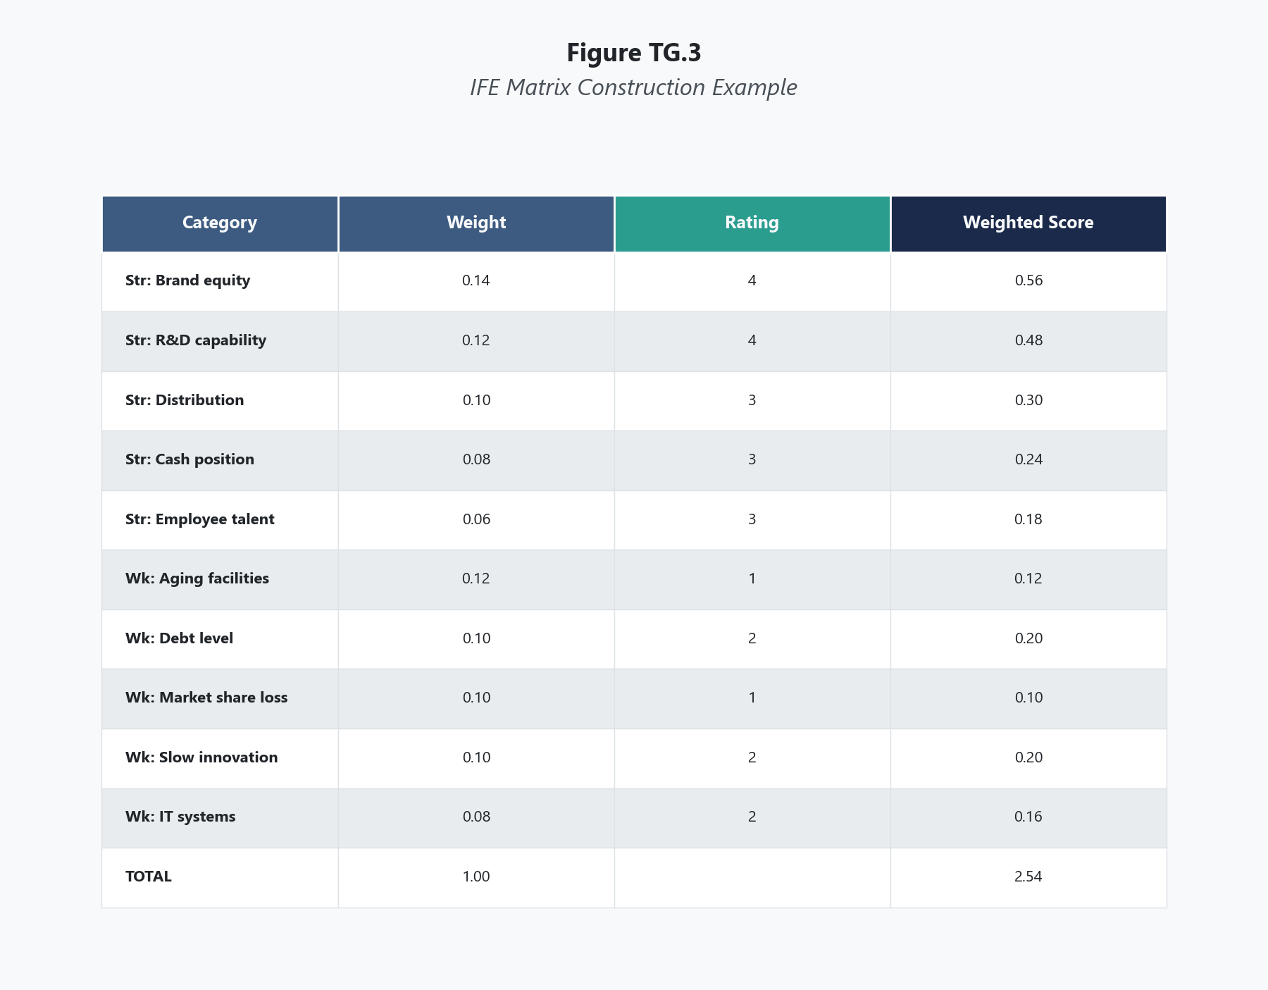
List 15 to 20 internal factors, divided between strengths and weaknesses. These should be specific and grounded in evidence, not aspirational. Each factor should represent an internal capability, resource, or condition that materially affects the organization's ability to compete.
Weak factor: "Good management." Strong factor: "Executive team averages 18 years of industry experience, with turnover below 5% annually over the past decade."
Include both strengths (internal capabilities that give the firm an advantage) and weaknesses (internal deficiencies that put the firm at a disadvantage). A typical list contains 8 to 12 strengths and 5 to 10 weaknesses, though the actual distribution should reflect the honest assessment, not a target ratio.

Step 2: Assign Weights to Each Factor
Assign a weight between 0.0 and 1.0 to each factor based on its relative importance to success in the firm's industry. The weight reflects how much that internal capability matters for any competitor in this market. All weights must sum to exactly 1.00.
A factor weighted at 0.15 carries far more strategic significance than one weighted at 0.03. The weight is an industry-level judgment: if a particular internal capability is essential for competing effectively in this industry, it deserves a higher weight regardless of whether it is a strength or a weakness for the specific company. Both strengths and weaknesses can carry high weights.
The most common error here is assigning higher weights to strengths and lower weights to weaknesses. This is self-deception built into the methodology. A critical weakness in a high-importance area deserves a high weight precisely because it is damaging.

Step 3: Rate Each Factor
Assign a rating between 1 and 4 to each factor:
- 4 = major strength
- 3 = minor strength
- 2 = minor weakness
- 1 = major weakness
Strengths must receive ratings of 3 or 4. Weaknesses must receive ratings of 1 or 2. There is no middle ground. A factor is either a strength or a weakness — the rating determines how significant it is within that category.
Unlike the EFE Matrix, where ratings reflect the firm's response to external conditions, IFE ratings reflect the firm's actual internal position. A rating of 4 means the capability is a decisive competitive advantage. A rating of 1 means the deficiency is a serious competitive liability.

Step 4: Calculate Weighted Scores
Multiply each factor's weight by its rating to produce a weighted score. This calculation combines "how important is this capability in our industry?" with "how strong or weak is our firm on this factor?" into a single number per line item.
For example, a strength weighted at 0.10 with a rating of 4 produces a weighted score of 0.40. A weakness weighted at 0.12 with a rating of 1 produces a weighted score of 0.12.

Step 5: Sum the Weighted Scores
Add all individual weighted scores to produce a total weighted score. This summary number characterizes the firm's overall internal strategic position.

Step 6: Interpret the Total Weighted Score
The total weighted score ranges from 1.0 to 4.0, with 2.5 as the midpoint. A score above 2.5 indicates an organization with a relatively strong internal position. A score below 2.5 indicates an organization with significant internal weaknesses that outweigh its strengths. See the Interpretation section below for detailed score range analysis.

Scoring Guide
Table 1 IFE Matrix Rating Scale
Rating | Classification | Meaning
4 | Major strength | A decisive internal capability that provides clear competitive advantage
3 | Minor strength | A positive internal capability that supports competitiveness but is not a primary differentiator
2 | Minor weakness | An internal deficiency that puts the firm at a modest disadvantage but is manageable
1 | Major weakness | A serious internal deficiency that significantly impairs competitive performance

Table 2 IFE Matrix Weight Guidelines
Weight Range | Interpretation
0.15 - 0.20 | Critical capability — among the most important for industry success
0.08 - 0.14 | Significant capability — materially affects competitive performance
0.03 - 0.07 | Moderate capability — relevant but not a primary success factor
0.01 - 0.02 | Minor capability — included for completeness but low relative importance

Interpreting Your Results
The total weighted score provides a single-number summary of internal strategic position. Use it as a starting point, then drill into the line items.
If your total weighted score is 3.0 to 4.0: The organization has a strong internal position. Key capabilities provide meaningful competitive advantages, and weaknesses are either minor or confined to low-importance areas. This does not mean the firm can become complacent. Internal strengths erode over time if they are not maintained and invested in. Competitors study your advantages and work to neutralize them. A score in this range means the internal foundation is solid — not that it will remain so without continued attention.
If your total weighted score is 2.5 to 2.99: The internal position is adequate but not distinctive. The firm has some strengths but they are offset by meaningful weaknesses or concentrated in lower-importance areas. Look at the highest-weighted factors and examine where ratings fall. Even modest improvements on heavily weighted weaknesses can shift the total score and, more importantly, shift competitive positioning. This range often characterizes firms that are competent but not differentiated.
If your total weighted score is 2.0 to 2.49: The organization's internal position is weak. Weaknesses dominate the profile, particularly in high-importance areas. This score should prompt a focused internal improvement initiative. Identify the highest-weighted factors rated 1 or 2 — these represent the capabilities that matter most in the industry and where the firm is falling short. Strategic plans built on a weak internal foundation are plans built on sand.
If your total weighted score is 1.0 to 1.99: The organization is in serious internal distress. The firm lacks the basic capabilities required to compete effectively in its industry. This score typically points to systemic problems — leadership deficiencies, chronic underinvestment, organizational dysfunction, or a fundamental misalignment between the firm's capabilities and the requirements of its market. Recovery requires honest diagnosis and likely significant organizational change.
One insight students consistently miss: the total weighted score is most useful when compared across time or across competitors. A single score in isolation tells you where you stand. A score compared to last year tells you whether you are improving or declining. A score compared to a key competitor tells you where your internal advantages and vulnerabilities actually lie.

Real-World Example
Consider Ford Motor Company in the early 2010s, during the period when CEO Alan Mulally's "One Ford" strategy was reshaping the company after the 2008 financial crisis. Unlike General Motors and Chrysler, Ford had avoided a government bailout, and its internal position reflected both the strengths of that decision and the lingering weaknesses of a company that had been in decline for years before the crisis.
Table 3 IFE Matrix for Ford Motor Company (Illustrative, Early 2010s)
Key Internal Factors | Weight | Rating | Weighted Score
Strengths
Strong brand recognition and reputation enhanced by avoiding government bailout | 0.10 | 4 | 0.40
Unified global product platform ("One Ford") reducing development costs and complexity | 0.12 | 4 | 0.48
Experienced leadership team under CEO Alan Mulally with clear strategic vision | 0.08 | 4 | 0.32
Improving vehicle quality ratings, approaching parity with Japanese competitors | 0.07 | 3 | 0.21
Strong position in profitable truck and SUV segments (F-Series market leader) | 0.09 | 4 | 0.36
Aggressive investment in fuel-efficient EcoBoost engine technology | 0.06 | 3 | 0.18
Weaknesses
High legacy pension and healthcare obligations increasing fixed cost burden | 0.10 | 1 | 0.10
Limited presence in luxury vehicle segment compared to competitors | 0.04 | 2 | 0.08
Dealer network quality inconsistent across regions, affecting customer experience | 0.06 | 2 | 0.12
Lagging behind Toyota and Honda in hybrid and electric vehicle technology | 0.08 | 1 | 0.08
Dependence on North American market for majority of profits | 0.07 | 2 | 0.14
Union labor agreements limiting operational flexibility in manufacturing | 0.05 | 1 | 0.05
Weaker brand perception in European and Asian markets relative to domestic competitors | 0.05 | 2 | 0.10
Information technology systems still being consolidated from pre-merger legacy platforms | 0.03 | 2 | 0.06
Total | 1.00 |  | 2.68

Ford's total weighted score of 2.68 indicated an internal position slightly above average — a company that had made significant progress but still carried substantial structural weaknesses. The strengths told a clear story: the One Ford platform strategy (weighted 0.12, rated 4) was the firm's most strategically valuable internal asset, generating massive cost savings by consolidating global product development. The F-Series truck dominance (0.09, rated 4) provided a reliable profit engine.
But the weaknesses told an equally important story. Legacy pension obligations (0.10, rated 1) represented the heaviest-weighted weakness — a major competitive burden Ford could not quickly resolve. The EV technology gap (0.08, rated 1) was the most forward-looking vulnerability, one that would grow more damaging as the market shifted. These were not problems that the One Ford strategy alone could solve.
The matrix gave Ford's leadership a clear picture: the company had built a strong operational foundation, but structural liabilities and a technology gap in electrification posed serious medium-term risks. This analysis foreshadowed the challenges Ford would face over the following decade as the EV transition accelerated.

Common Mistakes
Mistake 1: Listing External Factors as Internal Factors The mirror image of the most common EFE error. Factors like "growing market demand," "new competitor entering the market," or "favorable regulatory changes" are external conditions and belong in the EFE Matrix. Internal factors are capabilities, resources, and conditions that the organization controls. If the factor would exist regardless of what the company does, it is external.
Mistake 2: Inflating Strengths and Minimizing Weaknesses This is the most dangerous error because it corrupts the entire analysis. Leadership teams naturally gravitate toward favorable self-assessment. The IFE Matrix only produces honest results when the people constructing it are willing to rate weaknesses as harshly as the evidence warrants. A company that rates every weakness as a 2 (minor) when several deserve a 1 (major) will produce an artificially elevated total score — and will be blindsided by the weaknesses it refused to name.
Mistake 3: Using Ratios or Percentages as Factors Instead of Capabilities Factors like "current ratio of 2.1" or "ROE of 14%" are data points, not strategic factors. The factor should describe what the number means competitively. "Strong liquidity position (current ratio 2.1) enabling rapid response to acquisition opportunities" is a strategic factor. The number alone is not.
Mistake 4: Assigning a Rating of 2 or 3 to Avoid Committing Students and managers alike tend to cluster ratings in the middle, avoiding the extremes of 1 and 4. This compresses the total score toward the mean and reduces the matrix's ability to differentiate between factors that genuinely matter and those that do not. If a capability is a decisive advantage, rate it 4. If a deficiency is seriously damaging, rate it 1. The tool works by creating contrast, and contrast requires honest differentiation.
Mistake 5: Constructing the Matrix Alone One person's view of an organization's strengths and weaknesses is one person's blind spots. The IFE Matrix improves dramatically when constructed by a cross-functional team that includes perspectives from finance, operations, marketing, human resources, and technology. A marketing executive sees strengths that the CFO does not. An operations manager sees weaknesses that senior leadership has rationalized away. The matrix should synthesize multiple perspectives, not reflect one.

A Note on Honest Self-Assessment
The IFE Matrix asks organizations to do something that does not come naturally: tell the truth about themselves. Every leadership team has incentives to overstate strengths and minimize weaknesses, whether to reassure boards, motivate employees, or protect individual reputations. The tool is designed to cut through this tendency, but it only succeeds if the people using it are committed to honesty over comfort. Jeremiah 17:9 captures the core difficulty: "The heart is deceitful above all things, and desperately sick; who can understand it?" Applied to organizational life, the principle is direct. Leaders deceive themselves about their organizations for the same reasons individuals deceive themselves about their character — because the truth is uncomfortable, and self-deception is immediately rewarding even when it is ultimately destructive. The IFE Matrix does not eliminate self-deception. But it creates a structured process that makes self-deception harder to sustain, because it forces specific claims (this is a strength, this is a weakness) attached to specific weights (this is how much it matters) and specific ratings (this is how significant it is). When those claims are examined by a team rather than an individual, the worst distortions tend to surface. The tool works best when the people using it want to know the truth more than they want to feel good about the answer.

Key Terms
- Functional Area Audit: A systematic evaluation of an organization's internal capabilities across its major operational functions — management, marketing, finance, production, R&D, and MIS — to identify strengths and weaknesses.
- Internal Factor Evaluation (IFE) Matrix: A quantitative strategic management tool that summarizes an organization's key internal strengths and weaknesses through a weighted scoring system, producing a total score between 1.0 and 4.0 that characterizes overall internal strategic position.
- Key Internal Factor: A specific strength or weakness within the organization that is material enough to affect strategic outcomes and can be assessed for its competitive significance.
- Major Strength: An internal capability rated 4 on the IFE scale, representing a decisive competitive advantage that significantly contributes to the firm's ability to outperform competitors.
- Major Weakness: An internal deficiency rated 1 on the IFE scale, representing a serious competitive liability that significantly impairs the firm's strategic performance.
- Rating: A score from 1 to 4 assigned to each internal factor, where 4 and 3 denote strengths of varying significance and 2 and 1 denote weaknesses of varying severity.
- Strength: An internal resource, capability, or condition that gives the organization a competitive advantage or contributes positively to its strategic position.
- Total Weighted Score: The sum of all individual weighted scores in the IFE Matrix, ranging from 1.0 to 4.0, with 2.5 as the benchmark separating relatively strong from relatively weak internal positions.
- Weakness: An internal deficiency, limitation, or condition that puts the organization at a competitive disadvantage or impairs its strategic performance.
- Weight: A value between 0.0 and 1.0 assigned to each internal factor reflecting its relative importance to competitive success in the industry, with all weights summing to 1.00.
- Weighted Score: The product of a factor's weight and its rating, representing the combined strategic effect of how important the capability is and how strong or weak the firm's position is on that factor.

References
David, F. R., & David, F. R. (2017). Strategic management: A competitive advantage approach, concepts and cases (16th ed.). Pearson.
Hoffman, B. G. (2012). American icon: Alan Mulally and the fight to save Ford Motor Company. Crown Business.
Hitt, M. A., Ireland, R. D., & Hoskisson, R. E. (2020). Strategic management: Competitiveness and globalization (13th ed.). Cengage Learning.
Thompson, A. A., Peteraf, M. A., Gamble, J. E., & Strickland, A. J. (2022). Crafting and executing strategy: The quest for competitive advantage (23rd ed.). McGraw-Hill Education.

Knowledge Check

Multiple Choice
Question 1 [Bloom's: Analyze]
A regional healthcare system constructs an IFE Matrix and assigns the factor "state-of-the-art diagnostic imaging equipment" a weight of 0.09 and a rating of 4, producing a weighted score of 0.36. A competing hospital system assigns the same factor a weight of 0.09 and a rating of 2. What is the most accurate interpretation of this comparison?
A) The first system operates in a more favorable internal environment than the second B) Both systems recognize diagnostic imaging as equally important to success in their industry, but the first system has a significantly stronger capability in this area C) The first system should lower its weight because a rating of 4 indicates the factor is no longer a competitive concern D) The second system's lower rating means diagnostic imaging is less important to its industry
Correct Answer: B Rationale: Weights reflect industry-level importance — both systems correctly identify diagnostic imaging as carrying 0.09 importance. Ratings are firm-specific assessments. The first system rates its imaging capability as a major strength (4), while the second rates it as a minor weakness (2). Option A confuses internal capability with environment. Option C misunderstands the relationship between ratings and weights — high capability does not reduce importance. Option D confuses firm-specific ratings with industry-level weights.
Question 2 [Bloom's: Analyze]
A manufacturing company's IFE Matrix shows a total weighted score of 2.85. However, its two highest-weighted factors — "automated production technology" (weight 0.14) and "skilled engineering workforce" (weight 0.11) — are both rated 4. Meanwhile, five weakness factors with ratings of 1 carry a combined weight of only 0.12. What does this pattern suggest about the matrix's construction?
A) The matrix is well-constructed because the total score accurately reflects the company's strong position in its most important capabilities B) The matrix likely underweights the firm's weaknesses, which may artificially inflate the total score and obscure the true severity of internal deficiencies C) A total score of 2.85 is too low given the strong ratings on key factors, indicating a mathematical error D) The company should remove the low-weighted weakness factors to simplify the analysis
Correct Answer: B Rationale: When major weaknesses (rated 1) carry a combined weight of only 0.12 while the top two strengths carry 0.25, the weighting scheme may reflect bias rather than genuine industry analysis. If weaknesses are in areas that truly matter to industry competition, they should carry proportionate weights regardless of the discomfort that creates. The pattern of heavily weighting strengths and lightly weighting weaknesses is the most common form of IFE bias. Option A accepts the matrix uncritically. Option C misunderstands the math. Option D would further reduce the matrix's diagnostic value.
Question 3 [Bloom's: Analyze]
Two competing retail chains construct IFE Matrices. Chain A scores 3.15 with strengths concentrated in supply chain efficiency and e-commerce platform. Chain B scores 2.40 with strengths concentrated in customer service quality and store location portfolio. A consultant argues that Chain B is better positioned for long-term success despite the lower score. Under what conditions could the consultant's argument be valid?
A) The consultant's argument cannot be valid because a higher IFE score always indicates a stronger competitive position B) If the retail industry is shifting toward experiential in-store shopping and away from pure e-commerce competition, Chain B's strengths may be more strategically relevant in the emerging environment even though Chain A currently executes better on today's success factors C) If Chain B has fewer total factors in its matrix, the lower score is simply a mathematical artifact D) The consultant is correct because customer service is always more important than supply chain efficiency
Correct Answer: B Rationale: The IFE Matrix evaluates how well a firm performs on factors important to its current industry. If industry success factors are shifting — for instance, if consumers are returning to valuing in-store experience over online convenience — then Chain A's current strengths may become less relevant while Chain B's strengths gain importance. The IFE score is a snapshot based on current industry weights. It does not predict which capabilities will matter most in the future. Option A treats the IFE score as an absolute verdict rather than a context-dependent assessment. Option C is incorrect because the number of factors does not mechanically determine the score. Option D overgeneralizes without considering industry context.

Critical Thinking
A family-owned construction firm has operated successfully for 35 years, building its reputation on the founder's personal relationships with major clients, deep knowledge of local building codes, and a loyal workforce with an average tenure of 15 years. The founder is now 68 years old and beginning to plan for succession. An IFE Matrix analysis reveals that the firm's three highest-weighted strengths — client relationships (0.14, rated 4), regulatory expertise (0.10, rated 4), and workforce loyalty (0.08, rated 4) — are all directly tied to the founder personally. The firm's major weaknesses include no formal succession plan (0.09, rated 1), no documented processes or knowledge management systems (0.07, rated 1), and limited presence on digital platforms for project bidding (0.06, rated 1).
Question: Evaluate what this IFE Matrix reveals about the difference between organizational strengths and personal strengths. The firm's total weighted score is 2.72, which suggests an above-average internal position. But is that score misleading given the concentration of strengths in one individual? In your response, address how the matrix handles (or fails to handle) key-person risk, what strategic actions the firm should prioritize before the founder's departure, and how the relationship between strengths and weaknesses in this case illustrates a broader principle about the fragility of internal capabilities that are not institutionalized.
Rubric:
Score | Criteria
Excellent (9-10) | Demonstrates nuanced understanding of the distinction between personal and organizational capabilities. Recognizes that the IFE score masks a concentration risk the matrix is not designed to capture. Proposes specific, sequenced actions for institutionalizing the founder's strengths before succession. Identifies the broader principle that strengths tied to individuals rather than systems are inherently fragile. Engages the tension between the firm's current strength and its structural vulnerability. Well-organized with clear reasoning.
Proficient (7-8) | Addresses the key-person risk and the gap between the score and the firm's actual vulnerability. Correctly identifies that the matrix treats personal strengths as organizational strengths without distinguishing between them. Proposes reasonable succession-related actions. Clear reasoning with minor gaps.
Developing (5-6) | Addresses the question but oversimplifies — may focus on succession planning without connecting it to the broader IFE analysis, or may critique the matrix without offering constructive alternatives. Limited engagement with the distinction between personal and institutional capability. Some logical gaps.
Needs Work (3-4) | Misses the core insight about personal vs. organizational strengths. Minimal application of IFE concepts. Does not engage the specific factor data provided. Unclear reasoning or surface-level treatment.
Insufficient (0-2) | Off-topic, demonstrates fundamental misunderstanding of the IFE Matrix, or fails to engage the scenario meaningfully.

The Competitive Profile Matrix

What This Tool Does
The Competitive Profile Matrix (CPM) compares a firm directly against its major competitors on the factors that determine success in their shared industry. Unlike the EFE Matrix, which evaluates only external opportunities and threats, or the IFE Matrix, which evaluates only internal strengths and weaknesses, the CPM places competing firms side by side on the same set of critical success factors and produces a total weighted score for each. The result is a clear picture of where your firm leads, where it trails, and where competitive gaps are widest.

When to Use It
Use the CPM during the strategy formulation stage, typically alongside or immediately after the EFE and IFE analyses. It is most useful when the organization needs to understand its competitive position relative to specific rivals rather than in isolation. The CPM answers a question that the EFE and IFE cannot answer on their own: compared to the firms we actually compete against, where do we have advantages and where are we vulnerable? It should precede strategic choice tools like the SWOT Matrix or QSPM, because understanding your relative competitive standing informs which strategies are realistic and which are aspirational.

Before You Start
- Identify two to four direct competitors to include in the analysis (more than four becomes unwieldy without adding proportional insight)
- Define the critical success factors for the industry — the capabilities and conditions that determine which firms win and which lose in this market
- Gather competitive intelligence: public financial reports, industry analyses, market share data, customer satisfaction surveys, product reviews, analyst assessments
- Ensure the team constructing the matrix has enough knowledge of each competitor to rate them credibly — guesswork produces misleading results
- Understand that the CPM uses the same weighting logic as the EFE and IFE but applies it comparatively across multiple firms

Step-by-Step Instructions
Figure TG.4. Competitive Profile Matrix Example
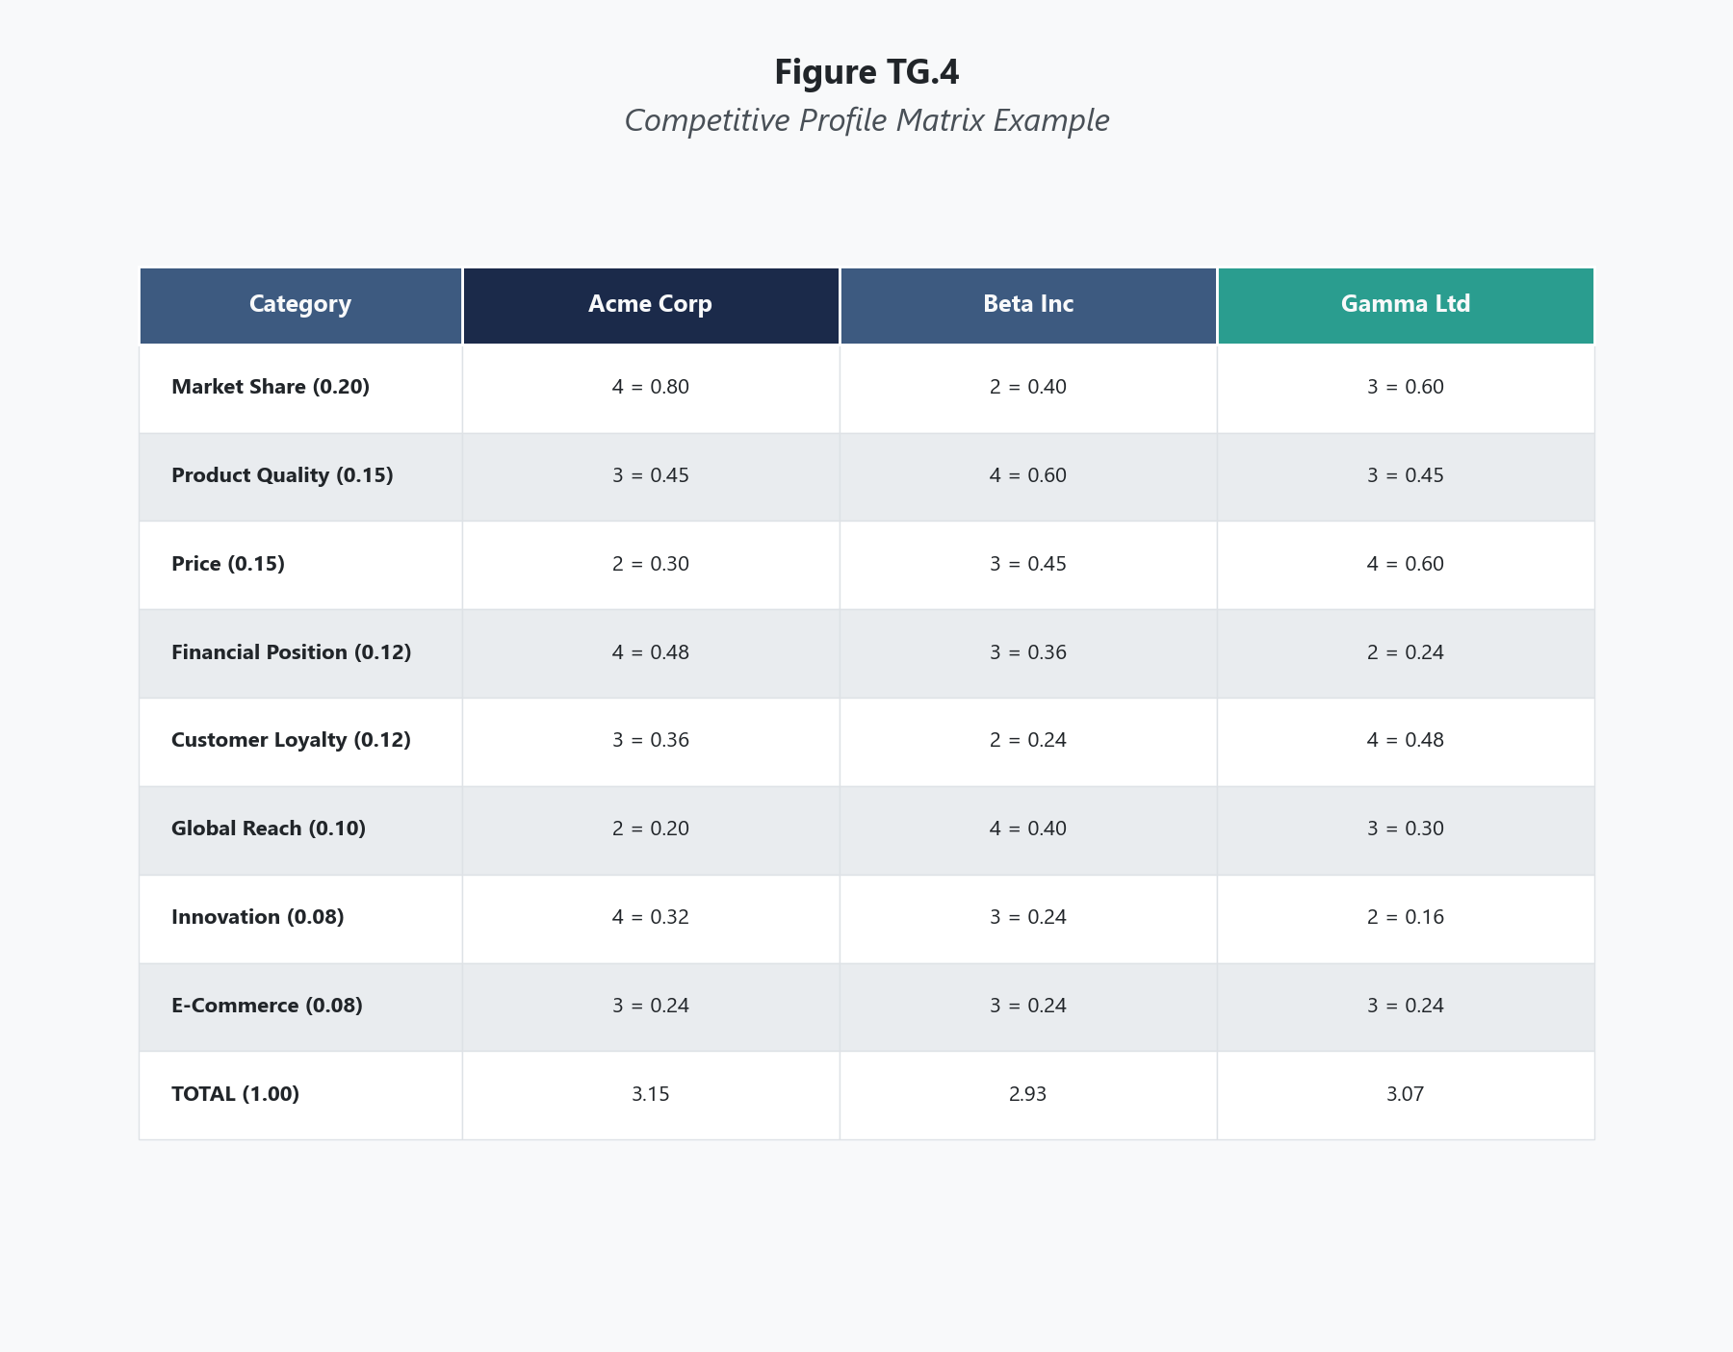
List 8 to 12 critical success factors (CSFs) — the capabilities, resources, and competitive attributes that determine success in this specific industry. These are not the same as the EFE's external factors or the IFE's internal factors, though there may be overlap. CSFs are the things customers care about, the capabilities that drive market share, and the attributes that separate winners from losers in this market.
Examples of critical success factors vary by industry: brand recognition, product quality, price competitiveness, market share, financial position, customer loyalty, global expansion, technological capability, distribution effectiveness, e-commerce presence. The factors should be specific to the industry, not generic.
Weak CSF: "Management quality." This is too vague to rate comparatively. Strong CSF: "Speed of new product development from concept to market launch." This can be observed, measured, and compared across firms.

Step 2: Assign Weights to Each Factor
Assign a weight between 0.0 and 1.0 to each critical success factor based on its relative importance to success in the industry. All weights must sum to exactly 1.00. The weights are identical across all firms in the matrix because the importance of each factor is an industry-level judgment, not a firm-specific one.
A factor weighted at 0.15 is far more important to competitive success than one weighted at 0.04. The weights force you to decide what matters most. If everything matters equally, you have not thought hard enough about what actually drives winning in this industry.

Step 3: Rate Each Firm on Each Factor
Assign a rating between 1 and 4 to each firm on each critical success factor:
- 4 = major strength (the firm excels on this factor relative to the industry)
- 3 = minor strength (the firm is above average)
- 2 = minor weakness (the firm is below average)
- 1 = major weakness (the firm is significantly deficient)
Rate every firm in the matrix on every factor, including your own organization. The ratings are comparative: a 4 means the firm is among the best in the industry on this factor, not that it is perfect. A firm can earn a 4 on brand recognition and a 1 on e-commerce capability simultaneously.
The most important discipline here is honesty about your own firm. The temptation is to rate competitors harshly and your own organization generously. This produces a matrix that flatters leadership and misleads strategy. Rate every firm the same way: based on evidence, not loyalty.

Step 4: Calculate Weighted Scores
Multiply each factor's weight by each firm's rating on that factor to produce a weighted score for every cell in the matrix. Each firm will have a weighted score for every critical success factor.

Step 5: Sum the Weighted Scores for Each Firm
Add all weighted scores for each firm to produce a total weighted score per competitor. This number represents each firm's overall competitive strength relative to the others in the matrix.

Step 6: Analyze the Results Comparatively
The total weighted scores rank the firms, but the real value is in the line-item comparison. Examine where your firm's ratings exceed competitors' ratings (competitive advantages) and where they fall short (competitive vulnerabilities). Pay particular attention to gaps on heavily weighted factors — a one-point rating difference on a factor weighted at 0.15 creates a 0.15 gap in weighted score, which is strategically significant.

Scoring Guide
Table 1 CPM Rating Scale
Rating | Meaning | Interpretation
4 | Major strength | Among the best in the industry on this factor
3 | Minor strength | Above average, competitive but not leading
2 | Minor weakness | Below average, trailing most competitors
1 | Major weakness | Significantly deficient, a clear competitive liability

Table 2 CPM Weight Guidelines
Weight Range | Interpretation
0.15 - 0.20 | Critical — a primary driver of competitive success in this industry
0.08 - 0.14 | Important — materially influences competitive outcomes
0.04 - 0.07 | Moderate — relevant but not a primary differentiator
0.01 - 0.03 | Minor — included for completeness, low competitive impact

Interpreting Your Results
The CPM produces a ranked comparison, but interpretation requires more than reading the totals.
If your firm has the highest total weighted score: You hold the strongest overall competitive position among the firms analyzed. This does not guarantee success — it means your current capabilities align well with what the industry rewards. Examine where competitors are rated higher than you even in an overall losing position. These are the specific areas where rivals have advantages they could leverage against you.
If your firm is in the middle of the pack: You are competitive but not differentiated. Look at the highest-weighted factors and identify where you are tied or trailing. Middle-of-pack firms face a strategic choice: invest to overtake the leader on key factors, or find a niche where different factors carry more weight than the industry average suggests.
If your firm has the lowest total weighted score: You are at a competitive disadvantage on the factors that matter most in this industry. This demands honest assessment: Can you realistically close the gaps on the highest-weighted factors? Or do you need a fundamentally different strategy — perhaps competing in a segment where the success factors differ from the industry mainstream?
Regardless of rank, focus on the gaps: The most actionable insight from the CPM is not the total score but the factor-level comparison. A firm with an overall lead can still have critical vulnerabilities on specific factors. A firm trailing overall may hold decisive advantages on one or two factors that could anchor a differentiation strategy. The matrix shows you where to compete and where to concede.

Real-World Example
Consider the U.S. athletic footwear and apparel industry in the late 2010s, comparing three major competitors: Nike, Adidas, and Under Armour.
Table 3 CPM for U.S. Athletic Footwear and Apparel (Illustrative, Late 2010s)
Critical Success Factors | Weight | Nike |  | Adidas |  | Under Armour
 |  | Rating | Score | Rating | Score | Rating | Score
Brand recognition and global brand equity | 0.15 | 4 | 0.60 | 3 | 0.45 | 2 | 0.30
Product innovation and design pipeline | 0.14 | 4 | 0.56 | 3 | 0.42 | 2 | 0.28
Direct-to-consumer digital sales capability | 0.12 | 4 | 0.48 | 3 | 0.36 | 2 | 0.24
Athlete endorsement and sponsorship portfolio | 0.10 | 4 | 0.40 | 3 | 0.30 | 2 | 0.20
Supply chain efficiency and speed to market | 0.10 | 3 | 0.30 | 4 | 0.40 | 2 | 0.20
International market presence and growth | 0.09 | 4 | 0.36 | 4 | 0.36 | 1 | 0.09
Price competitiveness across product tiers | 0.08 | 3 | 0.24 | 3 | 0.24 | 2 | 0.16
Sustainability and corporate responsibility reputation | 0.07 | 3 | 0.21 | 4 | 0.28 | 2 | 0.14
Lifestyle and fashion crossover appeal | 0.08 | 3 | 0.24 | 4 | 0.32 | 1 | 0.08
Customer loyalty and repeat purchase rate | 0.07 | 4 | 0.28 | 3 | 0.21 | 3 | 0.21
Total | 1.00 |  | 3.67 |  | 3.34 |  | 1.90

Nike's total score of 3.67 reflected dominant competitive strength across the industry's most heavily weighted factors. Its brand equity, innovation pipeline, and direct-to-consumer digital capability — the three highest-weighted CSFs — were all rated 4. Adidas at 3.34 was a credible competitor that actually led Nike on supply chain efficiency, sustainability reputation, and lifestyle crossover appeal. These were real competitive advantages, even though Adidas trailed Nike overall.
Under Armour's score of 1.90 told a sobering story. The firm scored below average on nearly every critical success factor. Its one area of relative strength — customer loyalty (rated 3) — carried a weight of only 0.07, meaning it contributed little to the total. Under Armour's most severe deficits were in international presence (rated 1, weight 0.09) and lifestyle appeal (rated 1, weight 0.08), areas where the market was growing fastest. The matrix did not just confirm that Under Armour was trailing — it identified precisely where the gaps were widest and which gaps mattered most.
The strategic implications were clear. Nike needed to defend its positions on the highest-weighted factors while monitoring Adidas' advantages in supply chain and sustainability. Adidas had a viable path to close the gap by pressing its advantages in areas where consumer priorities were shifting. Under Armour faced a more fundamental question: whether it could realistically compete on the same critical success factors as Nike and Adidas, or whether it needed to redefine its competitive space entirely.

Common Mistakes
Mistake 1: Selecting Factors That Favor Your Firm The critical success factors must reflect what matters to the industry, not what your firm happens to be good at. If you choose factors where your company excels and omit factors where competitors lead, you produce a rigged comparison that tells you nothing useful. The test: Would an objective industry analyst use the same factors?
Mistake 2: Rating Competitors Without Sufficient Information Assigning ratings to competitors you have not actually researched produces fiction, not analysis. Every rating should be grounded in observable evidence — financial performance, market share data, product reviews, customer satisfaction scores, analyst reports. If you cannot justify a rating with evidence, you are guessing, and the matrix becomes unreliable.
Mistake 3: Including Too Many or Too Few Competitors Analyzing one competitor provides limited insight because you cannot see relative positioning across the market. Analyzing six or more competitors creates a cluttered matrix that is difficult to interpret and often relies on thin data for peripheral competitors. Two to four well-chosen direct competitors provides the best balance of breadth and analytical rigor.
Mistake 4: Treating Ratings as Absolute Rather Than Relative A rating of 3 does not mean "good." It means "above average relative to competitors in this industry." A firm operating in an exceptionally strong competitive field might rate a 3 on a factor where it would rate a 4 in a weaker field. The ratings are always relative to the specific competitive set being analyzed.
Mistake 5: Ignoring Factor-Level Insights in Favor of the Total Score The total score ranks the firms, but the strategic value lives in the line items. Two firms with identical total scores of 2.8 could have completely different competitive profiles — one strong in innovation and weak in distribution, the other the reverse. Reading only the totals misses the most actionable intelligence the matrix provides.

A Note on Competition and Character
Competitive analysis changes how you see rivals. It can sharpen your strategy, but it can also distort your perspective. When you spend hours dissecting a competitor's weaknesses, it becomes easy to view them as adversaries to defeat rather than organizations staffed by people pursuing their own legitimate purposes. The CPM is an analytical tool, not a weapon. Philippians 1:27 calls for a distinctive standard of conduct: "Whatever happens, conduct yourselves in a manner worthy of the gospel of Christ." Applied to competitive strategy, the principle is practical. You can analyze competitors rigorously, identify their vulnerabilities, and develop strategies to outperform them — all without resorting to deception, sabotage, or exploitation. The firms you compete against employ people with families. They serve customers who depend on them. They contribute to communities. Winning a market does not require treating rivals as enemies to be destroyed. The best competitive strategies succeed because they create superior value for customers, not because they inflict maximum damage on competitors. Analyze honestly, compete vigorously, and conduct yourself in a way that your character survives the competition intact.

Key Terms
- Competitive Profile Matrix (CPM): A strategic management tool that compares a firm against its major competitors by rating each on a common set of critical success factors, producing total weighted scores that reveal relative competitive positioning.
- Critical Success Factor (CSF): A capability, resource, or competitive attribute that is essential for any firm to succeed in a particular industry; the factors on which competitive battles are won or lost.
- Competitive Advantage: A condition in which a firm's rating on a critical success factor exceeds its competitors' ratings, indicating a relative strength on that dimension of competition.
- Competitive Gap: The difference between a firm's rating and a competitor's rating on a specific critical success factor, representing an area of relative weakness or vulnerability.
- Competitive Intelligence: Information gathered about competitors through legal, ethical means — public filings, industry reports, market data, analyst assessments — used to inform the ratings in a CPM.
- Rating: A score from 1 to 4 assigned to each firm on each critical success factor, where 4 represents a major strength relative to the industry and 1 represents a major weakness.
- Total Weighted Score: The sum of all weighted scores for a single firm in the CPM, representing that firm's overall competitive strength across all critical success factors analyzed.
- Weight: A value between 0.0 and 1.0 assigned to each critical success factor reflecting its relative importance to competitive success in the industry, with all weights summing to 1.00.
- Weighted Score: The product of a critical success factor's weight and a firm's rating on that factor, capturing both how important the factor is and how strong the firm's position is.

References
David, F. R., & David, F. R. (2017). Strategic management: A competitive advantage approach, concepts and cases (16th ed.). Pearson.
Hitt, M. A., Ireland, R. D., & Hoskisson, R. E. (2020). Strategic management: Competitiveness and globalization (13th ed.). Cengage Learning.
Porter, M. E. (2008). The five competitive forces that shape strategy. Harvard Business Review, 86(1), 78-93.
Thompson, A. A., Peteraf, M. A., Gamble, J. E., & Strickland, A. J. (2022). Crafting and executing strategy: The quest for competitive advantage (23rd ed.). McGraw-Hill Education.

Knowledge Check

Multiple Choice
Question 1 [Bloom's: Analyze]
Three competing fast-casual restaurant chains are evaluated using a CPM. On the critical success factor "mobile ordering and delivery integration" (weight 0.13), Chain A receives a rating of 4, Chain B receives a 2, and Chain C receives a 3. Chain B's CEO dismisses the result, arguing that "our customers prefer dining in, so mobile ordering is irrelevant to us." What is the most significant problem with the CEO's reasoning?
A) The CEO is correct — if Chain B's customers prefer dining in, the weight should be lowered for Chain B B) The CEO is confusing the firm's current customer base with the industry's competitive requirements; the weight reflects industry-level importance, not one firm's customer preferences C) The CEO should reassign the rating to a 3 to reflect the dining-in preference D) Mobile ordering cannot be a critical success factor because it is a technology, not a capability
Correct Answer: B Rationale: Weights in the CPM reflect the importance of a factor to success in the industry as a whole, not to any individual firm's current strategy or customer base. If mobile ordering is important to competitive success in the fast-casual industry (weight 0.13), that reality applies to all firms regardless of whether their current customers use it. Chain B's low rating (2) accurately captures that it trails on this factor. The CEO's argument conflates the firm's current positioning with industry requirements — a dangerous rationalization that could leave Chain B strategically exposed as customer expectations evolve. Option A misunderstands the role of weights. Option C would mask a real competitive deficiency. Option D misclassifies the factor.
Question 2 [Bloom's: Analyze]
A technology company constructs a CPM comparing itself to two competitors. The company assigns itself a rating of 4 on "product innovation" (weight 0.16), while rating both competitors at 2. However, public data shows that Competitor A holds three times as many active patents, releases new products at twice the rate, and invests a higher percentage of revenue in R&D. What analytical failure does this scenario illustrate?
A) The company is using the wrong critical success factor — patents and R&D spending should be listed as separate factors B) The company has allowed self-serving bias to inflate its own rating and deflate competitor ratings, producing a matrix that misrepresents competitive reality C) The ratings are correct because innovation is subjective and cannot be measured by patents or R&D spending alone D) The company should increase the weight on product innovation to compensate for the rating discrepancy
Correct Answer: B Rationale: The most common and dangerous CPM error is rating your own firm favorably and competitors harshly without grounding those ratings in evidence. When observable data — patent counts, product release cadence, R&D investment levels — directly contradicts the ratings assigned, the matrix reflects bias rather than analysis. The company's rating of 4 for itself and 2 for a competitor that objectively outperforms it on every measurable innovation metric is unsupportable. Option A mistakes the form of the factor for the problem. Option C uses the subjectivity of innovation as a shield for ignoring contrary evidence. Option D would compound the error by increasing the weight of a biased rating.
Question 3 [Bloom's: Analyze]
Two regional hospital networks construct CPMs using the same eight critical success factors and the same weights. Hospital A scores a total of 3.10 and Hospital B scores 2.75. However, Hospital A's score is driven almost entirely by a rating of 4 on "physician reputation and specialist recruitment" (weight 0.18), while it rates 2 on six of the remaining seven factors. Hospital B rates 3 on seven of eight factors with no rating of 4. Which hospital is in a more strategically sustainable position, and why?
A) Hospital A, because it has the higher total score and a decisive advantage on the most heavily weighted factor B) Hospital B, because consistent above-average performance across all factors creates a more balanced and resilient competitive position than dependence on a single strength C) Neither — the total scores are too close to draw meaningful conclusions D) Hospital A, because a rating of 4 on the highest-weighted factor always indicates competitive dominance
Correct Answer: B Rationale: Hospital A's competitive position depends disproportionately on one factor. If physician reputation or specialist recruitment erodes — through retirements, competitor poaching, or shifting patient priorities — Hospital A's total score drops dramatically because it rates 2 (below average) on six other factors. Hospital B's consistent 3 ratings create a broader competitive foundation that can absorb weakness in any single area without collapsing. Strategic sustainability favors balanced capability over concentrated strength. Option A reads only the total without examining the underlying profile. Option C dismisses a meaningful 0.35-point gap and ignores the structural difference in profiles. Option D treats one factor as determinative regardless of the overall competitive profile.

Critical Thinking
A mid-sized software company constructs a CPM comparing itself against two larger competitors. The matrix reveals that the company trails both competitors on the three highest-weighted critical success factors: brand recognition (weight 0.15, rated 1 vs. competitors' 4 and 3), enterprise sales force (weight 0.13, rated 1 vs. competitors' 4 and 4), and global customer support infrastructure (weight 0.11, rated 1 vs. competitors' 3 and 4). However, the company leads both competitors on two lower-weighted factors: product customization capability (weight 0.08, rated 4 vs. competitors' 2 and 2) and customer satisfaction among existing clients (weight 0.06, rated 4 vs. competitors' 2 and 3). The company's total score is 1.95; the competitors score 3.40 and 3.25.
Question: The CPM clearly shows this company losing the competitive comparison on aggregate. But does the matrix tell the full strategic story? Evaluate whether the company's advantages on lower-weighted factors could form the basis of a viable competitive strategy, or whether the deficits on the highest-weighted factors are insurmountable. In your response, address what the CPM does and does not capture about different competitive strategies, whether the weights might look different in a specific market niche versus the broader industry, and what strategic options are available to a firm that cannot realistically close the gap on dominant competitors' core strengths.
Rubric:
Score | Criteria
Excellent (9-10) | Demonstrates nuanced understanding that CPM weights reflect broad industry success factors but may not apply equally to niche strategies. Recognizes that the company's strengths in customization and customer satisfaction could anchor a focused differentiation or niche strategy even though they carry low weights in the industry-wide analysis. Addresses the concept that different competitive strategies emphasize different success factors. Evaluates realistically whether the company can compete head-to-head or must pursue an alternative path. Proposes a coherent strategic direction grounded in the CPM data. Well-organized with clear reasoning.
Proficient (7-8) | Addresses the tension between aggregate score and factor-level advantages. Recognizes that the company may need a different competitive approach than the industry leaders. Applies CPM concepts correctly. Identifies that niche strategies could reweight the relative importance of different factors. Clear reasoning with minor gaps.
Developing (5-6) | Addresses the question but oversimplifies — either accepts the total score as a final verdict or dismisses it without engaging the weight structure. Limited application of competitive strategy concepts beyond the matrix itself. Some logical gaps in reasoning.
Needs Work (3-4) | Misses the distinction between industry-wide and niche-level critical success factors. Minimal application of CPM framework. Does not engage the specific factor data. Unclear reasoning.
Insufficient (0-2) | Off-topic, demonstrates fundamental misunderstanding of the CPM, or fails to engage the scenario meaningfully.

The SWOT Matrix

What This Tool Does
The SWOT Matrix (also called the Threats-Opportunities-Weaknesses-Strengths Matrix or TOWS Matrix) generates specific, actionable strategies by systematically matching internal factors (strengths and weaknesses) with external factors (opportunities and threats). Unlike a simple SWOT list that merely categorizes factors into four boxes, the SWOT Matrix creates four types of strategies by pairing each internal category with each external category. The result is not a description of the firm's situation but a set of concrete strategic alternatives that exploit the situation. The SWOT Matrix is where analysis becomes action.

When to Use It
Use the SWOT Matrix during the matching stage of strategy formulation, after the input-stage tools (EFE, IFE, CPM) are complete. The SWOT Matrix draws its inputs directly from the EFE and IFE — the strengths and weaknesses come from the IFE, and the opportunities and threats come from the EFE. It is typically used alongside the IE Matrix, Grand Strategy Matrix, and SPACE Matrix, and it feeds strategies into the QSPM for final prioritization. Of all the matching tools, the SWOT Matrix is the most widely used because it produces the most specific strategic recommendations — not just a direction or posture, but named strategies tied to particular combinations of factors.

Before You Start
- Have a completed IFE Matrix with clearly defined strengths and weaknesses
- Have a completed EFE Matrix with clearly defined opportunities and threats
- Understand the difference between a SWOT list (which merely categorizes) and a SWOT Matrix (which generates strategies through matching)
- Have the strategic planning team available — strategy generation benefits from diverse perspectives
- Be prepared to generate strategies, not just restate factors — the output of the SWOT Matrix is actionable strategic alternatives, not a summary of the situation

Step-by-Step Instructions
Figure TG.5. SWOT Matrix Strategy Development Example
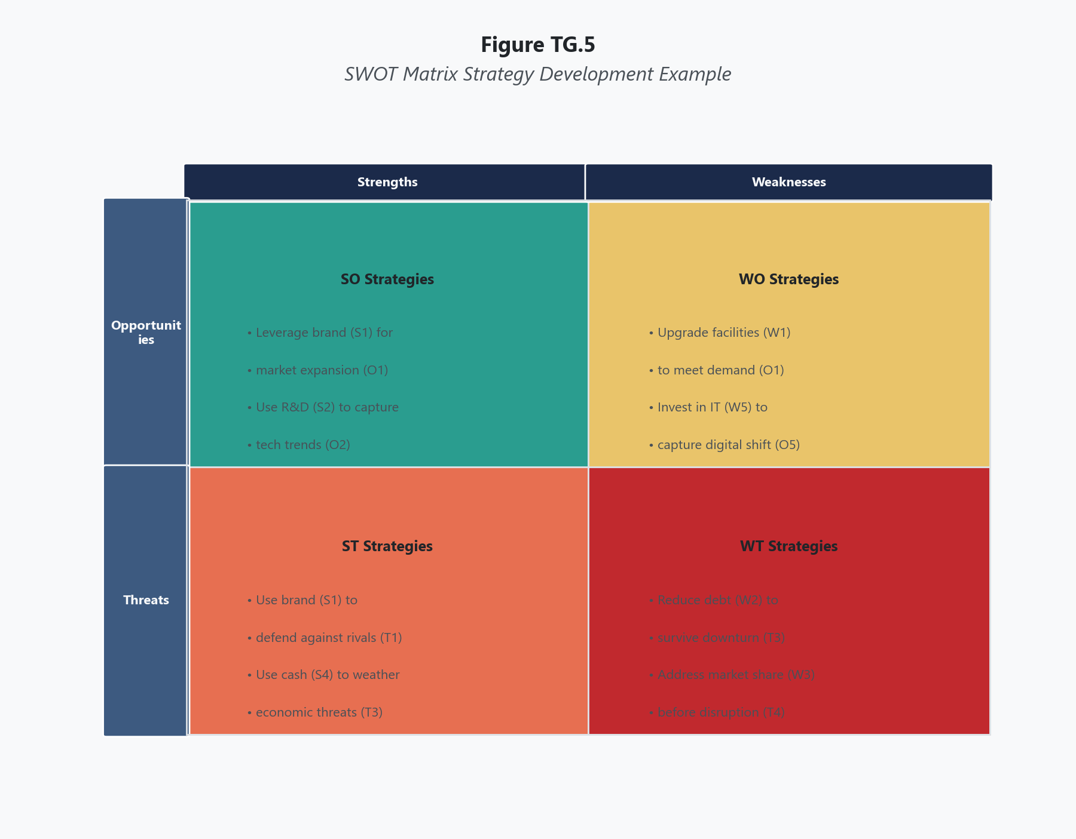
In the left column of the matrix, list the firm's key internal strengths from the IFE Matrix. Focus on the strengths that carry the most strategic weight — typically 5 to 10 factors. Label them S1, S2, S3, and so on for easy reference when formulating strategies.

Step 2: List Key Weaknesses
Below the strengths in the left column, list the firm's key internal weaknesses from the IFE Matrix. Again, focus on the most strategically significant weaknesses. Label them W1, W2, W3, and so on.

Step 3: List Key Opportunities
Across the top of the matrix, list the firm's key external opportunities from the EFE Matrix. Focus on the opportunities with the highest weights and greatest strategic relevance. Label them O1, O2, O3, and so on.

Step 4: List Key Threats
Next to or below the opportunities across the top, list the firm's key external threats from the EFE Matrix. Label them T1, T2, T3, and so on.

Step 5: Generate SO Strategies (Strengths-Opportunities)
In the cell where strengths and opportunities intersect, develop strategies that use internal strengths to capitalize on external opportunities. SO strategies are the most aggressive — they leverage what the firm does best to pursue the most attractive external conditions.
Each SO strategy should explicitly reference the specific strengths and opportunities it connects. For example: "Use strong R&D capability (S3) and brand recognition (S1) to launch a premium product line in the growing Asian market (O2)."
This specificity is what separates a useful SWOT Matrix from a vague one. A strategy that says "grow internationally" is not an SO strategy. A strategy that says "leverage existing distribution partnerships in Southeast Asia (S5) to capture growing demand for premium health products (O3)" is.

Step 6: Generate WO Strategies (Weaknesses-Opportunities)
In the cell where weaknesses and opportunities intersect, develop strategies that overcome internal weaknesses by exploiting external opportunities. WO strategies acknowledge that the firm has limitations but identifies external conditions that could help address them.
For example: "Address limited e-commerce capability (W2) by partnering with an established online marketplace (O4) to reach digital-first customers without building the platform from scratch."
WO strategies often involve partnerships, acquisitions, hiring, or investment in capability development — they require spending resources to fix weaknesses because the external opportunity justifies the investment.

Step 7: Generate ST Strategies (Strengths-Threats)
In the cell where strengths and threats intersect, develop strategies that use internal strengths to reduce or avoid external threats. ST strategies are defensive applications of offensive capabilities — using what the firm does well to protect itself from environmental dangers.
For example: "Use strong customer loyalty program (S4) and proprietary technology platform (S6) to defend market share against new low-cost competitors entering the market (T1)."

Step 8: Generate WT Strategies (Weaknesses-Threats)
In the cell where weaknesses and threats intersect, develop strategies that minimize internal weaknesses and avoid external threats. WT strategies are the most defensive — they address the firm's most vulnerable position where internal deficiency meets external danger.
For example: "Reduce exposure to currency fluctuation risk (T3) by divesting underperforming international operations (W5) that lack the scale to justify hedging costs."
WT strategies often involve retrenchment, divestiture, joint ventures, or cost reduction. They are not glamorous, but they can be the most important strategies in the matrix because they address the areas where the firm is most exposed.

Step 9: Review and Refine
Review all four strategy categories for internal consistency, feasibility, and completeness. Ensure that each strategy is specific enough to be actionable, references the factors it connects, and does not contradict strategies in other quadrants. The complete set of strategies from the SWOT Matrix becomes the input to the QSPM for final prioritization.

Scoring Guide
The SWOT Matrix does not produce numerical scores. Its output is a set of strategies organized by type. The quality of the matrix is assessed by the specificity, feasibility, and factor-grounding of the strategies generated.
Table 1 SWOT Matrix Strategy Types
Strategy Type | Matches | Strategic Logic | Character
SO (Strengths-Opportunities) | Internal strengths + External opportunities | Use strengths to capitalize on opportunities | Aggressive, growth-oriented
WO (Weaknesses-Opportunities) | Internal weaknesses + External opportunities | Overcome weaknesses by exploiting opportunities | Improvement-oriented, investment-focused
ST (Strengths-Threats) | Internal strengths + External threats | Use strengths to avoid or mitigate threats | Defensive application of strengths
WT (Weaknesses-Threats) | Internal weaknesses + External threats | Minimize weaknesses and avoid threats | Defensive, survival-oriented

Table 2 SWOT Matrix Quality Criteria
Criterion | Strong | Weak
Factor specificity | Each strategy references specific S/W/O/T factors by label | Strategies are generic and could apply to any firm
Actionability | Strategies describe specific actions the firm can take | Strategies describe goals or aspirations without implementation path
Matching logic | The connection between internal and external factors is clear and defensible | Factors are paired arbitrarily or the connection is not explained
Completeness | All four quadrants contain at least 2-3 strategies | One or more quadrants are empty or contain only one vague strategy
Balance | WT strategies receive as much analytical attention as SO strategies | SO quadrant is overloaded while WT is neglected

Interpreting Your Results
The SWOT Matrix produces strategies, not a single score or recommendation. Interpretation involves evaluating the full set of strategies and identifying patterns.
When SO strategies dominate: If the most compelling strategies are in the SO quadrant, the firm is in a favorable position — strong internally and facing attractive external conditions. This aligns with an aggressive posture on the SPACE Matrix and a Grow and Build recommendation on the IE Matrix. The firm should prioritize SO strategies while maintaining awareness that the other quadrants still contain risks.
When WO strategies are most critical: If the best opportunities require the firm to address internal weaknesses first, the WO quadrant becomes the strategic priority. This often corresponds to a Quadrant II position on the Grand Strategy Matrix (rapid market growth, weak competitive position). The firm must invest in capability before it can capture the opportunity.
When ST strategies are essential: If the primary strategic need is to defend against external threats using existing strengths, the firm is in a protective mode. This aligns with a competitive or conservative posture. ST strategies keep the firm viable while the external environment remains hostile or volatile.
When WT strategies cannot be avoided: If the SWOT Matrix reveals that the firm faces serious threats in areas where it is already weak, the WT quadrant demands attention regardless of what the other quadrants contain. Ignoring WT vulnerabilities because the SO quadrant looks more attractive is one of the most common and costly strategic errors. The WT quadrant does not go away because you prefer to focus elsewhere.
The most important pattern: Look at where the highest-weighted IFE and EFE factors appear across the four quadrants. If the most important external opportunity (by weight) intersects with the firm's greatest strength, the SO strategy connecting them deserves the highest priority. If the most heavily weighted threat intersects with the firm's most critical weakness, the WT strategy addressing that intersection may be the most urgent action in the entire matrix, even if it is less exciting than the SO alternatives.

Real-World Example
Consider Microsoft in the mid-2010s, during the strategic transformation under CEO Satya Nadella. Microsoft was shifting from a Windows-centric business model toward cloud computing, subscriptions, and cross-platform services.
Table 3 Abbreviated SWOT Matrix for Microsoft (Illustrative, Mid-2010s)
Key Strengths:
- S1: Dominant enterprise customer base with deep organizational relationships
- S2: Azure cloud platform with rapidly growing market share
- S3: Office 365 subscription model generating recurring revenue
- S4: Massive cash reserves and strong balance sheet
- S5: Extensive developer ecosystem and tools (Visual Studio, GitHub)
Key Weaknesses:
- W1: Declining Windows market relevance as computing shifts to mobile and cloud
- W2: Weak position in mobile devices and consumer hardware
- W3: Legacy organizational culture resistant to open-source and cross-platform approaches
- W4: Lagging in artificial intelligence research relative to Google
Key Opportunities:
- O1: Explosive growth in enterprise cloud computing adoption
- O2: Increasing demand for AI and machine learning integration in business software
- O3: Remote work trend accelerating demand for collaboration and productivity tools
- O4: Growing developer community adoption of open-source platforms
Key Threats:
- T1: Amazon AWS dominance in cloud infrastructure market
- T2: Google expansion into enterprise productivity and cloud services
- T3: Antitrust scrutiny and regulatory pressure on large technology platforms
- T4: Cybersecurity threats increasing costs and risks for cloud providers
SO Strategies (Use strengths to capitalize on opportunities):
- SO1: Leverage enterprise customer relationships (S1) and Azure platform (S2) to capture enterprise cloud migration spending (O1)
- SO2: Use Office 365 recurring revenue base (S3) and developer ecosystem (S5) to integrate AI capabilities into existing enterprise productivity tools (O2)
- SO3: Expand Microsoft Teams as the enterprise collaboration platform, leveraging Office 365 integration (S3) to capture remote work demand (O3)
WO Strategies (Overcome weaknesses by exploiting opportunities):
- WO1: Address cultural resistance to open-source (W3) by acquiring GitHub and embracing the open-source developer community (O4) to reposition Microsoft as developer-friendly
- WO2: Close the AI research gap (W4) by investing in strategic AI partnerships and acquisitions to integrate AI into Azure and Office products (O2)
- WO3: Reduce dependence on Windows revenue (W1) by accelerating the shift to cloud-based subscription models that are platform-agnostic (O1)
ST Strategies (Use strengths to mitigate threats):
- ST1: Use enterprise customer lock-in (S1) and integrated product ecosystem (S3, S5) to defend against Google's enterprise expansion (T2)
- ST2: Deploy cash reserves (S4) to invest in advanced cybersecurity capabilities for Azure, turning the cybersecurity threat (T4) into a competitive differentiator
- ST3: Leverage deep government and regulated-industry relationships (S1) to position Azure as the compliance-friendly cloud alternative to AWS (T1, T3)
WT Strategies (Minimize weaknesses and avoid threats):
- WT1: Accept the mobile device market loss (W2) rather than continuing to invest in a hardware battle against Apple and Google, redirecting resources to cloud and AI where competitive position is stronger (T2)
- WT2: Proactively engage with regulators on data privacy and competition issues (T3) to address the perception that legacy Windows dominance (W1) represents monopolistic behavior, positioning the cloud transition as evidence of competitive market evolution
This SWOT Matrix closely mirrors the actual strategic moves Microsoft made under Nadella. The GitHub acquisition (WO1), Teams expansion (SO3), Azure enterprise push (SO1), AI investment including the later OpenAI partnership (WO2), exit from mobile hardware (WT1), and cybersecurity positioning (ST2) all emerged as central elements of Microsoft's strategy. The matrix did not produce these insights magically — it forced the systematic matching of known internal realities to known external conditions, which is precisely the analytical discipline that separates deliberate strategy from reactive opportunism.

Common Mistakes
Mistake 1: Creating a SWOT List Instead of a SWOT Matrix The most pervasive error is listing strengths, weaknesses, opportunities, and threats in four boxes and calling it a SWOT analysis. A four-box list is a categorization exercise, not a strategy generation tool. The SWOT Matrix requires the next step: matching factors across internal and external categories to produce specific strategies. If your SWOT output is a list of factors with no strategies, you have completed step 4 of a 9-step process.
Mistake 2: Writing Generic Strategies That Could Apply to Any Firm Strategies like "increase market share," "improve quality," or "reduce costs" are not SWOT Matrix outputs. They are aspirations. Every strategy should explicitly reference the specific factors it connects and describe a concrete action. If you could paste the strategy into a different company's SWOT Matrix without changing a word, it is too generic.
Mistake 3: Neglecting the WT Quadrant Leadership teams gravitate toward SO strategies because they are the most optimistic and exciting. WT strategies are uncomfortable because they force the organization to confront its most vulnerable position — where internal weakness meets external danger. But the WT quadrant is often where the most urgent strategic action is needed. A firm that pursues SO strategies while ignoring WT vulnerabilities is building on a foundation it has not inspected.
Mistake 4: Treating Strengths and Opportunities as Interchangeable Students frequently mislabel internal strengths as opportunities or external opportunities as strengths. A strong brand is a strength (internal, the firm controls it). A growing market is an opportunity (external, the firm does not control it). The firm's ability to exploit a growing market depends on its strengths, but the growing market itself is not a strength. This distinction is not semantic — it determines which quadrant a factor belongs in and which strategy types it generates.
Mistake 5: Generating Strategies That Contradict Each Other A SWOT Matrix that recommends aggressive expansion in the SO quadrant and major retrenchment in the WT quadrant is not inherently contradictory — the firm may need to expand in one area while retreating in another. But strategies that directly conflict (e.g., "invest heavily in the China market" in SO and "divest all international operations" in WT) reveal an analytical inconsistency that needs resolution before the strategies are carried forward to the QSPM.

A Note on Naming What Is True
The SWOT Matrix only produces honest strategies if it receives honest inputs. And the hardest inputs to get right are the weaknesses. Every organization has a public narrative about its strengths — the brand, the culture, the innovation, the market position. Few organizations have an equally candid narrative about their weaknesses. Internal politics, ego, and career incentives all conspire to minimize, rationalize, or relabel weaknesses as "areas for development" or "opportunities for improvement." But a weakness mislabeled is a weakness unaddressed. And a weakness unaddressed eventually becomes a crisis. Proverbs 28:13 captures the principle in language that applies as directly to organizations as to individuals: "Whoever conceals their transgressions will not prosper, but whoever confesses and forsakes them will obtain mercy." In organizational terms, the mercy is strategic clarity. The firm that names its weaknesses honestly gains the ability to develop strategies that address them. The firm that conceals them from itself builds a SWOT Matrix on incomplete information and generates strategies that assume capabilities the organization does not possess. The WO and WT quadrants of the SWOT Matrix are acts of organizational confession — they require the firm to say, publicly and specifically, "here is where we are weak, and here is what we are going to do about it." That confession is the beginning of strategic integrity.

Key Terms
- Matching: The analytical process of systematically pairing internal factors (strengths and weaknesses) with external factors (opportunities and threats) to generate specific strategies; the core function of the SWOT Matrix.
- Opportunity: An external condition or trend identified in the EFE Matrix that the firm could exploit to improve its competitive position; used in the SWOT Matrix as one axis of strategy generation.
- SO Strategy: A strategy generated by matching internal strengths with external opportunities, designed to use the firm's capabilities to capitalize on favorable external conditions; typically the most aggressive strategy type.
- ST Strategy: A strategy generated by matching internal strengths with external threats, designed to use the firm's capabilities to defend against or mitigate unfavorable external conditions.
- Strength: An internal resource or capability identified in the IFE Matrix that provides competitive advantage; used in the SWOT Matrix as one axis of strategy generation.
- SWOT Matrix: A matching-stage strategic management tool that generates four types of strategies (SO, WO, ST, WT) by systematically pairing internal strengths and weaknesses with external opportunities and threats from the IFE and EFE Matrices.
- Threat: An external condition or trend identified in the EFE Matrix that could damage the firm's competitive position; used in the SWOT Matrix as one axis of strategy generation.
- Weakness: An internal deficiency or limitation identified in the IFE Matrix that puts the firm at a competitive disadvantage; used in the SWOT Matrix as one axis of strategy generation.
- WO Strategy: A strategy generated by matching internal weaknesses with external opportunities, designed to overcome the firm's deficiencies by exploiting favorable external conditions; typically involves investment, partnerships, or capability development.
- WT Strategy: A strategy generated by matching internal weaknesses with external threats, designed to minimize the firm's vulnerabilities and avoid the most dangerous external conditions; typically the most defensive strategy type, often involving retrenchment or divestiture.

References
David, F. R., & David, F. R. (2017). Strategic management: A competitive advantage approach, concepts and cases (16th ed.). Pearson.
Hitt, M. A., Ireland, R. D., & Hoskisson, R. E. (2020). Strategic management: Competitiveness and globalization (13th ed.). Cengage Learning.
Nadella, S., Shaw, G., & Nichols, J. T. (2017). Hit refresh: The quest to rediscover Microsoft's soul and imagine a better future for everyone. Harper Business.
Weihrich, H. (1982). The TOWS Matrix — A tool for situational analysis. Long Range Planning, 15(2), 54-66.

Knowledge Check

Multiple Choice
Question 1 [Bloom's: Analyze]
A retail company's SWOT Matrix includes the following SO strategy: "Improve product quality to increase customer satisfaction." What is the primary deficiency of this strategy as a SWOT Matrix output?
A) The strategy is too ambitious for an SO quadrant B) The strategy does not reference specific strengths or opportunities, making it a generic aspiration rather than a factor-grounded strategic alternative that connects identified internal capabilities to identified external conditions C) The strategy should be in the WO quadrant because improving quality implies a current weakness D) The strategy is acceptable because SO strategies are meant to be broad and directional
Correct Answer: B Rationale: A well-constructed SWOT Matrix strategy must reference the specific factors it connects. "Improve product quality to increase customer satisfaction" could apply to any company in any industry at any time — it is an aspiration, not a matched strategy. A proper SO strategy would read something like: "Leverage proprietary manufacturing process (S3) and trained workforce (S5) to launch a premium product line targeting the growing demand for sustainable consumer goods (O2)." This version connects specific strengths to a specific opportunity and describes a concrete action. Option A misjudges the nature of the problem. Option C incorrectly reclassifies the strategy. Option D accepts a standard that defeats the purpose of the matching framework.
Question 2 [Bloom's: Analyze]
A technology company's SWOT Matrix contains three SO strategies, four WO strategies, three ST strategies, and zero WT strategies. The planning team explains that they "couldn't find any strategies for the WT quadrant because our threats don't intersect with our weaknesses in any actionable way." What is the most likely explanation for the empty WT quadrant?
A) The team is correct — some firms genuinely have no intersection between weaknesses and threats B) The team is likely avoiding the uncomfortable analysis required by the WT quadrant, where the firm must confront its most vulnerable strategic position; an empty WT quadrant in a firm that has identified both weaknesses and threats almost certainly reflects analytical avoidance rather than analytical accuracy C) The team should move some ST strategies into the WT quadrant to balance the matrix D) The empty WT quadrant indicates that the firm's weaknesses are not strategically significant and can be removed from the IFE Matrix
Correct Answer: B Rationale: If a firm has identified weaknesses in the IFE and threats in the EFE, there are almost certainly strategic intersections between them. An empty WT quadrant is one of the most common signs that the SWOT Matrix was constructed with a bias toward optimism. The WT quadrant requires the firm to admit where it is most exposed — where internal deficiency meets external danger — and to develop strategies that are inherently defensive or unpleasant (retrenchment, divestiture, risk mitigation). Planning teams avoid this quadrant because the strategies it produces are the opposite of the growth narratives that leadership prefers. Option A accepts a statistically implausible claim at face value. Option C manipulates the matrix to create cosmetic balance. Option D uses the empty WT as justification for removing legitimate weaknesses.
Question 3 [Bloom's: Analyze]
A healthcare company lists "aging population increasing demand for medical services" as both an opportunity (O1) in the EFE portion and a strength (S3) in the IFE portion of its SWOT Matrix. A colleague flags this as an error. Why is the colleague correct?
A) The colleague is incorrect — the same factor can appear as both a strength and an opportunity if it benefits the firm B) The colleague is correct because the aging population is an external demographic trend the firm does not control, making it an opportunity, not a strength; the firm's ability to serve that population may be a strength, but the demographic trend itself is external and must be classified accordingly C) The colleague is correct because factors can only appear once in the entire SWOT Matrix D) The colleague is incorrect because healthcare companies create demand through their services, making population demographics an internal factor
Correct Answer: B Rationale: The distinction between internal and external factors is foundational to the SWOT framework. An aging population is a demographic trend that exists regardless of what the company does — it is an external opportunity. The company may have internal strengths that position it to capitalize on that trend (specialized geriatric expertise, senior-friendly facilities, Medicare reimbursement capability), and those are properly classified as strengths. But the demographic trend itself is external. Conflating the two corrupts the matching logic: if the aging population appears as both S3 and O1, the SO quadrant would match the factor with itself rather than generating a strategy that connects a genuine internal capability to a genuine external condition. Option A accepts the misclassification. Option C states an incorrect rule. Option D fundamentally misunderstands the internal/external distinction.

Critical Thinking
A mid-sized organic food company completes a SWOT Matrix and finds that its most compelling strategy is an SO strategy: "Leverage our strong organic brand reputation (S1) and established supply chain of certified organic farms (S2) to expand into the rapidly growing European organic food market (O1)." The strategy scores highest when carried forward to the QSPM. However, the WT quadrant of the same SWOT Matrix contains a critical strategy: "Address the company's $45 million debt burden (W3) and limited working capital (W4) in the context of rising interest rates (T2) and increasing commodity price volatility (T3) by restructuring debt, reducing inventory carrying costs, and establishing commodity price hedging before pursuing any capital-intensive expansion."
The CEO wants to pursue the European expansion immediately. The CFO argues that the WT strategy must be addressed first, warning that expanding internationally while carrying high debt in a rising-rate environment could push the firm into financial distress.
Question: Evaluate the tension between the SO strategy and the WT strategy. Can a firm legitimately pursue its most attractive growth opportunity while simultaneously addressing its most dangerous vulnerability? In your response, address whether the SWOT Matrix implies a sequencing of strategies or treats all four quadrants as simultaneous, what happens when a firm pursues SO strategies without resolving WT vulnerabilities, and how a leadership team should determine the right balance between offensive and defensive strategic action. Consider whether the CFO's argument represents prudent financial stewardship or excessive caution that could cause the firm to miss a time-sensitive market opportunity.
Rubric:
Score | Criteria
Excellent (9-10) | Demonstrates nuanced understanding that the SWOT Matrix generates strategies across all quadrants but does not prescribe sequencing. Recognizes that pursuing growth strategies while ignoring defensive vulnerabilities compounds risk — debt-funded international expansion in a rising-rate environment creates the specific danger the WT strategy was designed to prevent. Does not simply side with the CEO or CFO — evaluates both arguments on their merits and identifies conditions under which each is correct. Proposes a sequencing or phasing approach that addresses the WT vulnerability before or concurrently with the SO expansion. Addresses the distinction between financial prudence and strategic timidity. Well-organized with clear reasoning.
Proficient (7-8) | Addresses the tension between SO and WT strategies. Recognizes that ignoring WT strategies while pursuing SO strategies creates risk. Correctly identifies that the SWOT Matrix does not inherently sequence strategies. Proposes a reasonable approach to managing both. Clear reasoning with minor gaps.
Developing (5-6) | Addresses the question but oversimplifies — either sides entirely with the CEO (pursue growth) or entirely with the CFO (fix finances first) without engaging the trade-offs. Limited engagement with SWOT Matrix structure or strategy sequencing. Some logical gaps.
Needs Work (3-4) | Misses the core tension between offensive and defensive strategies. Minimal application of SWOT concepts. Does not engage the specific factor data. Unclear reasoning.
Insufficient (0-2) | Off-topic, demonstrates fundamental misunderstanding of the SWOT Matrix, or fails to engage the scenario meaningfully.

The SPACE Matrix

What This Tool Does
The Strategic Position and Action Evaluation (SPACE) Matrix determines an organization's appropriate strategic posture by evaluating four dimensions: two internal (financial position and competitive advantage) and two external (environmental stability and industry strength). Each dimension is scored, and the scores are plotted on a four-axis graph that identifies one of four strategic postures — aggressive, competitive, conservative, or defensive. The SPACE Matrix answers a question that other tools in the framework do not directly address: What kind of strategic behavior does our overall situation call for? Not which specific strategy to choose, but whether the organization should be attacking, defending, preserving, or competing.

When to Use It
Use the SPACE Matrix during the matching stage of strategy formulation, after the input-stage tools (EFE, IFE, CPM) have been completed and before final strategy selection tools like the QSPM. The SPACE Matrix complements the SWOT, IE, and Grand Strategy matrices by providing a different angle on strategic direction — one grounded in financial capacity, competitive standing, industry attractiveness, and environmental volatility rather than in the specific factors those other tools analyze. It is particularly useful when leadership disagrees about how aggressive the firm's strategy should be, because it forces an evidence-based assessment of whether the organization's situation actually supports an aggressive posture or demands a more conservative or defensive one.

Before You Start
- Gather financial data sufficient to assess the firm's financial position (return on investment, leverage, liquidity, working capital, cash flow)
- Have competitive analysis data to assess competitive advantage (market share, product quality, customer loyalty, technological know-how, control over suppliers and distributors)
- Have external analysis data to assess environmental stability (rate of inflation, technological changes, price elasticity of demand, competitive pressure, barriers to entry)
- Have industry data to assess industry strength (growth potential, profit potential, financial stability of the industry, technological know-how required, resource utilization, capital intensity)
- Assemble a cross-functional team — the SPACE Matrix requires judgment calls on multiple dimensions, and diverse perspectives produce more accurate assessments

Step-by-Step Instructions
Figure TG.6. SPACE Matrix Plotting Example
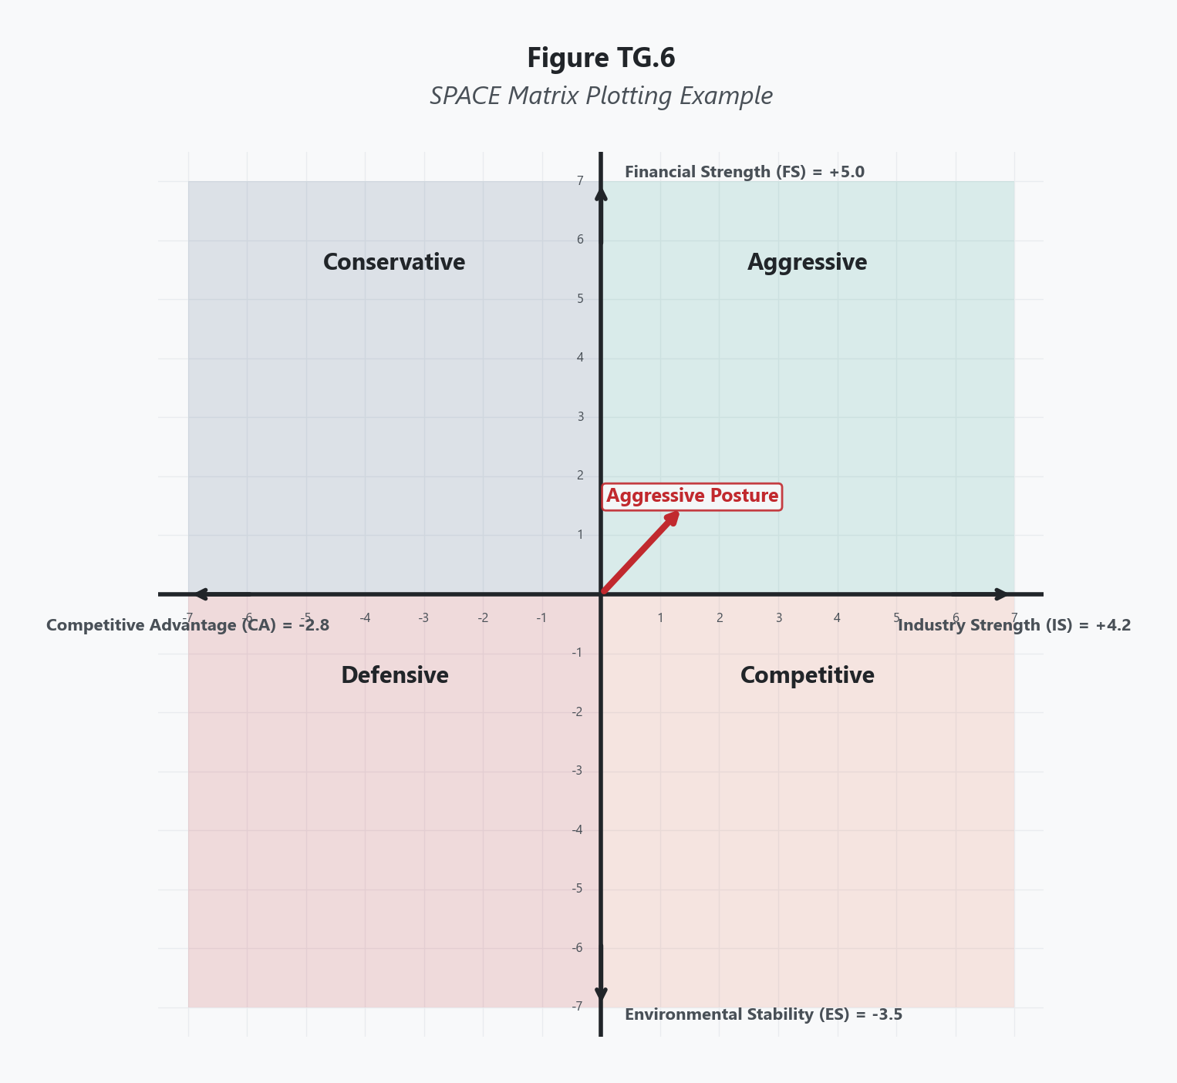
Select specific factors for each of the four dimensions. Each dimension typically includes 3 to 7 factors, though there is no fixed requirement. The factors should be tailored to the specific firm and industry being analyzed.
Financial Position (FP) — Internal dimension. Factors might include:
- Return on investment
- Leverage (debt-to-equity ratio)
- Liquidity (current ratio)
- Working capital adequacy
- Cash flow from operations
- Ease of exit from the market
Competitive Advantage (CA) — Internal dimension. Factors might include:
- Market share relative to competitors
- Product quality compared to rivals
- Product life cycle stage
- Customer loyalty and switching costs
- Capacity utilization
- Technological know-how and proprietary advantages
Environmental Stability (ES) — External dimension. Factors might include:
- Rate of inflation and macroeconomic volatility
- Technological change and disruption rate
- Price elasticity of demand
- Competitive pressure and rivalry intensity
- Barriers to entry in the industry
- Demand variability
Industry Strength (IS) — External dimension. Factors might include:
- Industry growth potential
- Industry profit potential
- Financial stability of the industry
- Technological sophistication required
- Resource utilization efficiency
- Capital intensity and barriers to entry

Step 2: Score Each Factor
Score each factor on a numerical scale. The scoring conventions differ by dimension:
- Financial Position (FP): Score each factor from +1 (worst) to +7 (best)
- Industry Strength (IS): Score each factor from +1 (worst) to +7 (best)
- Competitive Advantage (CA): Score each factor from -1 (best) to -7 (worst)
- Environmental Stability (ES): Score each factor from -1 (best) to -7 (worst)
Note the reversed scales for CA and ES. This is deliberate — these dimensions use negative numbers because they plot on the negative sides of the axes. A competitive advantage score of -1 means the firm has the strongest competitive advantage; -7 means the weakest. An environmental stability score of -1 means the environment is most stable; -7 means most volatile.
This scoring convention is the most common source of confusion with the SPACE Matrix. Pay careful attention to which direction represents strength on each dimension.

Step 3: Calculate the Average Score for Each Dimension
For each dimension, sum all factor scores and divide by the number of factors to produce an average score. You will have four averages:
- FP average (a positive number, typically between +1 and +7)
- IS average (a positive number, typically between +1 and +7)
- CA average (a negative number, typically between -1 and -7)
- ES average (a negative number, typically between -1 and -7)

Step 4: Calculate the Directional Vector Coordinates
The SPACE Matrix uses a four-axis chart (like a compass). To determine where the directional vector points, calculate two coordinates:
X-axis coordinate = CA average + IS average (This combines the two dimensions that determine horizontal position)
Y-axis coordinate = FP average + ES average (This combines the two dimensions that determine vertical position)
For example, if CA average = -3.5 and IS average = +4.0, the X-coordinate is +0.5. If FP average = +5.0 and ES average = -4.5, the Y-coordinate is +0.5.

Step 5: Plot the Directional Vector
On a four-axis chart with the origin at (0, 0), plot the point at the (X, Y) coordinates calculated in Step 4. Draw an arrow from the origin to that point. The quadrant in which the arrow falls determines the firm's recommended strategic posture:
- Quadrant I (upper right, X positive, Y positive): Aggressive posture
- Quadrant II (upper left, X negative, Y positive): Conservative posture
- Quadrant III (lower left, X negative, Y negative): Defensive posture
- Quadrant IV (lower right, X positive, Y negative): Competitive posture

Step 6: Interpret the Strategic Posture and Select Appropriate Strategies
Each posture maps to a set of strategic alternatives. The length and direction of the vector also carry meaning — a long vector pointing deep into a quadrant indicates a clear and strong posture, while a short vector near the origin suggests a less definitive position that may warrant strategies from adjacent quadrants.

Scoring Guide
Table 1 SPACE Matrix Dimension Scoring Scales
Dimension | Type | Scale | Direction
Financial Position (FP) | Internal | +1 to +7 | +1 = worst, +7 = best
Competitive Advantage (CA) | Internal | -1 to -7 | -1 = best, -7 = worst
Environmental Stability (ES) | External | -1 to -7 | -1 = most stable, -7 = most volatile
Industry Strength (IS) | External | +1 to +7 | +1 = weakest, +7 = strongest

Table 2 SPACE Matrix Strategic Postures and Recommended Strategies
Posture | Quadrant | X-Axis | Y-Axis | Characteristics | Appropriate Strategies
Aggressive | I (upper right) | Positive | Positive | Strong financial position, strong industry, stable environment, competitive advantage | Market penetration, market development, product development, forward/backward/horizontal integration, related diversification
Conservative | II (upper left) | Negative | Positive | Strong financial position but weak competitive advantage in a stable industry | Market penetration, market development, product development, related diversification
Defensive | III (lower left) | Negative | Negative | Weak financial position, weak competitive advantage, volatile environment, weak industry | Retrenchment, divestiture, liquidation, related diversification (if resources allow)
Competitive | IV (lower right) | Positive | Negative | Strong competitive advantage in a growing industry but weak financial position in an unstable environment | Forward/backward/horizontal integration, market penetration, market development, product development, joint ventures

Interpreting Your Results
Aggressive Posture (Quadrant I)
The organization is in an excellent position to use its internal strengths to capitalize on external opportunities, overcome external threats, and exploit internal capabilities. The industry is strong and stable, and the firm has both financial capacity and competitive advantage. This is the posture that supports the widest range of strategies — from intensive growth (penetration, development) to integration to diversification. An aggressive posture does not mean recklessness. It means the organization's situation supports bold moves backed by genuine capability and favorable conditions.
The risk in an aggressive posture is overreach. Leaders who see the vector pointing deep into Quadrant I may pursue too many initiatives simultaneously, spreading resources across more fronts than even a strong position can support. Discipline in prioritization remains essential even when the overall posture is aggressive.
Conservative Posture (Quadrant II)
The organization has financial strength but does not hold a strong competitive advantage, and the industry or market conditions limit aggressive expansion. Conservative firms should protect their existing competencies, avoid taking excessive risk, and grow through careful market penetration or closely related diversification. The financial strength provides a cushion that defensive firms lack, but the competitive weakness means that the firm should not overestimate its ability to compete aggressively in new markets or against entrenched rivals.
Conservative postures often characterize financially sound firms in mature, stable industries where competitive positions change slowly. The danger is complacency — mistaking financial stability for strategic security while competitive position gradually erodes.
Defensive Posture (Quadrant III)
The organization is weak internally and faces challenging external conditions. Financial resources are limited, competitive advantage is absent or eroding, the environment is volatile, and the industry offers limited support. Defensive firms must focus on survival: retrench to reduce costs, divest unprofitable operations, or prepare for liquidation if recovery is not feasible.
A defensive posture is the most uncomfortable finding because it tells leadership what they usually do not want to hear — the situation calls for retreat, not advance. But a defensive posture accurately identified is better than an aggressive strategy built on a weak foundation. The former preserves options for future recovery; the latter accelerates decline by committing scarce resources to battles the firm cannot win.
Competitive Posture (Quadrant IV)
The organization has competitive advantage in a growing industry but is constrained by financial weakness or environmental instability. Competitive firms have something valuable — market position, customer relationships, technological capability — but lack the financial resources or environmental stability to exploit it fully. The appropriate strategies involve leveraging competitive strengths through integration and partnerships while shoring up financial position.
Joint ventures are particularly relevant for competitive-posture firms because they allow the firm to access capital, technology, or distribution without bearing the full financial burden. The competitive posture often characterizes growing firms in volatile industries — companies with strong products or market positions that are outrunning their financial capacity to sustain growth.

Real-World Example
Consider Netflix in 2012, during the period when the company was transitioning from DVD-by-mail to streaming and beginning its investment in original content. The decision to commit billions to original programming was one of the most consequential strategic choices in modern media.
Table 3 SPACE Matrix Factor Scores for Netflix (Illustrative, 2012)
Financial Position (FP) | Score
Return on investment (positive but thin margins) | +3
Leverage (increasing debt to fund content) | +2
Cash flow (negative free cash flow due to content investment) | +2
Revenue growth rate (strong subscriber growth) | +6
Liquidity (adequate for operations, tight for expansion) | +3
FP Average | +3.2

Competitive Advantage (CA) | Score
Market share in streaming (dominant U.S. position) | -1
Technological platform (best-in-class streaming tech) | -1
Customer loyalty (high satisfaction, low churn) | -2
Product differentiation (limited original content in 2012) | -4
Control over content supply (dependent on studio licensing) | -6
CA Average | -2.8

Environmental Stability (ES) | Score
Technological change rate (rapid and accelerating) | -5
Competitive pressure (studios launching own platforms) | -5
Price elasticity (consumers price-sensitive on subscriptions) | -4
Regulatory environment (stable, minimal regulation) | -2
Demand variability (growing but uncertain ceiling) | -3
ES Average | -3.8

Industry Strength (IS) | Score
Growth potential (massive global streaming growth ahead) | +7
Profit potential (high at scale, uncertain for new entrants) | +5
Technological sophistication required (high barrier) | +5
Capital intensity (very high for content investment) | +3
Resource utilization potential (global scalability) | +6
IS Average | +5.2

Calculating the Vector:
- X-axis = CA average + IS average = (-2.8) + (+5.2) = +2.4
- Y-axis = FP average + ES average = (+3.2) + (-3.8) = -0.6
The vector points to Quadrant IV — Competitive posture (positive X, negative Y).
This result accurately captured Netflix's strategic reality in 2012. The company held strong competitive advantages (dominant streaming platform, technological leadership, customer loyalty) in an industry with enormous growth potential. But its financial position was strained by the content investment required, and the environment was volatile — studios were beginning to recognize that their content was funding a competitor and would eventually launch their own platforms.
The competitive posture recommended strategies like forward integration, market development, and product development — exactly the path Netflix chose. The company integrated forward by producing its own original content (beginning with House of Cards in 2013), reducing its dependence on studio-licensed content. It pursued aggressive market development by expanding internationally. And it continued product development by improving its recommendation algorithm and user interface.
The SPACE Matrix would not have told Netflix to play it safe. But it would have told Netflix that its aggressive moves needed to be funded carefully, because the financial cushion was thin and the environment was unstable. The competitive posture validated bold strategy while warning about the financial risks — a nuance that an "aggressive" finding would have missed.

Common Mistakes
Mistake 1: Confusing the Reversed Scales for CA and ES The most frequent error is scoring CA and ES in the wrong direction. A competitive advantage score of -1 means the best (strongest advantage), not the worst. An environmental stability score of -7 means the most volatile (worst), not the best. Reversing these scales produces a vector that points to the wrong quadrant and recommends the wrong posture. Double-check every CA and ES score before calculating averages.
Mistake 2: Using Generic Factors Instead of Firm-Specific Factors Copying a textbook list of SPACE factors without tailoring them to the specific firm and industry produces a generic analysis. The financial factors for a capital-intensive manufacturer differ from those for a software startup. The competitive advantage factors for a retail chain differ from those for a pharmaceutical company. Select factors that capture the specific strategic realities of the organization being analyzed.
Mistake 3: Averaging Too Few Factors Per Dimension Using only one or two factors per dimension makes the average highly sensitive to any single assessment. If you score only two CA factors and one is -2 and the other is -6, the average is -4, but neither score alone justified that average. Using 4 to 7 factors per dimension produces a more stable and representative average. The extra effort in identifying additional factors pays off in analytical reliability.
Mistake 4: Ignoring the Vector Length A vector that extends deep into a quadrant represents a strong, clear posture. A short vector near the origin represents an ambiguous position where the firm could reasonably adopt strategies from adjacent quadrants. A vector pointing to (+0.2, +0.1) technically falls in the aggressive quadrant, but the posture is barely distinguishable from conservative, competitive, or defensive. Short vectors should be interpreted cautiously, with strategies drawn from multiple postures.
Mistake 5: Treating the Posture as Permanent The SPACE Matrix is a snapshot. Financial positions change, competitive advantages erode or strengthen, industries mature, and environments stabilize or destabilize. A firm in a defensive posture today may move to competitive or conservative as it restructures. A firm in an aggressive posture may shift to competitive as its financial position weakens. Update the SPACE analysis regularly, especially after significant internal or external changes.

A Note on Strategic Integrity
The SPACE Matrix reveals not just what strategy to pursue but what kind of strategic behavior the organization's situation honestly supports. The temptation is to manipulate the scores until the vector points where leadership wants it to point — typically toward the aggressive quadrant, because aggressive sounds like winning and defensive sounds like losing. But a defensive posture honestly assessed is not failure. It is recognition that the organization's current situation calls for preservation and rebuilding rather than expansion. Micah 6:8 provides a standard that applies directly to this kind of organizational self-assessment: "He has shown you, O mortal, what is good. And what does the Lord require of you? To act justly and to love mercy and to walk humbly with your God." Walking humbly with the data means accepting the posture the analysis reveals, not the one the ego prefers. Acting justly means allocating resources based on honest assessment rather than political convenience. And loving mercy means treating the people affected by strategic decisions — employees, customers, communities — as stakeholders whose welfare deserves consideration, even when the posture is defensive and the decisions are painful. The SPACE Matrix works best when the people using it value truth more than comfort.

Key Terms
- Aggressive Posture: The strategic posture indicated when the SPACE Matrix directional vector falls in Quadrant I (positive X, positive Y), suggesting the organization has both internal strength and external support for bold, growth-oriented strategies.
- Competitive Advantage (CA): One of two internal dimensions in the SPACE Matrix, scored from -1 (strongest) to -7 (weakest), assessing factors such as market share, product quality, customer loyalty, and technological capability relative to competitors.
- Competitive Posture: The strategic posture indicated when the directional vector falls in Quadrant IV (positive X, negative Y), suggesting the organization has competitive strengths in a growing industry but faces financial constraints or environmental instability.
- Conservative Posture: The strategic posture indicated when the directional vector falls in Quadrant II (negative X, positive Y), suggesting the organization has financial strength but weak competitive advantage, calling for cautious growth strategies.
- Defensive Posture: The strategic posture indicated when the directional vector falls in Quadrant III (negative X, negative Y), suggesting the organization is weak internally and faces unfavorable external conditions, calling for retrenchment, divestiture, or survival-focused strategies.
- Directional Vector: The arrow drawn from the origin to the calculated (X, Y) coordinate on the SPACE Matrix chart, whose quadrant placement determines the recommended strategic posture and whose length indicates the strength of that recommendation.
- Environmental Stability (ES): One of two external dimensions in the SPACE Matrix, scored from -1 (most stable) to -7 (most volatile), assessing factors such as technological change rate, competitive pressure, price elasticity, and demand variability.
- Financial Position (FP): One of two internal dimensions in the SPACE Matrix, scored from +1 (weakest) to +7 (strongest), assessing factors such as return on investment, leverage, liquidity, cash flow, and revenue growth.
- Industry Strength (IS): One of two external dimensions in the SPACE Matrix, scored from +1 (weakest) to +7 (strongest), assessing factors such as growth potential, profit potential, technological sophistication, and capital intensity.
- SPACE Matrix: A matching-stage strategic management tool that evaluates four dimensions — Financial Position, Competitive Advantage, Environmental Stability, and Industry Strength — to determine a firm's appropriate strategic posture through a directional vector plotted on a four-axis chart.
- Strategic Posture: The overall orientation of a firm's strategic behavior — aggressive, conservative, defensive, or competitive — as determined by the SPACE Matrix directional vector, indicating what kind of strategic action the organization's situation supports.

References
David, F. R., & David, F. R. (2017). Strategic management: A competitive advantage approach, concepts and cases (16th ed.). Pearson.
Hitt, M. A., Ireland, R. D., & Hoskisson, R. E. (2020). Strategic management: Competitiveness and globalization (13th ed.). Cengage Learning.
Rowe, A. J., Mason, R. O., Dickel, K. E., Mann, R. B., & Mockler, R. J. (1994). Strategic management: A methodological approach (4th ed.). Addison-Wesley.
Thompson, A. A., Peteraf, M. A., Gamble, J. E., & Strickland, A. J. (2022). Crafting and executing strategy: The quest for competitive advantage (23rd ed.). McGraw-Hill Education.

Knowledge Check

Multiple Choice
Question 1 [Bloom's: Analyze]
A firm's SPACE Matrix produces the following dimension averages: FP = +5.5, CA = -2.0, ES = -5.0, IS = +6.0. The X-axis coordinate is +4.0 and the Y-axis coordinate is +0.5. A junior analyst reports that the firm is in a "strong aggressive posture." A senior strategist disagrees, noting that the Y-axis coordinate of +0.5 is barely positive. Who is making the better analytical judgment, and why?
A) The junior analyst, because any positive X and Y coordinates indicate an aggressive posture regardless of magnitude B) The senior strategist, because the Y-axis coordinate of +0.5 means the firm is barely above the conservative/competitive boundary, suggesting that the aggressive posture is not firmly established and strategies from adjacent quadrants should also be considered C) The junior analyst, because the strong X-axis coordinate of +4.0 confirms an unambiguously aggressive posture D) The senior strategist, because a Y-axis coordinate below +1.0 automatically disqualifies a firm from the aggressive quadrant
Correct Answer: B Rationale: The senior strategist correctly identifies that vector length and direction both matter. While the X-coordinate of +4.0 is strong (driven by excellent industry strength overcoming moderate competitive weakness), the Y-coordinate of +0.5 is marginal — the result of strong financial position (+5.5) nearly cancelled by high environmental volatility (-5.0). This means a modest deterioration in financial position or increase in environmental instability would push the firm into the competitive quadrant. The aggressive posture is technically correct but fragile on the Y-axis, and prudent strategy should account for strategies from the competitive quadrant as well. Option A ignores vector magnitude. Option C reads only one axis. Option D invents a threshold that does not exist in the framework.
Question 2 [Bloom's: Analyze]
Two companies in the same industry both produce SPACE Matrix vectors in the defensive quadrant. Company A's vector is (-4.5, -3.0), deep into Quadrant III. Company B's vector is (-0.8, -0.3), barely in Quadrant III. Both companies have the same CEO consulting firm advising them. The consultants recommend identical defensive strategies for both companies. What is wrong with this recommendation?
A) Nothing — both companies are in the defensive quadrant and should pursue the same strategies B) Company B's short vector near the origin indicates a much less definitive defensive posture than Company A's, meaning Company B should consider strategies from adjacent quadrants (conservative and competitive) rather than adopting the same aggressive retrenchment appropriate for Company A's deeply defensive position C) Company A should pursue aggressive strategies because a longer vector always indicates a stronger position D) The consultants should re-score the SPACE dimensions until at least one company moves to a different quadrant
Correct Answer: B Rationale: Vector length carries strategic meaning. Company A's vector (-4.5, -3.0) points deep into the defensive quadrant, indicating a clear and unambiguous need for defensive strategies — retrenchment, divestiture, or liquidation. Company B's vector (-0.8, -0.3) barely enters the defensive quadrant, meaning the position is ambiguous. Small changes in any dimension's scores could move Company B into the conservative or competitive quadrant. Company B should consider a broader range of strategies, potentially including market penetration or product development that a deeply defensive company cannot afford. Recommending identical strategies ignores the critical difference in vector magnitude. Option A treats all positions within a quadrant as identical. Option C reverses the meaning of vector direction. Option D promotes score manipulation.
Question 3 [Bloom's: Analyze]
An analyst scores a firm's competitive advantage factors as follows: market share = -2, product quality = -3, customer loyalty = -2, technological know-how = -5, control over suppliers = -6. The CA average is -3.6. A colleague argues that the analyst made an error because "negative numbers mean the firm is weak, so a -3.6 average indicates poor competitive advantage." Is the colleague correct?
A) Yes — negative CA averages always indicate competitive weakness, and the firm should be concerned B) No — in the SPACE Matrix, CA is scored on a reversed scale where -1 is the strongest and -7 is the weakest; a CA average of -3.6 represents a moderate competitive position, with strength in market share and customer loyalty partially offset by weakness in technological know-how and supplier control C) Yes — the analyst should convert the scores to positive numbers before averaging to avoid confusion D) No — but the negative sign should be removed for interpretation purposes, making the effective score +3.6
Correct Answer: B Rationale: The reversed scale for CA is the most misunderstood element of the SPACE Matrix. A CA score of -1 indicates the strongest competitive advantage, while -7 indicates the weakest. A CA average of -3.6 falls in the middle of the range and represents a moderate competitive position — the firm has areas of competitive strength (market share at -2, customer loyalty at -2) and areas of competitive weakness (technological know-how at -5, supplier control at -6). The colleague's error is interpreting the negative number as inherently bad rather than understanding the reversed scale. Option A perpetuates the misunderstanding. Option C would break the mathematical framework — the negative numbers are essential for calculating the directional vector. Option D removes the sign, which would also break the vector calculation.

Critical Thinking
A family-owned regional grocery chain completes a SPACE Matrix analysis and produces a directional vector of (-1.2, -2.5), placing it in the defensive quadrant. The analysis reveals that the chain's financial position is weakening (FP average: +2.8), its competitive advantage is modest (CA average: -3.5), the environment is volatile due to online grocery expansion and supply chain disruption (ES average: -5.3), and the industry is moderately attractive (IS average: +4.7).
The defensive posture recommends retrenchment or divestiture. However, the chain has been a cornerstone of its community for 50 years, employing 1,200 people across 15 stores. The founder's grandson, who serves as CEO, refuses to consider closing stores or selling the business. He argues that the SPACE Matrix "doesn't understand our community relationships" and proposes instead to invest in store renovations and a new loyalty program — strategies more consistent with an aggressive or competitive posture.
Question: Evaluate the CEO's resistance to the SPACE Matrix findings. Is his objection that the tool "doesn't understand community relationships" a legitimate critique of the tool's limitations, or is it a rationalization for avoiding a difficult truth? In your response, address what the SPACE Matrix does and does not capture, whether community relationships constitute a competitive advantage the CA scores failed to reflect or a non-strategic consideration the tool correctly excludes, and what strategic options exist between full acceptance of the defensive recommendation and full rejection of it. Consider the consequences of pursuing aggressive strategies from a defensive position versus the consequences of accepting the defensive posture and acting accordingly.
Rubric:
Score | Criteria
Excellent (9-10) | Demonstrates nuanced understanding of both the SPACE Matrix's analytical value and its limitations. Does not simply side with the tool or the CEO — evaluates whether community relationships are a measurable competitive advantage that should have been reflected in the CA scores or a non-strategic value that the tool correctly does not capture. Recognizes that pursuing aggressive strategies from a defensive position risks accelerating decline, but also acknowledges that defensive strategies carry real human costs. Proposes a middle path — perhaps selective retrenchment of the weakest stores while investing in the strongest locations, or seeking partnerships that address financial weakness without abandoning community presence. Addresses the distinction between strategic conviction and emotional attachment. Well-organized with clear reasoning.
Proficient (7-8) | Addresses the tension between the SPACE findings and the CEO's objection. Correctly identifies what the tool measures and where community relationships fit (or do not fit). Recognizes the risk of pursuing aggressive strategies from a defensive position. Proposes at least one alternative approach. Clear reasoning with minor gaps.
Developing (5-6) | Addresses the question but oversimplifies — either accepts the SPACE recommendation without engaging the community dimension, or dismisses the tool in favor of the CEO's argument. Limited engagement with alternative strategic approaches. Some logical gaps.
Needs Work (3-4) | Misses the core tension. Minimal application of SPACE Matrix concepts. Does not address the specific dimension scores or their strategic implications. Unclear reasoning.
Insufficient (0-2) | Off-topic, demonstrates fundamental misunderstanding of the SPACE Matrix, or fails to engage the scenario meaningfully.

The BCG Growth-Share Matrix

What This Tool Does
The BCG Growth-Share Matrix classifies a company's business units or product lines into four categories based on two variables: market growth rate and relative market share. Developed by the Boston Consulting Group in the early 1970s, this tool helps executives answer the most fundamental portfolio question: where should we invest, and where should we pull back? It transforms a sprawling collection of business units into a disciplined investment framework.

When to Use It
Use the BCG Matrix during the strategy formulation stage when a multi-business corporation needs to allocate resources across its portfolio of business units or product lines. It is most useful when the organization has multiple business units competing in different markets at different growth rates. The matrix is typically applied after completing external analysis (EFE) and competitive positioning work, so that market growth and competitive position data are already in hand.

Before You Start
- Identify all business units or major product lines in the portfolio
- Gather market growth rate data for each unit's industry (industry reports, analyst data)
- Calculate or estimate each unit's relative market share (unit's market share divided by the largest competitor's market share)
- Have revenue and profitability data available for each unit
- Understand the corporate strategy context: Is the company pursuing growth, stability, or retrenchment?

Step-by-Step Instructions
Figure TG.1. BCG Matrix Worked Example
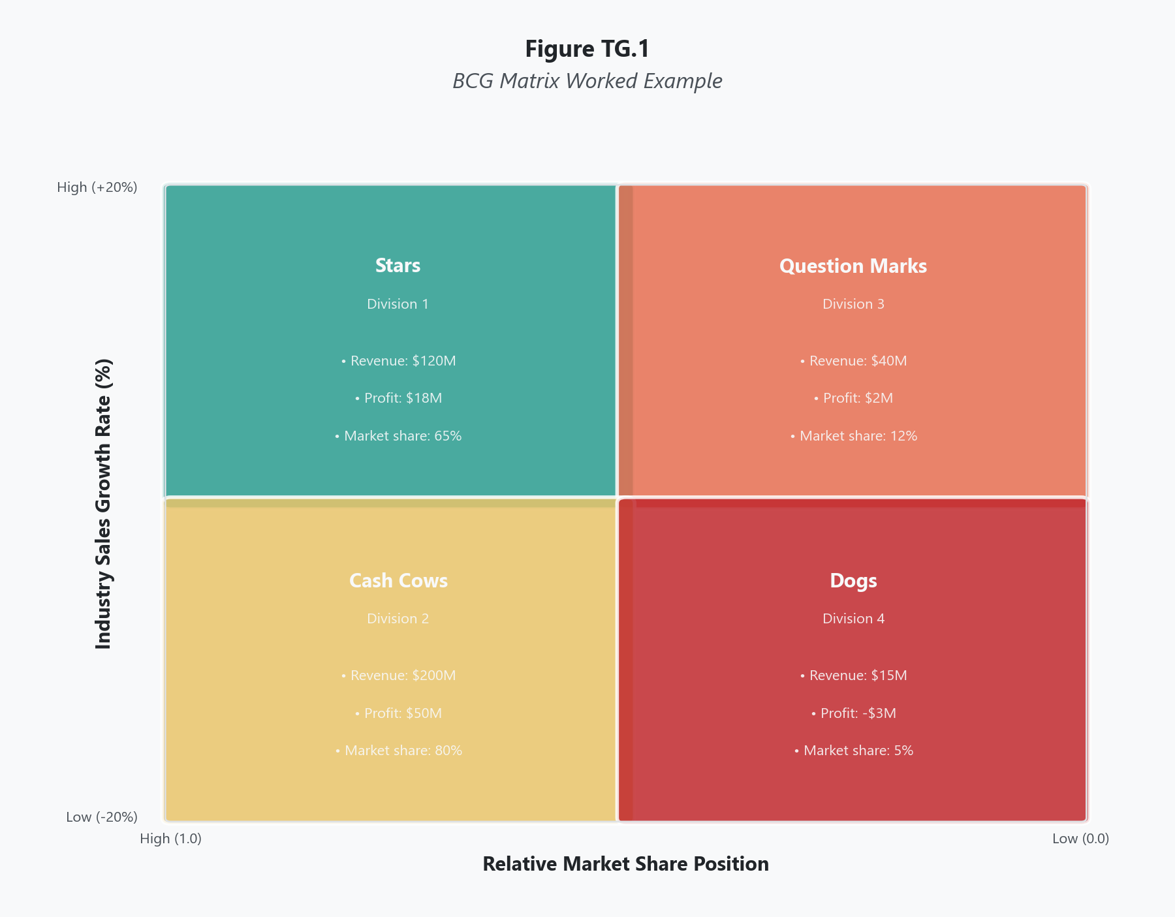
List every distinct business unit, division, or product line that operates in a separate market. Each unit should have its own competitive dynamics and its own identifiable revenue stream. Avoid lumping together businesses that serve fundamentally different markets just because they sit under the same division name.

Step 2: Determine Market Growth Rate for Each Unit
For each business unit, identify the annual growth rate of the industry or market in which it competes. Use a consistent timeframe, typically the most recent three to five years of data or a forward-looking projection. The conventional dividing line is 10 percent: markets growing above 10 percent are considered high-growth, and those below 10 percent are considered low-growth. Adjust this threshold based on the macroeconomic context and the specific industry norms. This value determines vertical placement on the matrix.

Step 3: Calculate Relative Market Share for Each Unit
Divide each unit's market share by the market share of its largest competitor. A value greater than 1.0 means the unit leads its market; a value less than 1.0 means it trails the leader. For example, if your unit holds 20 percent market share and the largest competitor holds 40 percent, your relative market share is 0.5. The conventional dividing line is 1.0. This value determines horizontal placement on the matrix. Note that the horizontal axis is typically displayed in reverse, with high relative market share on the left.

Step 4: Plot Each Unit on the Matrix
Place each business unit on a two-by-two grid. The vertical axis represents market growth rate (high at top, low at bottom). The horizontal axis represents relative market share (high at left, low at right). Each unit falls into one of four quadrants: Stars (upper left), Question Marks (upper right), Cash Cows (lower left), or Dogs (lower right). Size the circles proportionally to each unit's revenue contribution to make the visual more informative.

Step 5: Classify and Interpret Each Quadrant
Assign each unit its quadrant label and review the strategic implications:
- Stars occupy high-growth markets where the unit holds a leading position. They generate strong revenue but also consume significant cash to maintain growth. The strategic priority is continued investment to defend market leadership.
- Question Marks (also called Problem Children) sit in high-growth markets but hold a weak competitive position. They consume cash and may or may not develop into Stars. The strategic choice is binary: invest heavily to build market share, or divest before the unit drains resources without return.
- Cash Cows hold dominant positions in low-growth markets. They generate more cash than they need because the market demands less reinvestment. Profits from Cash Cows should fund Stars and selected Question Marks. The strategic priority is to harvest cash while maintaining the competitive position.
- Dogs hold weak positions in low-growth markets. They typically produce little profit and tie up capital and management attention. The default strategic recommendation is divestiture, liquidation, or managed decline, though there are circumstances, discussed below, where retaining a Dog serves a broader purpose.

Step 6: Develop Portfolio-Level Strategy
Step back and evaluate the portfolio as a whole. A healthy portfolio has a balanced mix: Cash Cows funding Stars and promising Question Marks, with Dogs either divested or on a path to exit. An unhealthy portfolio has too many Question Marks draining cash, no Cash Cows to fund growth, or too many Dogs tying up resources. Identify the specific investment, divestiture, and harvest decisions implied by the current positioning, and draft resource allocation recommendations.

Scoring Guide
Table 1 BCG Matrix Quadrant Classification Criteria
Quadrant | Market Growth Rate | Relative Market Share | Cash Flow Profile
Star | High (above 10%) | High (above 1.0) | Roughly neutral; high generation offset by high reinvestment needs
Question Mark | High (above 10%) | Low (below 1.0) | Negative; heavy cash consumption with uncertain returns
Cash Cow | Low (below 10%) | High (above 1.0) | Strongly positive; high generation with low reinvestment needs
Dog | Low (below 10%) | Low (below 1.0) | Roughly neutral to slightly negative; low generation, low investment

Interpreting Your Results
A completed BCG Matrix tells you where to deploy capital and where to stop spending. Read the portfolio, not just individual quadrants.
If your portfolio is dominated by Stars, you likely have strong growth but may face cash flow pressure. Ensure you have enough Cash Cows or external financing to sustain the investment those Stars require.
If your portfolio is dominated by Cash Cows, you have strong current cash flow but face a long-term growth problem. The company risks stagnation unless Cash Cow profits are funneled into Stars or high-potential Question Marks.
If your portfolio is dominated by Question Marks, you have a decision crisis. Each one demands a binary choice: invest aggressively or exit. Trying to maintain all of them at mediocre funding levels is the worst possible outcome, because none will reach the scale needed to become Stars.
If your portfolio is dominated by Dogs, the company faces serious strategic distress. Resources are locked in units with no growth prospect and no market leadership. The priority is divestiture and reallocation toward higher-potential businesses.
The most dangerous portfolio is one that looks balanced on the surface but lacks a clear investment thesis. Every unit should have an explicit strategic role: grow, harvest, or exit. Ambiguity kills resource allocation discipline.

Real-World Example
Consider Procter & Gamble's product portfolio in the early 2000s, before its major portfolio restructuring under CEO A.G. Lafley and later David Taylor. P&G operated in categories spanning beauty, grooming, health care, fabric and home care, and baby and family care, with over 170 brands.
Table 2 Illustrative BCG Classification of Select P&G Business Units (Early 2000s)
Business Unit | Market Growth | Relative Market Share | BCG Quadrant
Tide (Laundry) | Low (~3%) | High (market leader) | Cash Cow
Gillette (Grooming) | Moderate (~5%) | High (dominant share) | Cash Cow
SK-II (Premium Beauty, Asia) | High (~15%) | Moderate (growing) | Question Mark
Iams (Pet Food) | Moderate (~6%) | Low (trailing leaders) | Dog
Pampers (Diapers) | Low (~2%) | High (market leader) | Cash Cow

P&G used this type of analysis to rationalize its portfolio. Between 2014 and 2017, the company divested or discontinued roughly 100 brands, including several "Dog" and underperforming "Question Mark" categories. Proceeds and management focus were redirected toward the core categories where P&G held market leadership. The result was a leaner portfolio of approximately 65 brands that generated 95 percent of the company's profits. Cash Cows like Tide and Pampers continued funding investment in growth segments, while underperforming units no longer drained resources.
The lesson is straightforward: the BCG Matrix does not make the decision for you, but it clarifies which decisions you are avoiding.

Common Mistakes
Mistake 1: Using Absolute Market Share Instead of Relative Market Share Students frequently plot market share as a raw percentage rather than dividing by the leading competitor's share. A business with 25 percent market share looks strong in absolute terms, but if the leader holds 50 percent, the relative share is only 0.5, placing the unit on the weak side of the axis. Always divide by the largest competitor's share to get the correct positioning.
Mistake 2: Treating Quadrant Prescriptions as Automatic The matrix suggests general strategic directions, not commands. Selling every Dog and funding every Star without judgment leads to outcomes that ignore context. A Dog might serve as a loss leader that drives traffic to a Cash Cow. A Star might be in a market about to face regulatory disruption. Use the matrix as input to strategic thinking, not as a substitute for it.
Mistake 3: Ignoring the Time Dimension The BCG Matrix is a snapshot. Markets decelerate, and Stars become Cash Cows. Competitors gain share, and Cash Cows become Dogs. A single matrix tells you where units sit today, not where they are heading. Update the analysis regularly and track movement across quadrants over time.
Mistake 4: Failing to Account for Interdependencies Between Units Business units do not operate in isolation. Divesting a Dog that shares a distribution network with a Cash Cow can damage the Cash Cow's cost structure. The matrix does not capture synergies, shared resources, or cross-selling relationships. Before acting on a divestiture recommendation, map the interdependencies.
Mistake 5: Setting the Growth Rate Threshold Arbitrarily The 10 percent dividing line is a convention, not a law. In a low-growth economy, 5 percent growth may represent a high-growth market. In a technology sector, 10 percent may be below average. Calibrate the threshold to the company's industry and economic environment, and document the rationale for the threshold chosen.

A Note on Stewardship
Portfolio management is stewardship in its most tangible form. When you plot business units on the BCG Matrix, you are deciding how to allocate resources that affect not just shareholders but communities, employees, and customers whose livelihoods depend on those decisions. Luke 12:48 puts it plainly: "From everyone who has been given much, much will be demanded." A corporation with a diversified portfolio has been given much, and the allocation choices it makes carry proportional weight. Funding a Star while divesting a Dog is not inherently wrong, but the executive who makes that decision bears responsibility for understanding the full consequences. A Dog business unit that employs 200 people in a community with no other major employer is not just a quadrant classification. It is a stewardship question that pure financial analysis cannot answer. The matrix gives you clarity. Your values, and your willingness to account for what you have been given, determine what you do with it.

Key Terms
- BCG Growth-Share Matrix: A portfolio analysis framework developed by the Boston Consulting Group that classifies business units into four quadrants based on market growth rate and relative market share to guide resource allocation decisions.
- Cash Cow: A business unit with high relative market share in a low-growth market that generates more cash than it requires for reinvestment.
- Dog: A business unit with low relative market share in a low-growth market, typically generating minimal profit and consuming management attention without strong growth prospects.
- Market Growth Rate: The annual percentage increase in total market size for a given industry or product category, used as the vertical axis of the BCG Matrix.
- Portfolio Management: The process of evaluating, prioritizing, and allocating resources across a company's collection of business units or product lines to maximize overall corporate performance.
- Question Mark: A business unit with low relative market share in a high-growth market, also called a Problem Child, requiring a binary strategic decision to invest heavily or divest.
- Relative Market Share: A unit's market share divided by the market share of its largest competitor, used as the horizontal axis of the BCG Matrix; a value above 1.0 indicates market leadership.
- Star: A business unit with high relative market share in a high-growth market that generates strong revenue but also requires significant reinvestment to maintain its leading position.

References
David, F. R., & David, F. R. (2017). Strategic management: A competitive advantage approach, concepts and cases (16th ed.). Pearson.
Henderson, B. D. (1970). The product portfolio. Boston Consulting Group.
Kotler, P., & Keller, K. L. (2016). Marketing management (15th ed.). Pearson.
Lafley, A. G., & Martin, R. L. (2013). Playing to win: How strategy really works. Harvard Business Review Press.
Procter & Gamble. (2017). Annual report 2017. Procter & Gamble Company.

Knowledge Check

Multiple Choice
Question 1 [Bloom's: Analyze]
A diversified consumer goods company has four major divisions. Division A holds 35% market share in a market growing at 3% per year, where the next largest competitor holds 20%. Division B holds 12% market share in a market growing at 18% per year, where the market leader holds 30%. Division C holds 40% market share in a market growing at 14% per year, where the next largest competitor holds 25%. Division D holds 8% market share in a market growing at 2% per year, where the market leader holds 35%. Which division is classified as a Question Mark?
A) Division A, because it operates in a low-growth market despite strong share B) Division B, because it has low relative market share in a high-growth market C) Division C, because it has high relative market share in a high-growth market D) Division D, because it has low relative share in a low-growth market
Correct Answer: B Rationale: Division B has a relative market share of 0.4 (12%/30%) in a market growing at 18%, placing it in the Question Mark quadrant (low relative share, high growth). Division A is a Cash Cow (relative share 1.75, low growth). Division C is a Star (relative share 1.6, high growth). Division D is a Dog (relative share 0.23, low growth).
Question 2 [Bloom's: Analyze]
A technology conglomerate discovers that its portfolio contains five Cash Cows, one Star, and no Question Marks. What is the most significant strategic risk this portfolio composition reveals?
A) The company is generating too much cash and should increase dividends immediately B) The company lacks investments in high-growth markets and faces long-term stagnation C) The Cash Cows will inevitably become Stars if the company invests enough capital D) The company should convert its Cash Cows into Question Marks by entering new markets with those same units
Correct Answer: B Rationale: A portfolio dominated by Cash Cows with no Question Marks signals that the company is not investing in future growth opportunities. Cash Cows sit in mature, low-growth markets. Without Question Marks or additional Stars in high-growth markets, the company's revenue base will stagnate as those mature markets eventually decline. Option A treats a symptom rather than the strategic problem. Option C misunderstands the framework: Cash Cows cannot become Stars because their markets are low-growth by definition. Option D conflates the business unit with the market it serves.
Question 3 [Bloom's: Analyze]
An executive proposes divesting a Dog business unit that generates $5 million in annual profit. The Dog shares a manufacturing facility and distribution network with the company's largest Cash Cow, which generates $80 million in annual profit. Eliminating the Dog would increase the Cash Cow's per-unit costs by approximately 15%. What does this scenario reveal about the limitations of the BCG Matrix?
A) The matrix correctly identifies the Dog as a divestiture candidate, and the cost impact on the Cash Cow is an acceptable trade-off B) The matrix does not account for interdependencies between business units, making the divestiture recommendation potentially harmful to overall portfolio performance C) The matrix should be replaced with a financial model whenever business units share resources D) The executive should reclassify the Dog as a Cash Cow because it contributes to the profitability of another unit
Correct Answer: B Rationale: The BCG Matrix evaluates each business unit independently based on market growth and relative share. It does not capture operational synergies, shared infrastructure, or cross-subsidization effects. Divesting the Dog in this scenario could damage the Cash Cow's profitability far more than the Dog's own contribution would suggest. Option A ignores the $12 million cost impact on the Cash Cow (15% of $80M). Option C goes too far; the matrix is still useful as one input among several. Option D misapplies the classification criteria, which are based on market position, not internal cost contributions.

Critical Thinking
A regional hospital system operates four service lines: cardiac care (high growth, market leader), orthopedics (low growth, market leader), pediatric specialty care (high growth, small market share serving an underserved rural population), and a general family medicine clinic (low growth, small share relative to larger competitors in the area). The BCG Matrix would classify pediatric specialty care as a Question Mark and the family medicine clinic as a Dog.
Question: The CFO recommends divesting both the pediatric specialty care line and the family medicine clinic to concentrate resources on cardiac care and orthopedics. As a Christian healthcare executive, how do you evaluate this recommendation? In your response, address the strategic logic of the BCG analysis, the limitations of applying portfolio theory to healthcare, and how stewardship principles should inform the final decision. Consider which stakeholders are affected and what obligations, if any, extend beyond financial performance.
Rubric:
Score | Criteria
Excellent (9-10) | Demonstrates nuanced understanding of both the strategic rationale and its limitations in a healthcare context. Engages multiple stakeholder perspectives including patients, employees, and the underserved community. Applies stewardship and vocational purpose principles without proof-texting. Recognizes the tension between fiduciary responsibility and mission-driven care. Proposes a thoughtful path forward rather than a simple accept-or-reject answer. Well-organized with clear reasoning.
Proficient (7-8) | Addresses both strategic and ethical dimensions. Applies BCG concepts correctly and identifies key limitations. Shows integration of faith principles with business reasoning. Identifies major stakeholder impacts. Clear reasoning with minor gaps in analysis.
Developing (5-6) | Addresses the question but overemphasizes either the financial case or the ethical case without integrating both. Limited application of BCG concepts or superficial faith integration. Some logical gaps or missing stakeholder perspectives.
Needs Work (3-4) | Misses key dimensions of the problem. Minimal application of strategic frameworks. No meaningful faith integration or forced references. Unclear reasoning or overly simplistic answer.
Insufficient (0-2) | Off-topic, demonstrates fundamental misunderstanding of the BCG Matrix or the ethical dimensions, or fails to engage the scenario meaningfully.

The Internal-External Matrix

What This Tool Does
The Internal-External (IE) Matrix plots a firm's divisions or business units on a nine-cell grid based on two scores already calculated: the IFE total weighted score (horizontal axis) and the EFE total weighted score (vertical axis). Each cell maps to one of three strategic prescriptions — grow and build, hold and maintain, or harvest and divest. The IE Matrix takes the work you have already done in the IFE and EFE and converts it into a strategic direction for each business unit. For a multi-division firm, it provides a portfolio-level view that shows which divisions deserve investment and which should be managed for cash or exited.

When to Use It
Use the IE Matrix during the matching stage of strategy formulation, after you have completed both the IFE Matrix and the EFE Matrix for each division or business unit being analyzed. The IE Matrix depends entirely on those two inputs — without completed IFE and EFE scores, you cannot plot anything. It is typically used alongside the SWOT Matrix and Grand Strategy Matrix as a matching tool that translates analytical scores into strategic direction. For diversified firms with multiple divisions, the IE Matrix functions similarly to the BCG Matrix but uses a richer data foundation (weighted factor scores rather than just market growth and market share).

Before You Start
- Complete an IFE Matrix for each division or business unit, producing a total weighted score between 1.0 and 4.0
- Complete an EFE Matrix for each division or business unit, producing a total weighted score between 1.0 and 4.0
- Know the revenue or profit contribution of each division (used to size the circles on the matrix for visual weighting)
- Understand that the IE Matrix evaluates each division separately — a diversified company will have multiple plots on the same grid
- If the firm operates as a single business unit, the IE Matrix still applies, but it plots one point rather than a portfolio

Step-by-Step Instructions
Figure TG.7. IE Matrix Positioning Example
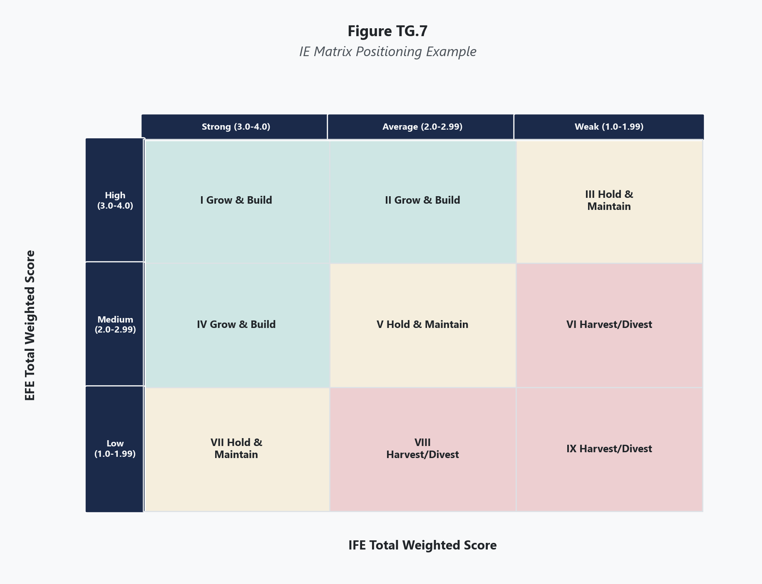
Collect the total weighted score from each division's IFE Matrix and EFE Matrix. These are your plotting coordinates. A division with an IFE score of 3.10 and an EFE score of 2.45 will be plotted at those coordinates on the grid. Ensure the scores are final — any revision to the underlying IFE or EFE factors, weights, or ratings will change the division's position on the IE Matrix.

Step 2: Set Up the Nine-Cell Grid
Draw a grid with the IFE total weighted score on the horizontal axis and the EFE total weighted score on the vertical axis. Both axes range from 1.0 to 4.0.
The horizontal axis (IFE) is divided into three regions:
- Strong (3.0 to 4.0) — left columns
- Average (2.0 to 2.99) — middle columns
- Weak (1.0 to 1.99) — right columns
The vertical axis (EFE) is divided into three regions:
- High (3.0 to 4.0) — top rows
- Medium (2.0 to 2.99) — middle rows
- Low (1.0 to 1.99) — bottom rows
This creates nine cells. The cells are conventionally numbered I through IX, with Cell I in the upper left and Cell IX in the lower right.

Step 3: Plot Each Division
Place each division on the grid at the intersection of its IFE and EFE scores. Represent each division as a circle, with the circle's size proportional to the division's revenue contribution (or profit contribution, depending on the analytical focus). This proportional sizing allows the viewer to see at a glance which divisions carry the most financial weight and where they fall strategically.

Step 4: Identify the Strategic Prescription for Each Division
The nine cells map to three strategic regions:
- Grow and Build (Cells I, II, IV): Divisions in these cells have strong-to-average internal positions combined with high-to-medium external positions. They warrant aggressive investment — market penetration, market development, product development, and integration strategies are appropriate.
- Hold and Maintain (Cells III, V, VII): Divisions in these cells occupy the middle ground. They are neither strong enough to justify aggressive investment nor weak enough to warrant exit. Market penetration and product development are the most common strategies — protect current position without committing to major expansion or accepting decline.
- Harvest or Divest (Cells VI, VIII, IX): Divisions in these cells have weak internal positions, weak external positions, or both. They are candidates for retrenchment, divestiture, or liquidation. These divisions consume resources that could be redeployed to divisions in the Grow and Build region.

Step 5: Evaluate Portfolio Balance
Step back and assess the portfolio as a whole. A healthy portfolio has the majority of revenue concentrated in the Grow and Build or Hold and Maintain regions, with minimal revenue trapped in the Harvest or Divest region. An unhealthy portfolio shows significant revenue in Cells VI, VIII, or IX — capital and management attention locked into divisions that the analysis says should be shrinking or exiting.
Compare the IE Matrix portfolio view to the BCG Matrix. The two tools should tell a broadly consistent story. If they contradict each other for a specific division, investigate the discrepancy — it usually points to an assumption in one analysis that needs reexamination.

Step 6: Develop Division-Level Strategic Recommendations
For each division, translate the strategic region into specific actionable recommendations. A division in Cell I (strong IFE, high EFE) with a large revenue circle warrants the most aggressive investment. A division in Cell IX (weak IFE, low EFE) with a small revenue circle is the most straightforward divestiture candidate. The harder decisions involve divisions in the Hold and Maintain region — these require judgment about whether the division is trending toward Grow and Build or sliding toward Harvest and Divest, which the static matrix alone cannot answer.

Scoring Guide
Table 1 IE Matrix Cell Assignments and Strategic Prescriptions
Cell | IFE Score Range | EFE Score Range | Strategic Region | Prescription
I | Strong (3.0-4.0) | High (3.0-4.0) | Grow and Build | Aggressive investment, integration, intensive strategies
II | Average (2.0-2.99) | High (3.0-4.0) | Grow and Build | Invest to strengthen internal position while external conditions are favorable
III | Weak (1.0-1.99) | High (3.0-4.0) | Hold and Maintain | External environment is favorable but internal weakness limits growth potential
IV | Strong (3.0-4.0) | Medium (2.0-2.99) | Grow and Build | Strong internal position justifies continued investment despite moderate external conditions
V | Average (2.0-2.99) | Medium (2.0-2.99) | Hold and Maintain | Protect position with market penetration and product development
VI | Weak (1.0-1.99) | Medium (2.0-2.99) | Harvest or Divest | Weak internal position in a moderate environment — consider retrenchment or exit
VII | Strong (3.0-4.0) | Low (1.0-1.99) | Hold and Maintain | Strong internally but facing an unfavorable external environment — defend and monitor
VIII | Average (2.0-2.99) | Low (1.0-1.99) | Harvest or Divest | Average capabilities in a hostile environment — limited upside justifies harvesting
IX | Weak (1.0-1.99) | Low (1.0-1.99) | Harvest or Divest | Weak position in hostile environment — divest or liquidate

Interpreting Your Results
Grow and Build (Cells I, II, IV)
Divisions in this region have earned the right to receive investment. Their internal capabilities are at least average (and often strong), and their external environment presents sufficient opportunity to justify the expenditure. But "grow and build" is not a blank check. The specific strategy should match the division's position within the region.
Cell I divisions — strong internally with a favorable external environment — are the prime candidates for the most aggressive strategies: forward integration, backward integration, horizontal integration, market penetration, market development, and product development. These divisions should receive priority in capital allocation.
Cell II divisions have a favorable external environment but only average internal capabilities. Investment should focus on strengthening the internal weaknesses that prevent the division from moving into Cell I. The external opportunity will not last forever — the division needs to build capability while the environment is supportive.
Cell IV divisions are strong internally but face only moderate external conditions. They should continue investing to maintain competitive advantages but should not overextend into aggressive expansion that the external environment may not reward.
Hold and Maintain (Cells III, V, VII)
Divisions in this region occupy strategic middle ground. They are not failing, but they are not positioned for aggressive growth either. The appropriate strategies are defensive: market penetration to protect share, product development to stay relevant, and selective investment that maintains competitive position without overcommitting resources.
The key question for Hold and Maintain divisions is trajectory. Is the division trending upward (improving IFE or EFE scores) or downward? A Cell V division that has been improving steadily may be approaching Grow and Build territory and deserves continued support. A Cell V division with declining scores may be sliding toward Harvest and Divest and should be managed more conservatively.
Cell III represents an unusual and instructive case: the external environment is highly favorable, but the division's internal position is weak. This creates a strategic question similar to Quadrant II of the Grand Strategy Matrix — should the firm invest heavily to fix internal weaknesses before the external window closes, or accept that the division cannot compete effectively and exit while conditions are still favorable enough to attract a buyer?
Harvest or Divest (Cells VI, VIII, IX)
Divisions in this region are consuming resources that the analysis suggests should be redeployed elsewhere. The strategic prescription is to extract maximum cash from these divisions while reducing investment, or to sell or close them.
Cell IX is the most straightforward: weak internally, facing a hostile external environment. Unless there are compelling strategic interdependencies with other divisions, divestiture or liquidation is the recommended path.
Cell VI and Cell VIII require more nuanced judgment. A Cell VI division (weak internally, moderate external environment) might be salvageable if the internal weaknesses are addressable and the cost of fixing them is justified by the moderate opportunity. A Cell VIII division (average internally, hostile external environment) might be worth holding temporarily if the external conditions are expected to improve.
The hardest decisions in the IE Matrix involve divisions that generate significant revenue but fall in the Harvest or Divest region. Selling a division that contributes 20 percent of corporate revenue takes courage. But continuing to invest in a division that the data says is competitively weak in an unfavorable environment takes more courage — and produces worse outcomes.

Real-World Example
Consider General Electric in the mid-2010s, before its major restructuring under CEO John Flannery and later Larry Culp. GE operated across multiple divisions with dramatically different competitive positions and external environments.
Table 2 Illustrative IE Matrix Scores for Select GE Divisions (Mid-2010s)
Division | IFE Score | EFE Score | IE Cell | Strategic Region | Revenue Share (Approx.)
GE Aviation | 3.45 | 3.20 | I | Grow and Build | 25%
GE Healthcare | 3.10 | 2.85 | IV | Grow and Build | 18%
GE Power | 2.30 | 1.75 | VIII | Harvest or Divest | 27%
GE Capital | 2.10 | 2.00 | V | Hold and Maintain | 20%
GE Transportation | 2.50 | 2.10 | V | Hold and Maintain | 5%
GE Lighting | 1.60 | 1.45 | IX | Harvest or Divest | 2%

The IE Matrix revealed a portfolio under severe strain. GE's two strongest divisions — Aviation (Cell I) and Healthcare (Cell IV) — were generating strong performance but together accounted for only 43 percent of revenue. Meanwhile, GE Power — the single largest revenue contributor at 27 percent — sat in Cell VIII (Harvest or Divest), reflecting weak external conditions in the global power generation market and an average internal position that had been deteriorating as gas turbine demand declined.
GE Lighting in Cell IX was the clearest divestiture candidate: weak internally, facing a hostile environment as the lighting industry commoditized. GE Capital and GE Transportation in Cell V warranted hold-and-maintain strategies — defensible but not growth engines.
The strategic implication was stark. The division that contributed the most revenue (Power) was the one the IE Matrix said should be harvested or divested. The divisions that warranted aggressive investment (Aviation and Healthcare) were not large enough on their own to replace Power's revenue contribution. This is the kind of uncomfortable truth the IE Matrix is designed to surface — and the kind of truth that organizations frequently resist acting on until the situation becomes a crisis.
GE's subsequent history confirmed the analysis. The company eventually restructured around Aviation, Healthcare, and Energy (a successor to Power), divesting or spinning off most other operations. The IE Matrix, had it been taken seriously in the mid-2010s, would have pointed to this outcome years earlier.

Common Mistakes
Mistake 1: Using Stale IFE and EFE Scores The IE Matrix is only as good as the scores feeding it. If the IFE and EFE Matrices were completed six months ago and have not been updated, the IE Matrix reflects a past reality that may no longer hold. Both input matrices should be current before plotting.
Mistake 2: Plotting the Entire Corporation as a Single Point A diversified firm with multiple divisions operating in different industries cannot be meaningfully represented by a single IFE and EFE score. Each division faces different external conditions and has different internal capabilities. Plotting each division separately is the entire point of the tool for multi-business corporations.
Mistake 3: Treating the Boundaries Between Regions as Precise A division with an IFE score of 2.95 and an EFE score of 2.95 sits in Cell V (Hold and Maintain), just barely missing Cell I (Grow and Build). The 0.05 difference in scores does not represent a meaningful strategic distinction. Divisions near the boundaries between regions should be evaluated with strategies from both adjacent regions in mind. The lines on the grid are conventions, not cliffs.
Mistake 4: Ignoring Circle Size in Portfolio Analysis The proportional circles represent revenue (or profit) contribution and carry critical strategic information. A small circle in Cell IX is a straightforward divestiture. A large circle in Cell IX is a strategic emergency. The size of the circle determines the urgency and difficulty of the strategic action, not just the direction.
Mistake 5: Failing to Compare the IE Matrix with the BCG Matrix The IE Matrix and BCG Matrix should produce broadly consistent portfolio assessments. A division that appears as a Star in the BCG Matrix should generally fall in the Grow and Build region of the IE Matrix. If a division is a Cash Cow on the BCG but sits in Harvest or Divest on the IE Matrix, something is wrong with one of the analyses — possibly the IFE or EFE data, possibly the BCG assumptions about market share and growth. Use the discrepancy as a diagnostic signal, not as a reason to pick whichever answer is more comfortable.

A Note on Faithful Stewardship of Resources
The IE Matrix confronts leaders with a specific kind of stewardship decision: how to allocate finite resources across divisions that compete for attention, capital, and talent. The matrix makes the case analytically — some divisions warrant investment, others warrant harvesting, and some should be exited. But acting on those conclusions requires more than analytical skill. It requires the willingness to follow the evidence even when it leads to difficult decisions. Paul's letter to the Corinthians captures the standard plainly: "Now it is required that those who have been given a trust must prove faithful" (1 Corinthians 4:2). Faithfulness in organizational stewardship means directing resources where they can produce the greatest good and withdrawing them from where they cannot — not because the decision is easy, but because the trust demands it. A leader who continues to fund a Cell IX division out of sentimentality or political convenience is not being kind. That leader is misallocating resources that could be strengthening a Cell I division or investing in the organization's future. The IE Matrix does not make this decision painless. But it clarifies the choice and removes the excuse of ignorance. Once you know where your divisions stand, what you do with that knowledge becomes a question of character.

Key Terms
- Grow and Build: The strategic prescription for divisions plotted in Cells I, II, and IV of the IE Matrix, indicating that the division's combination of internal strength and external opportunity justifies aggressive investment in intensive and integrative strategies.
- Harvest or Divest: The strategic prescription for divisions plotted in Cells VI, VIII, and IX of the IE Matrix, indicating that the division's weak internal position, unfavorable external environment, or both justify extracting cash, reducing investment, selling, or closing the division.
- Hold and Maintain: The strategic prescription for divisions plotted in Cells III, V, and VII of the IE Matrix, indicating that the division should protect its current position through market penetration and product development without committing to major expansion or accepting decline.
- Internal-External (IE) Matrix: A nine-cell portfolio management tool that plots divisions based on their IFE total weighted scores (horizontal axis) and EFE total weighted scores (vertical axis) to determine whether each division should grow, hold, or be harvested.
- Nine-Cell Grid: The structure of the IE Matrix, created by dividing both the IFE and EFE score ranges into three regions (strong/average/weak for IFE; high/medium/low for EFE), producing nine cells each mapped to a strategic prescription.
- Portfolio Balance: The distribution of a diversified firm's revenue and divisions across the three strategic regions of the IE Matrix, with a healthy portfolio concentrating most revenue in Grow and Build or Hold and Maintain rather than Harvest or Divest.
- Proportional Circle: A visual representation on the IE Matrix where each division is drawn as a circle sized according to its revenue or profit contribution, allowing the viewer to assess both strategic position and financial significance simultaneously.
- Strategic Region: One of the three zones on the IE Matrix — Grow and Build, Hold and Maintain, or Harvest or Divest — each encompassing three cells and prescribing a general strategic direction for divisions that fall within it.

References
David, F. R., & David, F. R. (2017). Strategic management: A competitive advantage approach, concepts and cases (16th ed.). Pearson.
General Electric Company. (2016). 2016 annual report. General Electric Company.
Gryta, T., & Mann, T. (2020). Lights out: Pride, delusion, and the fall of General Electric. Houghton Mifflin Harcourt.
Hitt, M. A., Ireland, R. D., & Hoskisson, R. E. (2020). Strategic management: Competitiveness and globalization (13th ed.). Cengage Learning.

Knowledge Check

Multiple Choice
Question 1 [Bloom's: Analyze]
A diversified corporation has four divisions. Division A has an IFE score of 3.30 and an EFE score of 3.50. Division B has an IFE score of 2.40 and an EFE score of 2.60. Division C has an IFE score of 1.70 and an EFE score of 1.50. Division D has an IFE score of 1.85 and an EFE score of 3.15. Division B contributes 45% of total corporate revenue. What is the most significant strategic concern this portfolio reveals?
A) Division C should be divested immediately because it falls in Cell IX B) Division A deserves all available capital because it falls in Cell I C) The largest revenue-generating division (B) sits in the Hold and Maintain region, meaning the firm's primary profit engine is not positioned for growth and the portfolio lacks a dominant Grow and Build contributor at scale D) Division D should be reclassified as Grow and Build because its EFE score is above 3.0
Correct Answer: C Rationale: Division B (IFE 2.40, EFE 2.60) falls in Cell V (Hold and Maintain) and generates 45% of revenue. This means nearly half the company's revenue comes from a division that the IE Matrix says should be defended but not aggressively grown. Division A is in Cell I (Grow and Build) but its revenue share is not specified and may be insufficient to drive corporate growth on its own. The most significant strategic concern is the mismatch between where the revenue is concentrated and where the growth potential lies. Option A is a reasonable action but not the most significant concern for the portfolio overall. Option B ignores the need for balanced capital allocation. Option D misapplies the framework — Division D (IFE 1.85, EFE 3.15) falls in Cell III (Hold and Maintain) because its weak internal position limits growth potential despite the favorable external environment.
Question 2 [Bloom's: Analyze]
A company's IE Matrix shows Division X plotted in Cell II (IFE 2.45, EFE 3.30) and its BCG Matrix classifies the same division as a Question Mark. Are these two assessments consistent, and what do they collectively suggest?
A) The assessments are inconsistent because Cell II is Grow and Build while Question Marks are high-risk B) The assessments are consistent — both indicate a division operating in a favorable, high-growth environment but holding only an average or below-leading competitive position, and both suggest the firm must decide whether to invest heavily to strengthen the division or accept the risk of it failing to capture the opportunity C) The BCG Matrix should take precedence because it uses more objective data D) The IE Matrix should take precedence because it incorporates more factors than the BCG Matrix
Correct Answer: B Rationale: Cell II of the IE Matrix (average internal strength, high external opportunity) aligns with the BCG Question Mark quadrant (high-growth market, low relative market share). Both tools identify the same strategic reality: the environment is favorable, but the division's competitive position is not strong enough to guarantee it will capture the opportunity. Both imply the same binary decision — invest aggressively to build strength, or accept that the division may not succeed. The assessments reinforce each other. Option A misreads the Grow and Build prescription as conflicting with risk — Cell II's Grow and Build recommendation specifically means investing to strengthen a division that is not yet strong. Options C and D create a false hierarchy; the tools complement each other.
Question 3 [Bloom's: Analyze]
A firm plots three divisions on the IE Matrix. Division 1 falls in Cell IV (IFE 3.20, EFE 2.30) and contributes 15% of revenue. Division 2 falls in Cell V (IFE 2.50, EFE 2.50) and contributes 50% of revenue. Division 3 falls in Cell VIII (IFE 2.20, EFE 1.60) and contributes 35% of revenue. The CEO proposes allocating capital equally across all three divisions. What does the IE Matrix suggest about this allocation decision?
A) Equal allocation is appropriate because it treats all divisions fairly and avoids the risk of over-investing in any single unit B) The IE Matrix indicates that Division 1 should receive the most investment (Grow and Build), Division 2 should receive moderate investment (Hold and Maintain), and Division 3 should receive reduced investment or be considered for divestiture (Harvest or Divest) — equal allocation ignores the strategic differentiation the matrix is designed to provide C) Division 2 should receive the most capital because it generates the most revenue D) Division 3 should receive the most capital because it needs the most improvement
Correct Answer: B Rationale: The IE Matrix exists to differentiate divisions by strategic prescription. Division 1 in Cell IV (Grow and Build) warrants the most aggressive investment. Division 2 in Cell V (Hold and Maintain) warrants defensive investment to protect its position. Division 3 in Cell VIII (Harvest or Divest) should receive reduced investment — yet it contributes 35% of revenue, making it a large-circle Harvest division that demands difficult action. Allocating capital equally defeats the purpose of the analysis by treating strategically different situations identically. Option A mistakes equal allocation for sound portfolio management. Option C uses revenue size as the allocation criterion rather than strategic position. Option D follows the logic of investing most where the need is greatest, which is precisely the trap the IE Matrix is designed to prevent — pouring resources into weak positions rather than strong ones.

Critical Thinking
A nonprofit healthcare network operates three divisions: a flagship urban hospital (IFE 3.40, EFE 2.85, Cell IV — Grow and Build), a network of rural clinics serving underserved communities (IFE 1.75, EFE 1.70, Cell IX — Harvest or Divest), and a research institute partnered with a local university (IFE 2.60, EFE 3.10, Cell II — Grow and Build). The rural clinics operate at a persistent financial loss but serve as the only healthcare access point for three counties with a combined population of 40,000 people. The IE Matrix clearly indicates that the rural clinics should be harvested or divested.
Question: Evaluate the IE Matrix's recommendation to harvest or divest the rural clinic network. Is the tool providing a valid strategic signal, or does it fail to capture dimensions of value that are essential to a nonprofit healthcare mission? In your response, address what the IE Matrix does and does not measure, whether financial sustainability is a prerequisite for mission fulfillment or a constraint that mission can sometimes override, and what alternative strategic approaches might allow the organization to address the clinics' weak IE position without abandoning the communities they serve. Consider how a leader weighs analytical tools against organizational purpose when they point in different directions.
Rubric:
Score | Criteria
Excellent (9-10) | Demonstrates nuanced understanding that the IE Matrix measures competitive and environmental positioning but does not capture mission value, community impact, or moral obligation. Recognizes the tool's recommendation as valid on its own terms while identifying its limitations for a nonprofit context. Engages the tension between financial sustainability and mission fulfillment without treating them as simply incompatible. Proposes creative strategic alternatives (partnerships, grant funding, restructuring, cross-subsidization) that address the weak IE position without abandoning service. Addresses the leadership challenge of tool-versus-purpose conflict. Well-organized with clear reasoning.
Proficient (7-8) | Addresses the tension between IE Matrix recommendations and nonprofit mission. Correctly identifies what the tool measures and what it misses. Proposes at least one alternative to divestiture. Recognizes that financial viability and mission are both legitimate considerations. Clear reasoning with minor gaps.
Developing (5-6) | Addresses the question but oversimplifies — either accepts the IE Matrix recommendation without engaging mission concerns, or dismisses the tool entirely without acknowledging the financial reality. Limited engagement with alternative strategic approaches. Some logical gaps.
Needs Work (3-4) | Misses the core tension between analytical recommendation and organizational mission. Minimal application of IE Matrix concepts. Does not propose alternatives. Unclear reasoning.
Insufficient (0-2) | Off-topic, demonstrates fundamental misunderstanding of the IE Matrix, or fails to engage the scenario meaningfully.

The Grand Strategy Matrix

What This Tool Does
The Grand Strategy Matrix positions a firm within one of four quadrants based on two dimensions: the rate of market growth in the firm's primary industry, and the firm's competitive position within that industry. Each quadrant maps to a distinct set of strategic alternatives that are most appropriate given that combination of conditions. The matrix does not tell you exactly which strategy to pursue — it narrows the field to a set of strategies that fit your situation and eliminates those that do not. It answers the question every strategist must confront: given where we are and what our market is doing, what kind of move should we make?

When to Use It
Use the Grand Strategy Matrix during the strategy formulation stage, after you have completed external analysis (EFE), internal analysis (IFE), and competitive profiling (CPM). Those tools provide the inputs needed to place the firm on the matrix's two axes. The Grand Strategy Matrix is a matching tool — it matches the firm's competitive standing and industry context to a set of appropriate strategic directions. It is typically used alongside or shortly before the SWOT Matrix and the QSPM, both of which benefit from knowing which general strategic categories are in play.

Before You Start
- Complete the EFE Matrix to understand external conditions and market dynamics, including market growth rate
- Complete the IFE Matrix and CPM to understand the firm's competitive position relative to rivals
- Have a clear assessment of whether the firm's primary market is growing rapidly or slowly (this determines vertical placement)
- Have a clear assessment of whether the firm holds a strong or weak competitive position (this determines horizontal placement)
- Understand the firm's financial capacity, because different quadrant strategies require different levels of investment

Step-by-Step Instructions
Figure TG.8. Grand Strategy Matrix Application Example
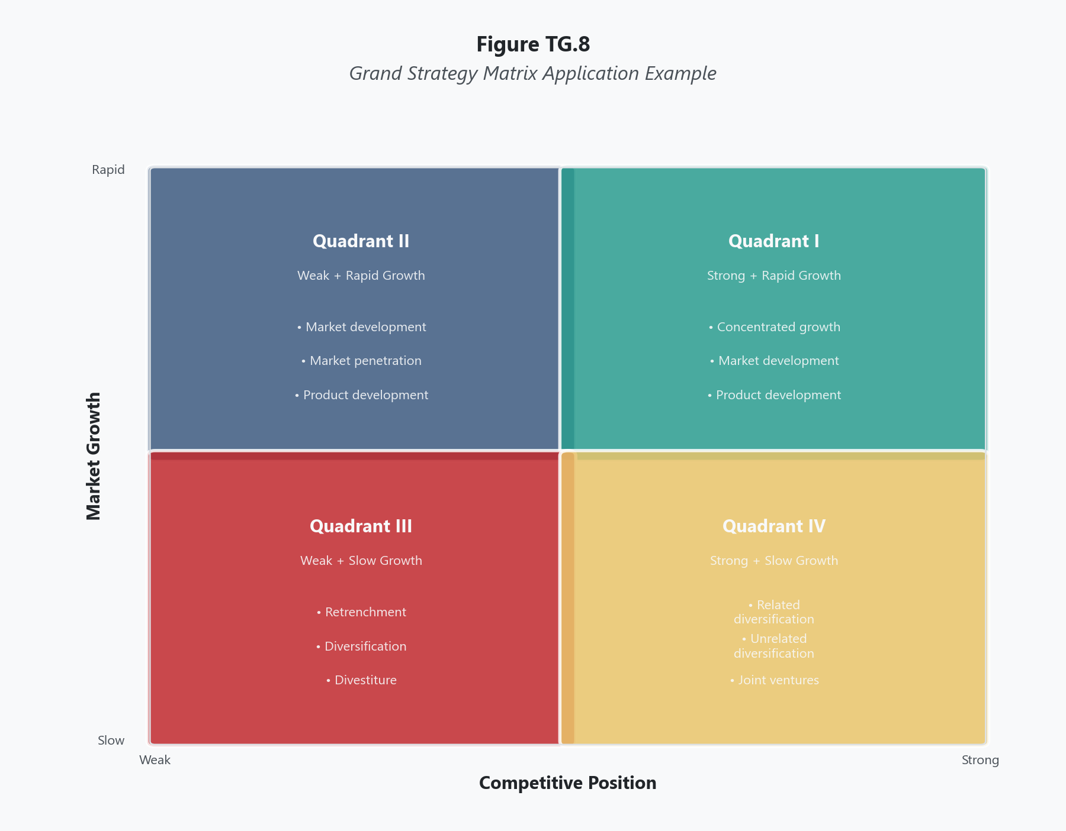
Determine whether the firm's primary industry is experiencing rapid growth or slow growth. This assessment should draw from the EFE Matrix, industry reports, and macroeconomic data. There is no fixed numerical threshold — "rapid" and "slow" are relative to the economic context and the specific industry. In general, an industry growing meaningfully faster than GDP is considered rapid growth; one growing at or below GDP is considered slow growth. This assessment determines whether the firm is placed in the upper or lower half of the matrix.

Step 2: Assess Competitive Position
Determine whether the firm holds a strong or weak competitive position within its industry. This assessment should draw from the IFE Matrix total weighted score, the CPM comparison against rivals, and qualitative judgments about market share, brand strength, operational capability, and financial position. A firm with an IFE score above 2.5 and a CPM score that leads or closely matches major competitors generally qualifies as holding a strong position. A firm trailing significantly on both measures holds a weak position. This assessment determines whether the firm is placed in the left or right half of the matrix.

Step 3: Plot the Firm on the Matrix
Place the firm in the appropriate quadrant based on the two assessments:
- Quadrant I (upper left): Rapid market growth + Strong competitive position
- Quadrant II (upper right): Rapid market growth + Weak competitive position
- Quadrant III (lower right): Slow market growth + Weak competitive position
- Quadrant IV (lower left): Slow market growth + Strong competitive position

Step 4: Identify the Appropriate Strategic Alternatives
Each quadrant carries a distinct set of strategies that are most suitable for that combination of market and competitive conditions. Review the strategies associated with the firm's quadrant (detailed in the Scoring Guide and Interpretation sections below) and evaluate which specific alternatives align best with the firm's resources, capabilities, and objectives.

Step 5: Evaluate Strategic Fit
Not every strategy listed in a quadrant will suit every firm in that quadrant. Use judgment to match the quadrant's strategic alternatives to the firm's specific circumstances. A Quadrant I firm with strong cash flow may pursue aggressive market development, while a Quadrant I firm with limited capital may focus on product development within existing markets. The quadrant narrows the options. Your analysis of the firm's specific situation determines the final selection.

Step 6: Connect to Downstream Tools
Feed the strategic alternatives identified through the Grand Strategy Matrix into the SWOT Matrix and the QSPM for further evaluation and prioritization. The Grand Strategy Matrix identifies the category of strategy. The SWOT Matrix and QSPM help you choose among specific strategies within that category and prioritize them quantitatively.

Scoring Guide
Table 1 Grand Strategy Matrix Quadrant Definitions and Strategic Alternatives
Quadrant | Market Growth | Competitive Position | Appropriate Strategies
I | Rapid | Strong | Market development, market penetration, product development, forward integration, backward integration, horizontal integration, related diversification
II | Rapid | Weak | Market development, market penetration, product development, horizontal integration, divestiture, liquidation
III | Slow | Weak | Retrenchment, related diversification, unrelated diversification, divestiture, liquidation
IV | Slow | Strong | Related diversification, unrelated diversification, joint ventures, market development, market penetration

Interpreting Your Results
Each quadrant represents a fundamentally different strategic situation. Understanding why certain strategies fit certain quadrants is as important as knowing which strategies belong where.
Quadrant I: Rapid Growth, Strong Position
This is the most favorable strategic position. The market is expanding, and the firm is well-positioned to capture that growth. Firms in Quadrant I can afford to be aggressive. Market penetration deepens share in an expanding market. Market development extends the firm's proven capabilities into new geographies or segments. Product development leverages the firm's strong position to launch new offerings into a receptive, growing market. Integration strategies — forward, backward, or horizontal — allow the firm to strengthen its value chain or consolidate competitors while growth provides the revenue to fund acquisitions.
The risk in Quadrant I is complacency. A strong position in a growing market can mask operational weaknesses or emerging competitive threats. The firm should invest aggressively but not recklessly, and should monitor the sustainability of both market growth and competitive advantage.
Quadrant II: Rapid Growth, Weak Position
The market opportunity is real, but the firm is not capturing it effectively. This is the most urgent strategic situation because the market will not wait. Firms in Quadrant II must decide quickly whether to invest aggressively to strengthen their competitive position or to exit before resources are consumed without return.
Market penetration and product development can work if the firm has identifiable, fixable weaknesses — a distribution gap, a product quality deficit, a marketing shortfall. Horizontal integration through acquiring a stronger competitor can provide instant capability. But if the competitive weakness is structural — fundamental cost disadvantage, technological obsolescence, misaligned business model — then divestiture or liquidation may be the responsible choice. The worst outcome for a Quadrant II firm is half-measures: investing enough to stay alive but not enough to become competitive, slowly draining resources in a market that rewards only the strong.
Quadrant III: Slow Growth, Weak Position
This is the most challenging strategic position. The market offers limited growth, and the firm lacks the competitive strength to capture even the growth that exists. Quadrant III firms face a fundamental question: Is this business worth saving?
Retrenchment — cutting costs, selling assets, reducing scope — can stabilize the firm and create a platform for recovery if the underlying business model is sound. Diversification, either related or unrelated, redirects resources from the struggling core business into markets with better prospects. But diversification requires capital that Quadrant III firms often lack, creating a strategic catch-22. Divestiture and liquidation are appropriate when the business cannot be turned around at a cost that is justified by the potential return. The hardest decision in strategy is admitting that a business has run its course.
Quadrant IV: Slow Growth, Strong Position
The firm is strong, but its market is not growing. This creates a strategic tension: the firm generates solid returns in its current market but cannot rely on market growth to drive expansion. Quadrant IV firms are typically cash-rich and operationally efficient — characteristics that fund strategic moves into new areas.
Related diversification leverages existing capabilities into adjacent markets where growth is stronger. Unrelated diversification deploys excess cash into entirely new industries, though this carries higher risk due to lack of operational synergy. Joint ventures provide access to growth markets while sharing risk. Market development — taking existing products into new geographic or demographic markets — can unlock growth that the domestic market no longer provides.
The danger for Quadrant IV firms is over-reliance on the core business. A strong position in a slow-growth market is stable today but vulnerable tomorrow. Markets that are slow-growth today may become declining markets within a planning horizon, and firms that have not diversified will find themselves trapped.

Real-World Example
Consider how four well-known companies might have been positioned on the Grand Strategy Matrix in the mid-2010s, each representing a different quadrant.
Table 2 Grand Strategy Matrix Positioning of Illustrative Companies (Mid-2010s)
Company | Quadrant | Market Growth | Competitive Position | Rationale
Amazon (cloud computing — AWS) | I | Rapid | Strong | The cloud computing market was growing at 30%+ annually, and AWS held dominant market share with strong margins and continuous innovation
Snap Inc. (Snapchat) | II | Rapid | Weak | The social media market was expanding rapidly, but Snapchat held a small share relative to Facebook and Instagram and struggled to monetize its user base effectively
Sears Holdings | III | Slow | Weak | The department store retail market was stagnating, and Sears had lost market share for decades, with deteriorating stores, declining foot traffic, and a weakening brand
Coca-Cola (carbonated soft drinks) | IV | Slow | Strong | The carbonated soft drink market was flat to declining in developed markets, but Coca-Cola maintained dominant brand recognition, distribution, and market share

Amazon (Quadrant I) pursued exactly the strategies the matrix prescribes: aggressive market penetration (expanding AWS globally), product development (launching new cloud services continuously), and forward integration (building its own hardware and networking infrastructure). Amazon's position allowed it to invest billions annually in growth because both the market opportunity and competitive strength justified the commitment.
Snap Inc. (Quadrant II) faced the classic Quadrant II dilemma. The social media market was growing rapidly, but Snapchat's competitive position was fragile — Facebook could copy its features (and did with Instagram Stories), its advertising platform was immature compared to rivals, and its user growth was decelerating. Snap needed to either invest aggressively to differentiate and build advertiser tools, or risk being marginalized in a market where scale determines survival. The company chose to invest, with mixed results over the following years.
Sears Holdings (Quadrant III) illustrated why Quadrant III is the most painful position. The market was not growing, the competitive position was weak, and the firm lacked the financial resources to diversify effectively. Sears attempted retrenchment — closing stores, selling assets, reducing costs — but the underlying competitive position had deteriorated too far. The company eventually filed for bankruptcy in 2018. The Grand Strategy Matrix would have identified the severity of Sears' position years earlier, though whether leadership would have acted on that analysis is a different question.
Coca-Cola (Quadrant IV) demonstrated the Quadrant IV playbook. With its core carbonated beverage market flattening, Coca-Cola diversified into faster-growing categories: bottled water (Dasani, Smartwater), sports drinks (acquisition of stake in BodyArmor), coffee (Costa Coffee acquisition), and health-oriented beverages. It pursued market development in emerging economies where per-capita soft drink consumption was still growing. Coca-Cola's strong competitive position and cash generation funded these moves without requiring the company to abandon its core strength.

Common Mistakes
Mistake 1: Placing the Firm Based on Aspiration Rather Than Reality The matrix requires honest assessment of current conditions. A firm with a weak competitive position that aspires to Quadrant I does not belong in Quadrant I. Where you want to be is a strategic goal. Where you actually are is the starting point for choosing how to get there. Misplacement leads to strategies that assume capabilities the firm does not possess.
Mistake 2: Treating Quadrant Strategies as Mandatory The strategies listed for each quadrant are appropriate options, not automatic prescriptions. A Quadrant III firm might have good reasons to attempt market penetration rather than retrenchment if it has identified a specific, addressable competitive weakness. The matrix narrows the strategic field — it does not make the final decision.
Mistake 3: Using Binary Thinking on the Axes Market growth is not simply "rapid" or "slow," and competitive position is not simply "strong" or "weak." A firm near the boundary of two quadrants should consider strategies from both adjacent quadrants. A company with moderate growth and moderate competitive strength sits near the center of the matrix and should evaluate a wider range of strategic alternatives than a firm firmly positioned in one corner.
Mistake 4: Ignoring the Time Dimension Markets accelerate and decelerate. Competitive positions strengthen and erode. A firm in Quadrant I today may be in Quadrant IV within five years as market growth slows. A Quadrant II firm that invests effectively may move to Quadrant I. The matrix is a snapshot that should be updated regularly, and strategic planning should account for the direction of movement on both axes, not just the current position.
Mistake 5: Applying the Matrix to a Diversified Firm Without Segmenting A diversified corporation operates in multiple markets with different growth rates and holds different competitive positions in each. Plotting the entire corporation as a single point on the matrix produces a meaningless average. Each major business unit or product line should be plotted separately, just as you would use a separate EFE and IFE for each distinct competitive arena.

A Note on Strategic Commitment Under Uncertainty
The Grand Strategy Matrix asks you to commit to a strategic direction based on two assessments — market growth and competitive position — that are inherently uncertain. Market growth projections are frequently wrong. Competitive position assessments involve subjective judgment. And yet the matrix demands that you act on these imperfect assessments, because strategic paralysis is its own form of failure. Ecclesiastes 11:4-6 speaks directly to this tension: "Whoever watches the wind will not plant; whoever looks at the clouds will not reap. As you do not know the path of the wind, or how the body is formed in a mother's womb, so you cannot understand the work of God, who makes everything. Sow your seed in the morning, and at evening let your hands not be idle, for you do not know which will succeed, whether this or that, or whether both will do equally well." The counsel is not recklessness. It is the recognition that waiting for perfect information before acting is itself a decision — and usually a poor one. Strategic leaders analyze the best information available, choose a direction, commit resources, and adjust as new information emerges. The Grand Strategy Matrix does not promise certainty. It provides a framework for acting wisely when certainty is unavailable, which is always.

Key Terms
- Backward Integration: A strategy in which a firm acquires or gains control over its suppliers, moving upstream in the value chain to secure inputs or reduce costs.
- Competitive Position: An assessment of a firm's strength relative to its rivals in a given industry, informed by IFE scores, CPM comparisons, market share, and operational capability; determines horizontal placement on the Grand Strategy Matrix.
- Divestiture: The sale or disposal of a business unit, division, or product line, typically pursued when the unit no longer fits the firm's strategic direction or cannot be made competitive.
- Forward Integration: A strategy in which a firm acquires or gains control over its distribution channels or direct customer relationships, moving downstream in the value chain.
- Grand Strategy Matrix: A strategic matching tool that positions firms in one of four quadrants based on market growth rate and competitive position, mapping each quadrant to a set of appropriate strategic alternatives.
- Horizontal Integration: A strategy in which a firm acquires or merges with competitors operating at the same level of the value chain, consolidating market share and reducing competitive intensity.
- Liquidation: The orderly closure and sale of a firm's assets, typically the last resort when a business cannot be sold as a going concern and continued operation is not viable.
- Market Development: A strategy that takes existing products or services into new markets — new geographic regions, new customer segments, or new distribution channels.
- Market Growth Rate: The pace at which total revenue or unit volume in an industry is expanding or contracting; determines vertical placement on the Grand Strategy Matrix.
- Market Penetration: A strategy that seeks to increase market share for existing products in existing markets through pricing, promotion, distribution expansion, or competitive displacement.
- Product Development: A strategy that creates new or improved products for existing markets, leveraging the firm's current market knowledge and customer relationships.
- Related Diversification: A strategy in which a firm enters new industries that share strategic fit with its existing business — common technologies, distribution channels, customers, or capabilities.
- Retrenchment: A defensive strategy involving cost reduction, asset sales, workforce reduction, or scope narrowing to stabilize a firm that is underperforming or in financial distress.
- Unrelated Diversification: A strategy in which a firm enters industries with no strategic fit to its existing business, typically motivated by financial opportunity rather than operational synergy.

References
Christensen, C. R., Andrews, K. R., Bower, J. L., Hamermesh, R. G., & Porter, M. E. (1982). Business policy: Text and cases (5th ed.). Richard D. Irwin.
David, F. R., & David, F. R. (2017). Strategic management: A competitive advantage approach, concepts and cases (16th ed.). Pearson.
Hitt, M. A., Ireland, R. D., & Hoskisson, R. E. (2020). Strategic management: Competitiveness and globalization (13th ed.). Cengage Learning.
Thompson, A. A., Peteraf, M. A., Gamble, J. E., & Strickland, A. J. (2022). Crafting and executing strategy: The quest for competitive advantage (23rd ed.). McGraw-Hill Education.

Knowledge Check

Multiple Choice
Question 1 [Bloom's: Analyze]
A fast-growing electric vehicle startup holds approximately 2% market share in a market growing at 35% annually. Its IFE score is 2.15 and it trails the market leader significantly on the CPM. The firm has strong engineering talent but limited manufacturing capacity, a thin dealer network, and negative cash flow. Which quadrant does this firm occupy, and what is the most critical strategic implication?
A) Quadrant I — the firm should pursue aggressive market penetration because the market is growing rapidly B) Quadrant II — the firm must decide quickly whether to invest heavily to strengthen its competitive position or exit before resources are exhausted in a market that rewards only strong competitors C) Quadrant III — the firm should pursue retrenchment to stabilize operations before attempting growth D) Quadrant IV — the firm should diversify into adjacent markets to leverage its engineering talent
Correct Answer: B Rationale: The firm operates in a rapid-growth market (35% annually) but holds a weak competitive position (2% share, IFE of 2.15, trailing on CPM). This places it squarely in Quadrant II. The critical implication is the urgency of the decision: in a fast-growing market, competitors are gaining scale, brand recognition, and manufacturing efficiency rapidly. Half-measures — investing modestly while hoping for improvement — will likely leave the firm permanently behind. The firm must either commit fully to building competitive strength or exit. Option A misidentifies the quadrant by ignoring the weak competitive position. Option C misidentifies both dimensions — the market is not slow-growth. Option D misidentifies both dimensions.
Question 2 [Bloom's: Analyze]
A large consumer packaged goods company operates in a mature market growing at 1.5% annually. It holds the number-one market share position, generates strong free cash flow, and has an IFE score of 3.20. The company's CEO proposes using excess cash to acquire a high-growth technology startup in an unrelated industry. Which quadrant does the firm occupy, and how should the Grand Strategy Matrix inform the evaluation of this proposal?
A) Quadrant IV — unrelated diversification is among the appropriate strategies for this quadrant, but the firm should carefully evaluate whether the acquisition's risk profile is justified given the lack of operational synergy B) Quadrant I — the firm's strong financial position means it should pursue aggressive growth in its current market rather than diversifying C) Quadrant III — the slow market growth indicates the firm should retrench before making acquisitions D) Quadrant IV — unrelated diversification is always the best strategy for firms in slow-growth markets with strong competitive positions
Correct Answer: A Rationale: The firm is in Quadrant IV (slow market growth, strong competitive position). Unrelated diversification is listed among appropriate Quadrant IV strategies because these firms typically have excess cash and limited growth opportunities in their core market. However, the Grand Strategy Matrix identifies it as an option, not a prescription. Unrelated diversification carries elevated risk because the acquiring firm lacks operational knowledge of the target industry. The matrix supports considering this strategy but demands rigorous evaluation of the specific opportunity. Option B misidentifies the quadrant — 1.5% growth is not rapid. Option C misidentifies the quadrant — the firm has a strong competitive position, not a weak one. Option D overstates the matrix's prescriptive power — it identifies options, not mandates.
Question 3 [Bloom's: Analyze]
A regional airline operates in a market where overall domestic air travel growth has slowed to 2% annually. However, the specific routes the airline serves — mid-tier cities underserved by major carriers — are growing at 8% annually. The airline holds dominant market share on its routes with high customer satisfaction, but it ranks poorly against major carriers on fleet size, brand recognition, and international capability. An analyst places the airline in Quadrant IV. A colleague argues it belongs in Quadrant I. Who is correct, and what does this disagreement reveal about the Grand Strategy Matrix?
A) The analyst is correct because the overall domestic air travel market is growing slowly B) The colleague is correct because the airline's specific market segment is growing rapidly C) The disagreement reveals that the Grand Strategy Matrix requires careful definition of the relevant market — the airline's competitive position and growth rate depend on whether you define its market as overall domestic air travel or as mid-tier city routes, and the strategic implications differ significantly D) Neither is correct — the airline should be placed in Quadrant II because it trails major carriers on most competitive dimensions
Correct Answer: C Rationale: This question exposes a fundamental challenge in applying the Grand Strategy Matrix: the choice of market definition determines quadrant placement, which determines strategic alternatives. If the market is defined as overall domestic air travel, the airline sits in Quadrant IV (slow growth, strong position on its niche routes). If the market is defined as mid-tier city routes specifically, it sits in Quadrant I (rapid growth, strong position). The strategic recommendations differ substantially — Quadrant IV emphasizes diversification, while Quadrant I emphasizes aggressive growth within the current market. The correct approach requires explicitly defining the relevant market and acknowledging the limitations of any single definition. Option A and B each adopt one market definition without recognizing the ambiguity. Option D incorrectly applies the CPM comparison against major carriers to a niche player whose competitive position should be assessed against its actual competitors on its actual routes.

Critical Thinking
A century-old family-owned furniture manufacturer operates in a slow-growth domestic market (1-2% annual growth). The company holds the number-two market share position nationally with strong brand recognition, high-quality craftsmanship, and a loyal customer base. Its IFE score is 3.05, placing it firmly in Quadrant IV. The Grand Strategy Matrix suggests the firm should consider diversification, joint ventures, or market development.
The founding family has run the company for four generations and views furniture manufacturing as the family's calling and legacy. The CEO (fourth-generation) opposes diversification, arguing that the company should "stay true to what we know and do it excellently." However, the CFO projects that within 10 years, the domestic market will contract by 15% due to import competition and shifting consumer preferences toward disposable furniture. Two board members advocate for acquiring a complementary home decor company (related diversification), while one advocates for investing in international market development in Southeast Asia where a growing middle class is creating demand for premium furniture.
Question: Evaluate the strategic tension between the Grand Strategy Matrix's recommendations and the family's identity-based resistance to change. In your response, analyze whether the CEO's commitment to the core business is a legitimate strategic conviction or a dangerous attachment to the past. Assess the two proposed alternatives (related diversification vs. international market development) against the firm's Quadrant IV position and specific capabilities. Address how a leader balances institutional identity, stakeholder obligations, and strategic reality when the data suggests a direction that the organization's culture resists.
Rubric:
Score | Criteria
Excellent (9-10) | Demonstrates nuanced understanding of the tension between strategic necessity and organizational identity. Does not simply dismiss the CEO's position or accept it uncritically — evaluates both its legitimacy and its risks. Analyzes both proposed alternatives against the firm's specific capabilities and Quadrant IV context, identifying trade-offs rather than declaring one universally superior. Addresses the long-term consequences of inaction with the CFO's market contraction projection. Engages the distinction between strategic conviction and strategic rigidity. Proposes a path that respects institutional identity while addressing strategic vulnerability. Well-organized with clear reasoning.
Proficient (7-8) | Addresses the tension between identity and strategic necessity. Correctly applies Quadrant IV logic. Evaluates both alternatives with reasonable analysis. Recognizes that the CEO's position carries both merit and risk. Clear reasoning with minor gaps in trade-off analysis.
Developing (5-6) | Addresses the question but oversimplifies — either dismisses the CEO entirely or accepts the resistance without critique. Evaluates the alternatives superficially or picks one without adequate justification. Limited engagement with the long-term market contraction data. Some logical gaps.
Needs Work (3-4) | Misses the core tension. Minimal application of Grand Strategy Matrix concepts. Does not evaluate the proposed alternatives. Unclear reasoning or surface-level analysis.
Insufficient (0-2) | Off-topic, demonstrates fundamental misunderstanding of the Grand Strategy Matrix, or fails to engage the scenario meaningfully.

The Quantitative Strategic Planning Matrix

What This Tool Does
The Quantitative Strategic Planning Matrix (QSPM) evaluates and ranks alternative strategies using the same key factors already identified in the IFE and EFE Matrices. It takes the strategies generated by matching tools — the SWOT Matrix, Grand Strategy Matrix, IE Matrix — and subjects them to a disciplined, quantitative comparison. The output is a Total Attractiveness Score (TAS) for each strategy, providing an objective basis for deciding which strategy to pursue. The QSPM is the only tool in the strategic management framework that answers the question: Given everything we know about our strengths, weaknesses, opportunities, and threats, which strategy makes the best use of our situation?

When to Use It
Use the QSPM during the decision stage of strategy formulation, after all input-stage analyses (EFE, IFE, CPM) and matching-stage analyses (SWOT, IE, Grand Strategy, BCG) are complete. The QSPM requires both the key factors and their weights from the EFE and IFE as direct inputs. It also requires at least two feasible alternative strategies identified through the matching stage. The QSPM is the final analytical step before strategy implementation planning begins. Without it, strategy selection relies on debate, intuition, and organizational politics rather than structured analysis.

Before You Start
- Have a completed EFE Matrix with all key external factors and their assigned weights
- Have a completed IFE Matrix with all key internal factors and their assigned weights
- Identify two or three alternative strategies to compare (these should come from your SWOT Matrix, IE Matrix, or Grand Strategy Matrix analysis)
- Ensure the alternative strategies are genuinely distinct — comparing two minor variations of the same approach produces little insight
- Have access to the strategic planning team that constructed the input matrices, because they will assign the attractiveness scores
- Understand that the QSPM evaluates strategies against the same factors already analyzed — it does not introduce new data, only new judgments about how each strategy relates to those factors

Step-by-Step Instructions
Figure TG.9. QSPM Decision Analysis Example
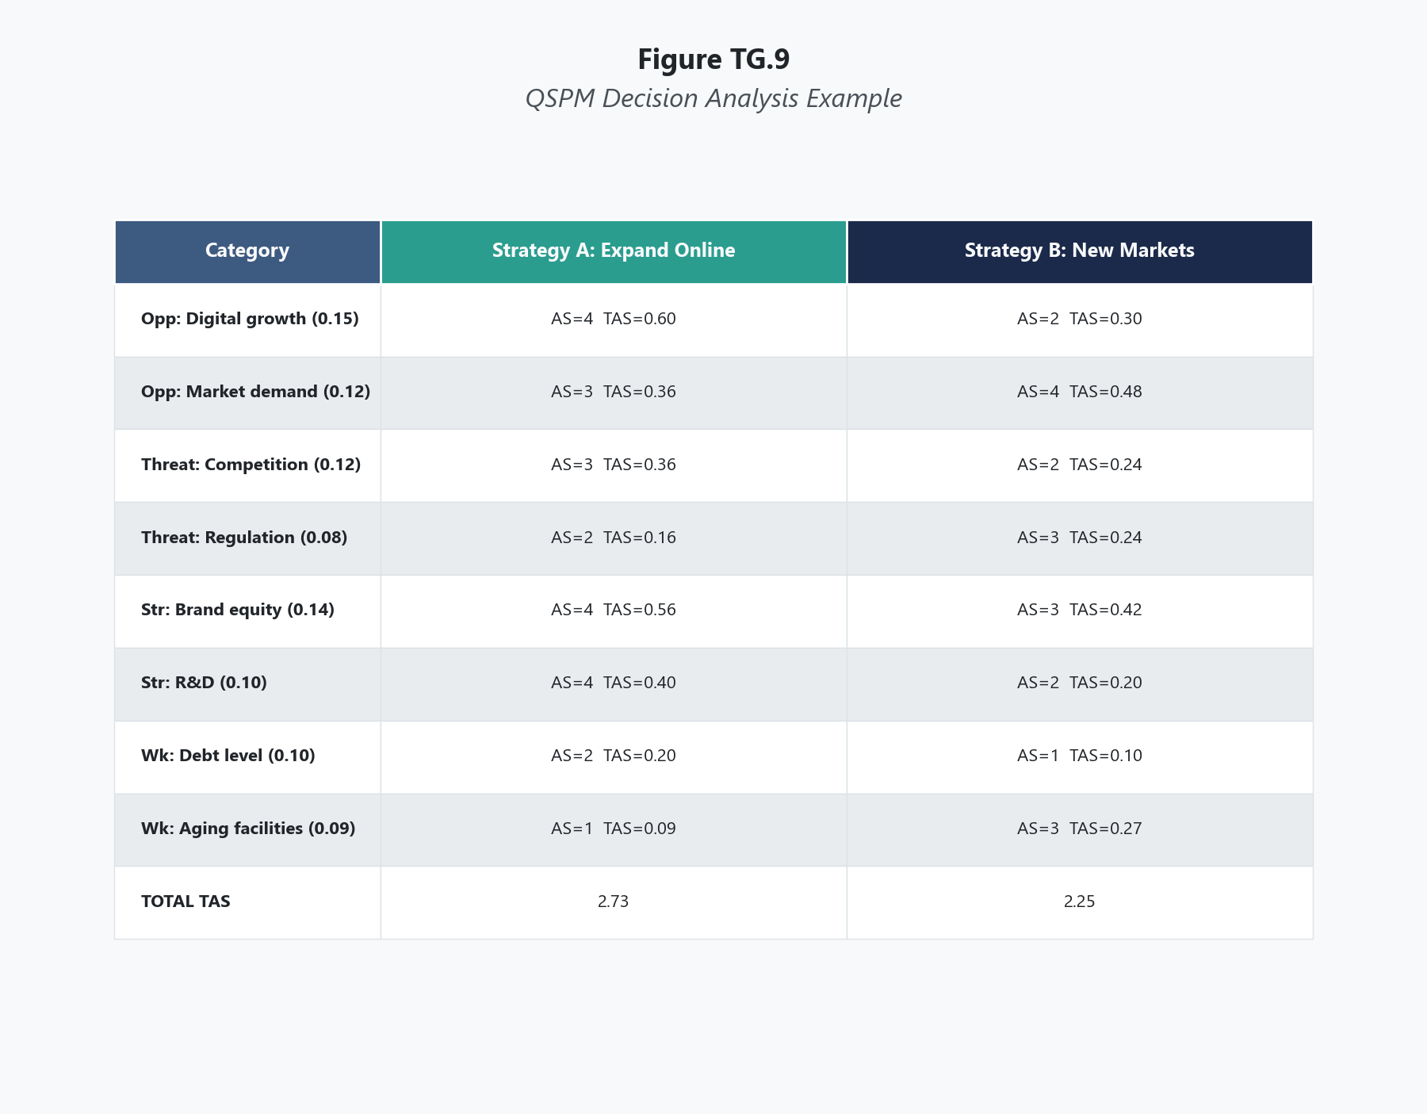
In the left column of the QSPM, list all key external factors (opportunities and threats) from the EFE Matrix, followed by all key internal factors (strengths and weaknesses) from the IFE Matrix. These should be copied exactly from those matrices, preserving the original factor descriptions. A typical QSPM contains 15 to 20 external factors and 15 to 20 internal factors, for a total of 30 to 40 rows.

Step 2: Transfer the Weights
In the second column, record the weight assigned to each factor from the original EFE and IFE Matrices. These weights remain unchanged — the QSPM uses the same importance weights you already determined. This is critical: the weights anchor the analysis in your prior assessment of what matters, preventing the attractiveness scoring from overriding the importance analysis.

Step 3: Identify the Alternative Strategies
Write the alternative strategies as column headers across the top of the matrix. Typically you compare two or three strategies, though the framework can accommodate more. Each strategy should be described clearly enough that the team can evaluate it meaningfully.
For example, a QSPM might compare:
- Strategy 1: Market development — expand into Southeast Asian markets
- Strategy 2: Product development — launch a new premium product line domestically
- Strategy 3: Horizontal integration — acquire a regional competitor

Step 4: Assign Attractiveness Scores
For each key factor, assign an Attractiveness Score (AS) indicating how relevant or important that factor is to each strategy being considered. The scale is:
- 4 = highly attractive (the strategy strongly capitalizes on this opportunity/strength or effectively addresses this threat/weakness)
- 3 = reasonably attractive
- 2 = somewhat attractive
- 1 = not attractive (the strategy does not relate to or address this factor)
- — (dash) = the factor has no effect on the strategic choice being made
This is the step that requires the most judgment. The attractiveness score asks: "Given this specific factor, how well does this strategy respond?" Not every factor is relevant to every strategy. If an external opportunity like "growing demand in Asian markets" has no bearing on a strategy focused entirely on domestic product development, assign a dash rather than forcing a rating.
A critical discipline: assign attractiveness scores independently for each strategy. Do not score strategies relative to each other on each factor. Score each strategy on its own relationship to the factor. The comparison emerges from the math, not from side-by-side rating.

Step 5: Calculate Total Attractiveness Scores
For each factor, multiply the weight by the attractiveness score to produce a weighted attractiveness score. Then sum all weighted attractiveness scores for each strategy to produce its Total Attractiveness Score (TAS).
The strategy with the highest TAS is the most attractive given the full set of internal and external factors analyzed. The difference between TAS values indicates how much more attractive one strategy is than another — a narrow gap suggests the strategies are comparably attractive, while a wide gap indicates a clear preference.

Step 6: Interpret and Decide
The highest TAS identifies the recommended strategy, but interpretation matters. Consider:
- How wide is the gap between the top strategy and the alternatives? A difference of 0.50 or more typically signals a clear winner. A difference of 0.10 suggests the strategies are nearly equivalent, and the decision may turn on factors the QSPM does not capture (implementation feasibility, organizational readiness, timing).
- Are there factors where the top-scoring strategy received low attractiveness scores? These represent the strategy's vulnerabilities — areas where execution will require particular attention.
- Did any factor receive a dash across all strategies? If so, that factor may not be relevant to the strategic decision at hand, though it remains relevant to overall organizational management.

Scoring Guide
Table 1 QSPM Attractiveness Score Scale
Score | Meaning | When to Assign
4 | Highly attractive | The strategy directly and strongly capitalizes on or addresses this factor
3 | Reasonably attractive | The strategy meaningfully relates to and benefits from this factor
2 | Somewhat attractive | The strategy has a modest or indirect connection to this factor
1 | Not attractive | The strategy does not meaningfully capitalize on or address this factor
— (dash) | Not applicable | The factor has no effect on the choice between these specific strategies

Table 2 Interpreting TAS Differentials
TAS Gap Between Strategies | Interpretation
Greater than 1.0 | Strong preference — the higher-scoring strategy is substantially more attractive
0.50 to 1.0 | Moderate preference — meaningful advantage for the higher-scoring strategy
0.20 to 0.49 | Slight preference — strategies are competitive; implementation factors may tip the decision
Less than 0.20 | Near-equivalent — strategies are roughly equal in attractiveness; the decision likely depends on qualitative considerations

Interpreting Your Results
The TAS provides a structured basis for strategy selection, but it does not eliminate judgment.
When one strategy clearly dominates: If one strategy scores highest across most factors and produces a TAS gap of 0.50 or more, the QSPM provides a strong quantitative recommendation. The planning team should examine whether any critical factors produced low attractiveness scores for the winning strategy — these are the areas that will require the most careful execution planning.
When strategies score closely: A narrow TAS gap means the QSPM cannot definitively distinguish between the alternatives on the basis of the analyzed factors. This is not a failure of the tool — it is valuable information. It tells you that, given what you know about your internal and external position, both strategies are approximately equally responsive to your situation. The decision then shifts to factors the QSPM does not capture: which strategy is easier to implement, which aligns better with organizational culture, which can be executed faster, which carries less downside risk.
When the recommended strategy is surprising: If the QSPM recommends a strategy that the leadership team did not expect or does not favor, resist the impulse to adjust scores until the preferred strategy wins. The surprise may reflect genuine analytical insight — the team's intuition may be anchored in incomplete information or cognitive bias. Investigate why the scores produced the unexpected result before discounting it.
When factors receive dashes across all strategies: Factors that receive dashes on every strategy do not influence the strategic choice. This can happen when a factor is important to organizational performance but is not differentially affected by the strategies being compared. These factors remain important for management but do not help distinguish between the strategic alternatives.

Real-World Example
Consider Target Corporation in the mid-2010s, facing a strategic crossroads after a period of uneven performance. Target had completed its EFE and IFE analyses and, through SWOT and IE Matrix work, identified three viable strategic alternatives:
- Strategy 1: Accelerate small-format urban store expansion (market development)
- Strategy 2: Invest heavily in e-commerce and same-day delivery to compete with Amazon (product/market development)
- Strategy 3: Acquire a specialty retailer to diversify into higher-margin categories (horizontal integration/related diversification)
Table 3 Illustrative QSPM for Target Corporation (Mid-2010s)
Key Factors | Weight | Strategy 1: Small-Format Expansion |  | Strategy 2: E-Commerce Investment |  | Strategy 3: Specialty Acquisition
 |  | AS | WAS | AS | WAS | AS | WAS
External Opportunities
Growing urban population preferring walkable retail | 0.08 | 4 | 0.32 | 2 | 0.16 | 1 | 0.08
Increasing consumer demand for same-day delivery | 0.09 | 2 | 0.18 | 4 | 0.36 | 1 | 0.09
Expansion of private-label consumer acceptance | 0.06 | 3 | 0.18 | 3 | 0.18 | 2 | 0.12
Rising interest in curated, design-forward retail | 0.05 | 3 | 0.15 | 2 | 0.10 | 4 | 0.20
Growth in health and wellness product categories | 0.04 | 2 | 0.08 | 2 | 0.08 | 3 | 0.12
External Threats
Amazon's dominance in e-commerce and logistics | 0.10 | 2 | 0.20 | 4 | 0.40 | 1 | 0.10
Walmart's aggressive price competition and store density | 0.08 | 3 | 0.24 | 3 | 0.24 | 2 | 0.16
Rising labor costs in retail sector | 0.06 | 2 | 0.12 | 3 | 0.18 | 2 | 0.12
Shifting consumer preference from physical to online shopping | 0.07 | 2 | 0.14 | 4 | 0.28 | 1 | 0.07
Internal Strengths
Strong brand identity with design-conscious consumers | 0.08 | 4 | 0.32 | 3 | 0.24 | 3 | 0.24
Effective private-label portfolio (Good & Gather, Threshold) | 0.06 | 3 | 0.18 | 3 | 0.18 | 2 | 0.12
Established supply chain and distribution network | 0.07 | 3 | 0.21 | 4 | 0.28 | 2 | 0.14
Experienced store operations management team | 0.05 | 4 | 0.20 | 2 | 0.10 | 2 | 0.10
Internal Weaknesses
E-commerce platform less developed than Amazon or Walmart | 0.07 | 1 | 0.07 | 4 | 0.28 | 1 | 0.07
Limited presence in dense urban markets | 0.04 | 4 | 0.16 | 1 | 0.04 | 1 | 0.04
Integration challenges from prior acquisitions | 0.04 | — | — | — | — | 1 | 0.04
Totals |  |  | 2.75 |  | 3.10 |  | 1.81

The QSPM produced a clear ranking: Strategy 2 (e-commerce and same-day delivery investment) scored highest at 3.10, Strategy 1 (small-format expansion) scored 2.75, and Strategy 3 (specialty acquisition) scored 1.81.
Strategy 2 dominated because it scored highest on the most heavily weighted factors — Amazon's competitive threat (0.10), consumer shift to online shopping (0.07), same-day delivery demand (0.09), and the internal weakness of Target's underdeveloped e-commerce platform (0.07). The strategy directly addressed both the largest external threats and the most consequential internal weakness.
Strategy 1 scored respectably because it leveraged Target's brand strength and operational expertise, but it did not address the e-commerce threat as directly. Strategy 3 scored lowest because it failed to respond to the external factors carrying the most weight.
Target's actual strategic choices in this period aligned closely with what this QSPM would have recommended. The company invested billions in e-commerce infrastructure, same-day delivery (acquiring Shipt), and digital fulfillment from existing stores, while also pursuing small-format expansion as a secondary strategy. The specialty acquisition approach was not pursued. The QSPM framework would have provided analytical support for exactly this prioritization.

Common Mistakes
Mistake 1: Scoring Strategies Relative to Each Other Instead of Against Each Factor The attractiveness score should reflect how well a strategy relates to each individual factor, not how it compares to the other strategies on that factor. If both strategies strongly capitalize on an opportunity, both can receive a 4. The comparison emerges from the total, not from forced differentiation at the factor level. Forcing one strategy to score higher and the other lower on every factor introduces artificial contrast that corrupts the analysis.
Mistake 2: Adjusting Scores to Produce the Preferred Outcome The QSPM is designed to discipline strategic choice, not to confirm predetermined preferences. If the scores produce a result that leadership does not favor, the response should be to investigate why the analysis recommends a different strategy — not to revise attractiveness scores until the preferred strategy wins. Reverse-engineering scores to match intuition defeats the purpose of the tool.
Mistake 3: Comparing Strategies That Are Not Genuinely Distinct Comparing "expand into the Southeast" against "expand into the Southwest" does not generate meaningful strategic insight — both are geographic market development with minor variation. The QSPM works best when the alternative strategies represent fundamentally different strategic approaches (market development vs. product development vs. integration, for example). Distinct alternatives produce meaningful differentiation in attractiveness scores.
Mistake 4: Ignoring Dashes and Forcing Scores on Every Factor If a factor genuinely has no bearing on the choice between two strategies, assign a dash. Forcing a score where none is warranted introduces noise that can shift the TAS without justification. A factor like "rising energy costs" might be a genuine EFE threat but equally relevant (or irrelevant) to all strategies under consideration. Assigning identical scores to all strategies on that factor adds weight to the total without differentiating — a dash is more honest and produces a cleaner comparison.
Mistake 5: Using the QSPM Without Completing the Input and Matching Stages The QSPM is the capstone of a sequential analytical process. It requires EFE and IFE weights as inputs and strategies generated through matching tools as column headers. Skipping straight to the QSPM without completing the prior stages means the factors, weights, and strategies are improvised rather than analytically grounded. The QSPM's quantitative precision is only as reliable as the analytical work that precedes it.

A Note on Planning and Humility
The QSPM represents the most structured, disciplined form of strategic decision-making in the framework. It takes everything the organization knows about its internal capabilities and external environment and applies that knowledge systematically to choose among alternative futures. The tool works. But it works within limits that every leader should recognize. Proverbs 16:9 captures the balance precisely: "In their hearts humans plan their course, but the Lord establishes their steps." The counsel is not against planning — it is against the arrogance of believing that planning eliminates uncertainty. The QSPM produces a recommended strategy based on the best available information, analyzed with the best available method. That recommendation deserves respect. But the external environment will shift in ways the EFE did not predict. Internal capabilities will develop strengths and expose weaknesses the IFE did not anticipate. Competitors will make moves the CPM did not foresee. The leader who treats the QSPM result as a final answer rather than a best current judgment will be unprepared when reality diverges from the model. Plan rigorously. Analyze honestly. Choose with conviction. And hold the outcome with the humility of someone who understands that the most disciplined plan still operates within forces larger than any matrix can contain.

Key Terms
- Alternative Strategy: A distinct strategic option identified through matching-stage tools (SWOT, IE, Grand Strategy) that is evaluated against competing options in the QSPM.
- Attractiveness Score (AS): A rating from 1 to 4 (or a dash for not applicable) assigned to each key factor for each strategy, indicating how well the strategy capitalizes on or addresses that factor.
- Decision Stage: The third and final stage of the strategy formulation framework, where the QSPM is used to evaluate and prioritize strategies identified in the matching stage.
- Input Stage: The first stage of the strategy formulation framework, where EFE, IFE, and CPM analyses produce the key factors and weights that feed into matching and decision tools.
- Key Factor: A specific strength, weakness, opportunity, or threat from the IFE or EFE Matrix that is carried into the QSPM as a row in the evaluation matrix.
- Matching Stage: The second stage of the strategy formulation framework, where tools like the SWOT Matrix, IE Matrix, and Grand Strategy Matrix generate alternative strategies by matching internal and external factors.
- Quantitative Strategic Planning Matrix (QSPM): A decision-stage tool that evaluates alternative strategies by systematically scoring each strategy's attractiveness against every key internal and external factor, producing a Total Attractiveness Score for objective strategy comparison.
- Total Attractiveness Score (TAS): The sum of all weighted attractiveness scores for a single strategy, representing its overall attractiveness given the full set of internal and external factors; the strategy with the highest TAS is the recommended choice.
- Weight: The importance value assigned to each key factor in the original EFE or IFE Matrix, carried unchanged into the QSPM and multiplied by the attractiveness score to produce weighted attractiveness scores.
- Weighted Attractiveness Score (WAS): The product of a key factor's weight and its attractiveness score for a given strategy, representing how much that factor contributes to the strategy's overall attractiveness.

References
David, F. R., & David, F. R. (2017). Strategic management: A competitive advantage approach, concepts and cases (16th ed.). Pearson.
Hitt, M. A., Ireland, R. D., & Hoskisson, R. E. (2020). Strategic management: Competitiveness and globalization (13th ed.). Cengage Learning.
Target Corporation. (2017). 2017 annual report. Target Corporation.
Thompson, A. A., Peteraf, M. A., Gamble, J. E., & Strickland, A. J. (2022). Crafting and executing strategy: The quest for competitive advantage (23rd ed.). McGraw-Hill Education.

Knowledge Check

Multiple Choice
Question 1 [Bloom's: Analyze]
A strategic planning team constructs a QSPM comparing two strategies. On the factor "growing consumer demand for sustainable products" (weight 0.09), Strategy A receives an attractiveness score of 4 and Strategy B receives an attractiveness score of 4. A team member objects, arguing that both strategies cannot receive the same score because "the whole point is to differentiate." Is the team member correct?
A) Yes — the QSPM requires different scores for each strategy on every factor to produce meaningful differentiation B) No — attractiveness scores reflect each strategy's independent relationship to the factor, not a forced comparison between strategies; if both strategies equally capitalize on this opportunity, both correctly receive a 4 C) Yes — identical scores waste the factor's analytical value because the weighted attractiveness scores will be equal, contributing nothing to the TAS differential D) No — but the team should assign a dash instead if both strategies score equally
Correct Answer: B Rationale: Attractiveness scores are assigned independently — each strategy is evaluated on its own relationship to the factor, not relative to the other strategy. If both strategies equally capitalize on growing sustainable product demand, both legitimately score 4. The differentiation between strategies emerges from the full set of factors, not from forced differences on individual factors. Option A and C describe a common error — forcing artificial differentiation at the factor level corrupts the analysis. Option D misapplies the dash, which is used when a factor has no relevance to the strategic choice, not when strategies score equally.
Question 2 [Bloom's: Analyze]
A company's QSPM produces the following Total Attractiveness Scores: Strategy A = 5.25, Strategy B = 5.10, Strategy C = 3.80. The CEO favors Strategy A based on the scores. The CFO argues that the 0.15 difference between Strategy A and Strategy B is too small to be decisive and that implementation feasibility should determine the choice between them. Who is making the stronger analytical argument?
A) The CEO, because the QSPM is designed to produce a definitive ranking and the highest TAS should always be selected B) The CFO, because a TAS differential of 0.15 indicates near-equivalent attractiveness, meaning both strategies respond similarly to the organization's key factors and the decision should incorporate considerations the QSPM does not capture C) Neither — the QSPM should be rerun with additional factors until a larger gap emerges D) The CEO, because Strategy C's low score validates the QSPM's ability to differentiate, proving that the A-B comparison is also reliable
Correct Answer: B Rationale: A TAS gap of 0.15 across 30+ factors indicates that the two strategies are nearly equivalent in how they respond to the organization's internal and external situation. At this margin, small changes in attractiveness scores — which involve subjective judgment — could reverse the ranking. The CFO correctly recognizes that the QSPM has done its job by eliminating Strategy C (which is clearly less attractive) and narrowing the field to two comparable options, but cannot meaningfully distinguish between A and B at this gap. The decision between them should incorporate factors the QSPM does not capture: implementation cost, timeline, organizational readiness, and risk tolerance. Option A treats the QSPM as infallible at any margin. Option C attempts to force a larger gap rather than accepting the analytical reality. Option D conflates the tool's ability to make large distinctions with its ability to make fine distinctions.
Question 3 [Bloom's: Analyze]
A planning team constructs a QSPM and discovers that the strategy they expected to score lowest — a retrenchment strategy — actually produces the highest TAS. The team's initial preference was for a market development strategy, which scored second. The team leader proposes revising the attractiveness scores on several factors to bring the market development strategy's TAS above the retrenchment strategy's. What is the fundamental problem with this proposal?
A) There is no problem — attractiveness scores involve judgment, and the team is within its rights to revise them based on deeper reflection B) The proposal treats the QSPM as a tool for confirming preferences rather than informing decisions, which defeats the analytical purpose; if the team disagrees with the result, they should investigate why the retrenchment strategy scored highest rather than adjusting scores to produce their preferred outcome C) The team should add more factors rather than revising scores, because additional factors will naturally produce the correct result D) The retrenchment strategy should be removed from the comparison since it is the least desirable option, and the QSPM should be rerun with only the remaining strategies
Correct Answer: B Rationale: The most dangerous misuse of the QSPM is reverse-engineering scores to confirm a predetermined preference. If the retrenchment strategy scored highest, it means the organization's key factors — weighted by their importance — are more favorably addressed by retrenchment than by market development. This may reflect a genuinely weak internal position, a hostile external environment, or both. The appropriate response is to examine why the analysis produced this result: Are the IFE weaknesses so severe that they undermine expansion strategies? Are the EFE threats so dominant that defensive positioning is objectively more responsive? The answer may lead the team to accept the retrenchment recommendation, or it may reveal flaws in the input matrices that should be corrected at the source — but it should not lead to score manipulation. Option A permits score manipulation under the guise of "judgment." Option C attempts to dilute the result through volume. Option D removes a legitimate option to avoid an uncomfortable finding.

Critical Thinking
A mid-sized pharmaceutical company uses the QSPM to evaluate three strategies: (1) invest in developing a novel drug for a rare disease with a small but desperate patient population and limited commercial potential, (2) develop a generic version of a blockbuster drug going off patent with large commercial potential and low development risk, and (3) acquire a biotech startup with a promising but unproven gene therapy platform. The QSPM produces TAS scores of 4.15 for Strategy 2 (generic drug), 3.85 for Strategy 3 (biotech acquisition), and 2.90 for Strategy 1 (rare disease drug).
The QSPM clearly favors the generic drug strategy on quantitative grounds — it capitalizes on the firm's manufacturing strengths, addresses the competitive threat from other generic manufacturers, and carries the lowest development risk. However, the firm's mission statement explicitly commits to "advancing treatments for patients with the greatest unmet medical need," and the rare disease strategy is the only option that directly serves a patient population with no existing treatment.
Question: Evaluate the tension between the QSPM's quantitative recommendation and the firm's stated mission. Should the QSPM result determine the strategic choice, or should mission considerations override the analytical ranking? In your response, address what the QSPM measures and what it does not measure, whether a mission statement carries strategic weight or is merely aspirational, how a leader resolves conflicts between analytical tools and organizational values, and whether there is a way to honor both the quantitative analysis and the mission without simply choosing one over the other.
Rubric:
Score | Criteria
Excellent (9-10) | Demonstrates nuanced understanding that the QSPM measures strategy-factor alignment but does not measure mission alignment, stakeholder obligation, or organizational identity. Does not simply dismiss either the QSPM result or the mission — engages both as legitimate inputs to the decision. Recognizes that a mission statement is either a binding strategic commitment or an empty claim, and that this decision reveals which it is. Proposes creative approaches (phased implementation, portfolio allocation, partnership models) that honor both analytical findings and mission commitments. Addresses the leadership challenge of making decisions when tools and values diverge. Well-organized with clear reasoning.
Proficient (7-8) | Addresses the tension between QSPM results and mission. Correctly identifies what the QSPM captures and what it misses. Recognizes that mission commitments should carry strategic weight. Proposes at least one approach that does not simply choose one over the other. Clear reasoning with minor gaps.
Developing (5-6) | Addresses the question but oversimplifies — either accepts the QSPM ranking without engaging the mission concern, or dismisses the QSPM in favor of mission without acknowledging the quantitative analysis. Limited engagement with how leaders resolve tool-vs-values conflicts. Some logical gaps.
Needs Work (3-4) | Misses the core tension. Minimal application of QSPM concepts. Does not engage the mission dimension or the specific TAS data. Unclear reasoning.
Insufficient (0-2) | Off-topic, demonstrates fundamental misunderstanding of the QSPM, or fails to engage the scenario meaningfully.

The Perceptual Map

What This Tool Does
The Perceptual Map (also called a positioning map or strategic group map when applied at the industry level) plots competitors on a two-dimensional grid based on two strategic variables that drive customer choice or competitive differentiation in an industry. The result is a visual representation of how firms are positioned relative to each other in the minds of customers or along dimensions that define competitive space. The map answers questions that numerical matrices cannot: Where is the competitive crowding? Where are the open spaces? And does your position match the position you think you occupy?

When to Use It
Use the Perceptual Map during the strategy formulation stage, typically during or after external and competitive analysis. It complements the CPM by showing relative positioning visually rather than numerically. The Perceptual Map is particularly useful when an organization needs to understand competitive clustering (which competitors occupy similar positions), identify underserved market space (gaps on the map where no competitor currently sits), evaluate whether a repositioning strategy is feasible, or assess whether the firm's intended position matches how the market actually perceives it. It can be applied to an entire industry (strategic group mapping) or to a specific product category (product positioning).

Before You Start
- Identify the competitors to include — typically 6 to 12 firms or brands that compete in the same market
- Select two strategic variables for the axes that are genuinely important to competitive differentiation in this industry (see Step 1 for guidance)
- Gather data or make informed assessments about where each competitor falls on both dimensions
- If constructing a customer perception map, have access to customer survey data, market research, or brand perception studies
- If constructing a strategic group map, have industry data on the strategic variables (price points, geographic scope, product breadth, etc.)
- Understand that the Perceptual Map is a qualitative-visual tool — its value comes from pattern recognition, not numerical precision

Step-by-Step Instructions
Figure TG.10. Perceptual Map Construction Example
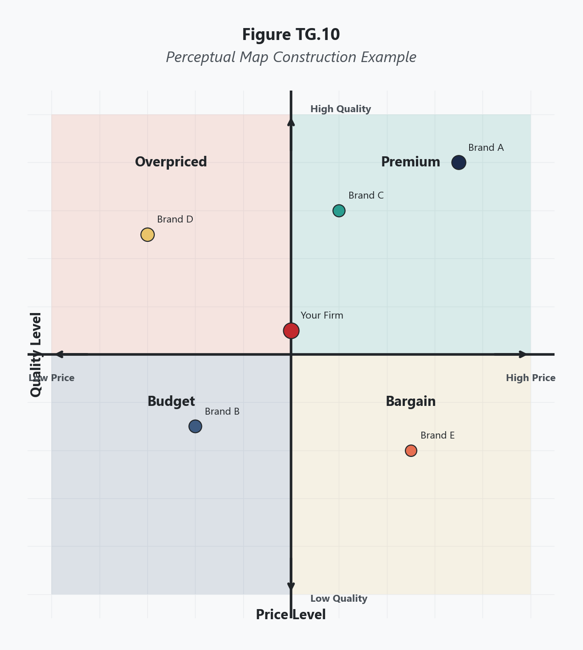
Choose two strategic variables that represent the most important dimensions of competition or customer decision-making in the industry. The axes must be independent of each other — if they are highly correlated (e.g., price and quality often move together), the map will show a diagonal line rather than a meaningful distribution, and you lose analytical value.
Strong axis combinations reveal competitive structure:
- Price vs. product breadth (works in retail, consumer goods)
- Quality/luxury vs. accessibility/convenience (works in hospitality, automotive)
- Geographic scope vs. specialization depth (works in professional services, healthcare)
- Innovation rate vs. cost leadership (works in technology, manufacturing)
- Customization vs. standardization (works in software, financial services)
Weak axis combinations collapse the map:
- Price vs. quality (too correlated in most industries — high price and high quality cluster together)
- Revenue vs. market share (measuring the same thing differently)
The axis selection is the single most important decision in constructing the map. Different axes produce different maps of the same industry, each revealing different competitive dynamics. There is no single "correct" map — only maps that are more or less useful for the strategic question being asked.

Step 2: Define the Scale for Each Axis
Each axis runs from low to high on its respective variable. The scale does not need to be numerically precise for a qualitative perceptual map, but each end should be clearly defined. For example, if the horizontal axis is "product line breadth," the left end represents firms with a narrow, focused product line and the right end represents firms with a broad, diversified product portfolio. Defining the endpoints clearly ensures that placements are consistent and defensible.

Step 3: Plot Each Competitor
Place each competitor on the map at the intersection of its position on both axes. Use judgment informed by data — financial reports, market research, customer surveys, competitive intelligence. Each competitor should be represented by a labeled point or a circle sized proportionally to market share or revenue (proportional sizing adds information but is optional).
Plot your own firm on the same map using the same criteria. The discipline of placing yourself alongside competitors using the same standards — rather than in a separate, more generous assessment — is where the map's strategic value begins.

Step 4: Identify Competitive Clusters
Examine the map for groups of competitors that occupy similar positions. These clusters represent strategic groups — sets of firms that compete most directly with each other because they offer similar value propositions on the dimensions mapped. Firms within a cluster face their most intense competition from each other. Firms in different clusters may compete less directly because they serve different customer preferences or employ different strategic approaches.

Step 5: Identify Gaps and White Space
Look for areas of the map where no competitors are currently positioned. These gaps represent potential strategic opportunities — market space that is currently unoccupied. However, not every gap is an opportunity. Some gaps exist because there is no customer demand in that space (a high-price, low-quality position is a gap because no one wants it, not because it is underserved). Evaluate each gap by asking: Is there customer demand in this space that is currently unmet? Could a firm profitably serve customers in this position?

Step 6: Assess Your Firm's Position
Evaluate your firm's position in the context of the full map. Consider:
- Are you in a crowded cluster with many direct competitors, or in a more differentiated position?
- Does your position align with your intended strategy? (If you aim to be the premium provider but the map shows you positioned in the middle of the pack, your strategy is not translating to market perception.)
- Are you close to a gap that represents an attractive repositioning opportunity?
- Is your current position defensible, or are competitors encroaching?

Step 7: Draw Strategic Implications
Translate the visual patterns into strategic recommendations. Crowded clusters suggest that differentiation strategies are needed to stand out. Attractive gaps suggest repositioning or new market entry opportunities. A mismatch between intended and actual position suggests that the firm's strategy is not being executed effectively or that market perceptions have not caught up with strategic changes. Use the map as input to the SWOT Matrix and strategic option development.

Scoring Guide
The Perceptual Map does not produce a numerical score. Its output is a visual pattern from which strategic insights are drawn. The quality of the analysis depends on three factors:
Table 1 Perceptual Map Quality Criteria
Criterion | Strong | Weak
Axis selection | Two independent, strategically meaningful dimensions that reveal competitive structure | Correlated axes that produce a diagonal, or dimensions irrelevant to competitive differentiation
Competitor placement | Based on data, market research, or informed multi-person assessment; defensible if challenged | Based on one person's impression without supporting evidence
Interpretation | Identifies clusters, gaps, strategic implications, and position/intention mismatches | Simply describes where dots are without drawing strategic conclusions

Interpreting Your Results
Crowded Clusters
When multiple competitors occupy nearly identical positions on the map, those firms compete primarily on execution rather than positioning. In a crowded cluster, the competitive battle is fought on operational efficiency, marketing spend, brand preference, and incremental product improvements rather than on fundamentally different value propositions. Firms in crowded clusters face persistent margin pressure because customers see them as interchangeable.
Strategic response: Differentiate along one or both axes to move away from the cluster, or accept the position and compete on operational excellence. Attempting to occupy the same position as five competitors while offering nothing distinctive is a recipe for commoditization.
Isolated Positions
A firm positioned far from any competitor occupies a differentiated niche. This can be a strength — the firm serves a customer segment that no one else targets — or a vulnerability — the firm may be positioned in a space where customer demand is insufficient to sustain the business.
Strategic response: Validate that the isolated position serves real, profitable demand. If it does, defend it. If demand is thin, consider whether the isolation reflects genuine differentiation or simply strategic drift.
Gaps and White Space
Unoccupied areas of the map warrant investigation. A gap between the premium cluster and the value cluster might represent a viable mid-market position that no competitor has claimed. A gap in the corner where high innovation meets low price might represent an impossible combination — or a disruptive opportunity waiting for a business model innovation that makes it possible.
Strategic response: Evaluate each gap for demand viability, cost feasibility, and competitive defensibility before committing resources. Not every gap is a blue ocean.
Position-Strategy Mismatches
The most strategically valuable finding from a Perceptual Map is often a disconnect between where leadership believes the firm is positioned and where the map actually places it. A company that communicates premium positioning but is mapped alongside mid-market competitors has a strategy execution problem. The market is not receiving the message, or the product does not deliver on the promise.
Strategic response: Close the gap between intention and perception. This may require product improvements, brand repositioning, pricing changes, or distribution adjustments — or it may require accepting that the intended position is not achievable and adjusting the strategy to match reality.

Real-World Example
Consider the U.S. quick-service and fast-casual restaurant industry in the late 2010s, mapped on two axes: average meal price (low to high) and menu customization and ingredient quality (low to high).
Table 2 Perceptual Map Positioning of U.S. Restaurant Chains (Illustrative, Late 2010s)
Restaurant Chain | Price Position | Customization/Quality Position
McDonald's | Low | Low-to-moderate
Burger King | Low | Low
Wendy's | Low-to-moderate | Moderate
Taco Bell | Low | Low-to-moderate
Chipotle | Moderate | High
Panera Bread | Moderate-to-high | High
Five Guys | Moderate | Moderate-to-high
Shake Shack | Moderate-to-high | High
Sweetgreen | High | High
Chick-fil-A | Low-to-moderate | Moderate-to-high

The map reveals several distinct patterns.
A dense cluster of traditional quick-service chains occupies the lower-left region: McDonald's, Burger King, and Taco Bell compete in a crowded space defined by low prices and limited customization. Differentiation within this cluster is difficult, and competition is fought primarily on convenience, marketing, and promotional pricing.
A fast-casual cluster occupies the upper-right region: Chipotle, Panera, Shake Shack, and Sweetgreen offer higher customization and ingredient quality at higher prices. This cluster was the growth segment of the industry during this period, attracting customers willing to pay more for perceived quality and transparency.
Chick-fil-A occupies an unusual position: moderate-to-high quality perception at a low-to-moderate price point. This position is difficult to replicate because it requires operational efficiency sufficient to deliver quality at a lower price. Chick-fil-A's ability to maintain this position reflects its streamlined menu, high throughput operations, and strong brand loyalty — a combination competitors struggled to match.
The map also reveals a notable gap in the high-price, low-customization space. No major chain positions itself as expensive but standardized. This gap exists for a reason — customers willing to pay premium prices expect customization and quality. It is a gap that represents an unviable position, not an opportunity.
The most strategically instructive observation involves Wendy's. The chain positioned itself rhetorically as a quality-focused alternative to McDonald's ("fresh, never frozen"), but the map places it only marginally differentiated from the traditional QSR cluster. Wendy's intended positioning and its market-perceived positioning did not fully align — a strategy execution gap that the Perceptual Map makes visible in a way that numerical tools do not.

Common Mistakes
Mistake 1: Choosing Correlated Axes If both axes measure essentially the same underlying variable, every competitor will plot along a diagonal line and the map reveals nothing. Price and quality, size and revenue, innovation and R&D spending — these pairings tend to correlate strongly. The map's value comes from two genuinely independent dimensions that create a true two-dimensional space. Test the axes by asking: Can a firm realistically be high on one and low on the other? If yes, the axes are sufficiently independent.
Mistake 2: Plotting Based on What You Want to Be Rather Than What You Are The map must reflect actual market positioning, not aspirational positioning. A firm that plots itself in the premium space because it wants to be premium — but whose prices, quality ratings, and customer perceptions place it squarely in the mid-market — produces a map that misleads strategy rather than informing it. Use customer data, competitive benchmarks, and external assessments to place your firm, not internal marketing narratives.
Mistake 3: Constructing Only One Map A single map with one pair of axes reveals one view of competitive structure. The same industry mapped on different axes will show different patterns and surface different insights. Constructing two or three maps with different axis pairs provides a more complete picture of competitive dynamics. The restaurant industry mapped on price vs. quality looks different from the same industry mapped on geographic scope vs. menu breadth.
Mistake 4: Treating Gaps as Automatic Opportunities An empty space on the map is not inherently valuable. Some positions are unoccupied because they are undesirable — no customer wants an expensive, low-quality product. Others are unoccupied because the economics are infeasible — a highly customized product at the lowest price may be physically impossible to deliver profitably. Every gap must be evaluated for demand existence and economic viability before it is treated as a strategic opportunity.
Mistake 5: Ignoring Movement Over Time A Perceptual Map is a snapshot. Competitors reposition, customer preferences shift, and the industry's competitive structure evolves. A map from three years ago may not reflect today's reality. Constructing maps at multiple time points and overlaying them reveals competitive migration patterns — which firms are moving upmarket, which are being pulled toward commoditization, and which are successfully holding differentiated positions. Static maps invite static thinking.

A Note on Seeing Yourself Clearly
The hardest part of constructing a Perceptual Map is not plotting competitors. It is plotting yourself honestly. Every leadership team has a mental image of where the firm sits in competitive space, and that image is almost always more flattering than reality. Customers see the firm differently than the firm sees itself. Competitors occupy positions that leadership may not want to acknowledge. The Perceptual Map works only when the people building it are willing to confront the gap between self-image and market reality. Paul's letter to the Galatians addresses this disposition directly: "If anyone thinks they are something when they are not, they deceive themselves. Each one should test their own actions" (Galatians 6:3-4). The counsel is not to ignore ambition or stop striving for better positioning. It is to ground your strategic assessment in evidence rather than aspiration. Test your position against actual customer perception, actual competitive benchmarks, and actual market data. The gap between where you think you are and where the market places you is the most valuable strategic insight the Perceptual Map can produce — but only if you are willing to see it.

Key Terms
- Competitive Cluster: A group of firms positioned near each other on a Perceptual Map, indicating similar competitive approaches and direct rivalry; also known as a strategic group.
- Differentiation: A competitive strategy in which a firm seeks to occupy a distinct position on the Perceptual Map by offering unique value on one or both mapped dimensions, creating distance from competitors in the same market.
- Gap Analysis: The process of identifying unoccupied areas on a Perceptual Map and evaluating whether those positions represent viable strategic opportunities based on customer demand and economic feasibility.
- Market Perception: How customers, competitors, and the broader market actually view a firm's position on relevant competitive dimensions, which may differ from the firm's intended or self-assessed positioning.
- Perceptual Map: A two-dimensional visual tool that plots competitors on axes representing strategically important variables, revealing competitive structure, clustering, gaps, and positioning alignment or misalignment.
- Positioning: The deliberate strategic choice of where a firm seeks to compete along key competitive dimensions, reflected by its placement on the Perceptual Map.
- Repositioning: A strategic move to shift a firm's position on the Perceptual Map by changing its value proposition along one or both mapped dimensions, typically in response to competitive pressure, market shifts, or a position-strategy mismatch.
- Strategic Group: A set of firms within an industry that follow similar strategies along key dimensions and compete most directly with each other; identified visually as clusters on the Perceptual Map.
- Strategic Variable: A dimension of competition or customer decision-making used as an axis on the Perceptual Map, such as price, quality, breadth, customization, geographic scope, or innovation rate.
- White Space: Unoccupied areas on the Perceptual Map where no competitor currently positions itself; a potential strategic opportunity requiring validation of customer demand and economic viability.

References
David, F. R., & David, F. R. (2017). Strategic management: A competitive advantage approach, concepts and cases (16th ed.). Pearson.
Porter, M. E. (1980). Competitive strategy: Techniques for analyzing industries and competitors. Free Press.
Ries, A., & Trout, J. (2001). Positioning: The battle for your mind (20th anniversary ed.). McGraw-Hill.
Thompson, A. A., Peteraf, M. A., Gamble, J. E., & Strickland, A. J. (2022). Crafting and executing strategy: The quest for competitive advantage (23rd ed.). McGraw-Hill Education.

Knowledge Check

Multiple Choice
Question 1 [Bloom's: Analyze]
An analyst constructs a Perceptual Map of the U.S. hotel industry using "price per night" on the horizontal axis and "luxury amenities" on the vertical axis. The resulting map shows all hotels plotted along a tight diagonal line from lower-left to upper-right. What is the primary analytical problem with this map?
A) The analyst included too many competitors, making the map cluttered B) The two axes are highly correlated — hotels with higher prices tend to offer more luxury amenities — which collapses the two-dimensional space into a single dimension and eliminates the map's ability to reveal competitive structure C) The map is correct and the diagonal pattern reveals that all hotels compete on the same value proposition D) The analyst should reverse the axes to produce a different pattern
Correct Answer: B Rationale: When the two axes are strongly correlated, every competitor falls along a diagonal and the map loses its analytical power. A two-dimensional map requires two independent dimensions to reveal meaningful patterns — clusters, gaps, and positioning differences. Price and luxury amenities move together in the hotel industry, making them a poor axis combination. Better axes might include geographic scope vs. service model (full-service vs. limited-service), or business travel focus vs. leisure focus. Option A does not address the structural problem. Option C misinterprets the diagonal as meaningful rather than recognizing it as an artifact of correlated axes. Option D would produce the same diagonal in reverse.
Question 2 [Bloom's: Analyze]
A mid-sized software company's leadership team constructs a Perceptual Map and places their firm in the "high innovation, premium price" quadrant. However, a subsequent customer survey reveals that customers perceive the firm as "average innovation, moderate price," placing it in the center of the map alongside several larger competitors. What is the most important strategic implication of this discrepancy?
A) The customer survey is unreliable and the leadership team's assessment should take precedence because they understand their own product better B) The discrepancy reveals a position-strategy mismatch — the firm's intended premium positioning is not translating to market perception, indicating either a product delivery gap, a communication failure, or an unrealistic self-assessment that requires investigation before strategic decisions are made C) The firm should immediately lower its prices to align with customer perception of moderate pricing D) The firm should increase marketing spending to correct customer misperceptions without changing the product
Correct Answer: B Rationale: A gap between intended positioning and market-perceived positioning is the most strategically important finding a Perceptual Map can produce. The discrepancy could stem from multiple causes: the product may not actually deliver premium innovation, the marketing may not effectively communicate the firm's advantages, or the leadership team may be overestimating its own capabilities. The correct response is to investigate the root cause before acting. Option A dismisses customer perception data, which is precisely what a perceptual map is designed to capture. Option C treats price as the only lever without understanding the full problem. Option D assumes the product is fine and only communication needs fixing, which may or may not be true.
Question 3 [Bloom's: Analyze]
A Perceptual Map of the U.S. streaming entertainment industry shows a clear gap in the "low price, original/exclusive content" space. Netflix occupies the "moderate price, high original content" position. Disney+ occupies the "low price, moderate original content" position. A startup proposes entering the gap by offering extensive original content at the industry's lowest price. What critical evaluation should be performed before treating this gap as a viable strategic opportunity?
A) No evaluation is needed — any gap on a Perceptual Map represents an underserved market opportunity B) The startup should evaluate whether the economics of producing extensive original content at the lowest price point are feasible, since content creation requires massive capital investment that may be incompatible with low pricing — the gap may exist precisely because the position is financially unsustainable C) The startup should simply copy Netflix's content strategy and undercut on price D) The gap indicates that customers do not value original content, so the startup should focus on licensed content instead
Correct Answer: B Rationale: Not every gap on a Perceptual Map represents a viable opportunity. Some positions are unoccupied because the economics do not work. Producing high volumes of original content requires billions in annual investment — Netflix and Amazon spend $15-17 billion annually on content. Offering that level of content at the lowest price in the industry would require either massive scale that a startup does not have, external subsidies, or a fundamentally different cost structure. The gap exists because established players with deep resources have chosen not to occupy it, which is itself a signal that the position may be economically infeasible. Option A treats all gaps as opportunities without critical evaluation. Option C ignores the fundamental cost problem. Option D misreads customer preferences — the gap is not about demand but about supply-side economics.

Critical Thinking
A regional craft brewery has built a strong local following over 15 years by producing small-batch, high-quality specialty beers sold exclusively through its own taproom and a handful of local restaurants. A Perceptual Map of the broader U.S. beer market shows the brewery occupying an extreme position: highest quality and narrowest distribution of any firm on the map. Major craft brands (Sierra Nevada, Sam Adams) occupy a middle position with moderate quality and broad distribution. Mass-market brands (Bud Light, Coors) cluster in the low-quality, broadest-distribution corner. There is a visible gap between the regional brewery's position and the mid-market craft cluster.
The brewery's owner is considering two strategic options: (1) expand distribution to regional grocery chains and bars to move toward the mid-market craft cluster, or (2) stay in the current position and deepen the premium experience through brewery tourism, membership programs, and limited-release collaborations.
Question: Using the Perceptual Map as your analytical foundation, evaluate both options. Consider what the map reveals about the competitive risks of moving toward a crowded cluster versus the growth limitations of staying in an isolated position. Address whether the brewery's current positioning is a strategic asset or a strategic constraint, and under what conditions each option would be the better choice. In your analysis, discuss how the map's two dimensions interact with factors the map does not capture — brand authenticity, production capacity, financial resources, and customer loyalty dynamics.
Rubric:
Score | Criteria
Excellent (9-10) | Demonstrates nuanced understanding that the Perceptual Map reveals positioning but does not capture the full strategic picture. Evaluates both options against the map's competitive structure while identifying the map's limitations (does not show profitability, brand equity depth, or capacity constraints). Recognizes the trade-off between growth potential and brand dilution risk. Identifies specific conditions under which each option would be superior. Engages the interaction between what the map shows and what it cannot show. Well-organized with clear reasoning.
Proficient (7-8) | Addresses both strategic options with reference to the map. Correctly identifies the risks of moving toward a crowded cluster and the limitations of an isolated position. Recognizes at least one factor the map does not capture that is relevant to the decision. Clear reasoning with minor gaps in the trade-off analysis.
Developing (5-6) | Addresses the question but evaluates the options superficially or picks one without adequately considering the other. Limited engagement with the Perceptual Map as an analytical tool. May treat the map as definitive rather than as one input among several. Some logical gaps.
Needs Work (3-4) | Misses the core trade-off between cluster entry and isolated positioning. Minimal application of Perceptual Map concepts. Does not address the map's limitations. Unclear reasoning.
Insufficient (0-2) | Off-topic, demonstrates fundamental misunderstanding of the Perceptual Map, or fails to engage the scenario meaningfully.

